DIE# 15226 – Morrison (EXTRUDER SIDE)
Pack on Orange Buggy – Wrap arms in cardboard
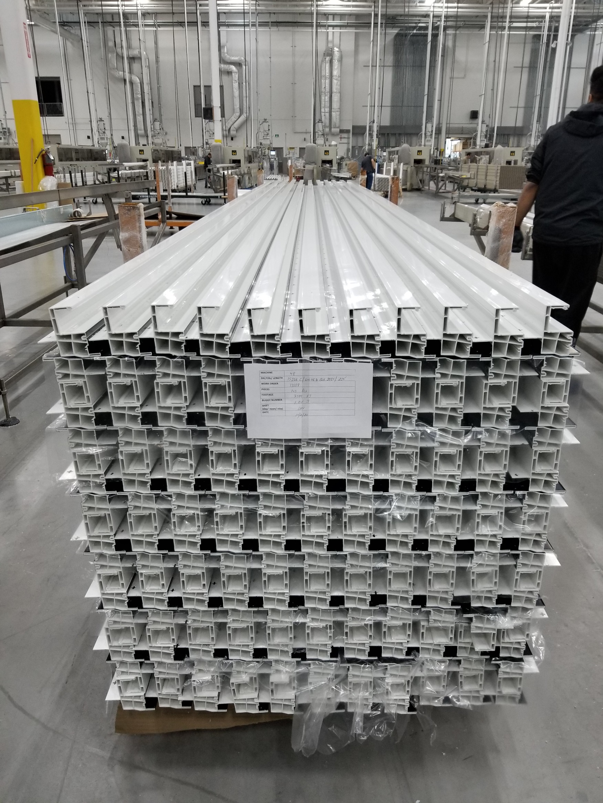
No Foam

