DIE# 15295 – Energy King (EXTRUDER SIDE)
Pack on Mini Green Buggy – Line arm with cardboard + Shrink wrap
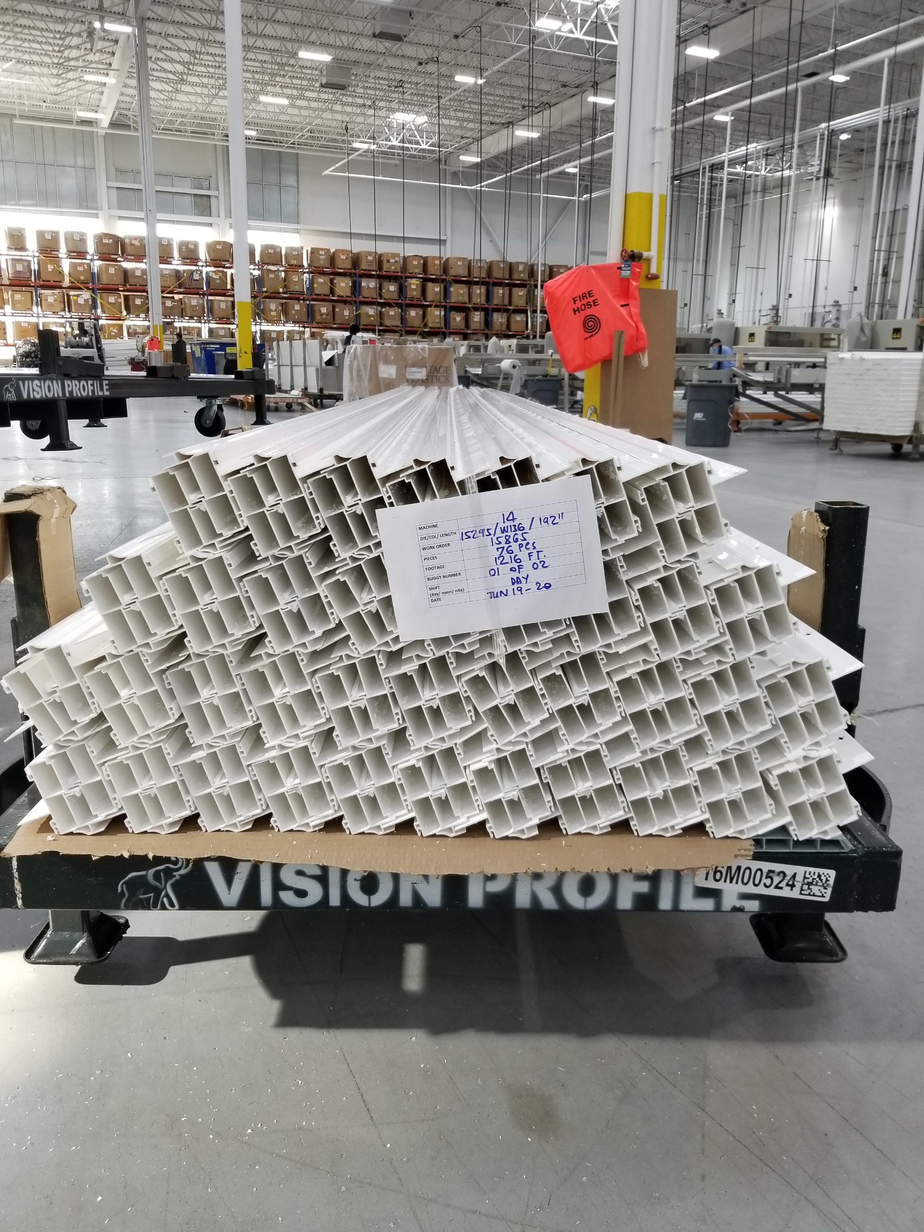
Small Foam on 1 side

