
QUALITY ALERT

Customer: Energy King Date: November 21, 2019
Die: 15296 Colour: WH-136
Type of Complaint: Energy King Complaint

Q.A # Q.I.R # CUSTOMER NCR #

Description: Energy King Complaint – Screen legs not straight making gap open and screen falling in. Pocket legs not straight making it difficult to router. Missing corner on low side causing issues with f
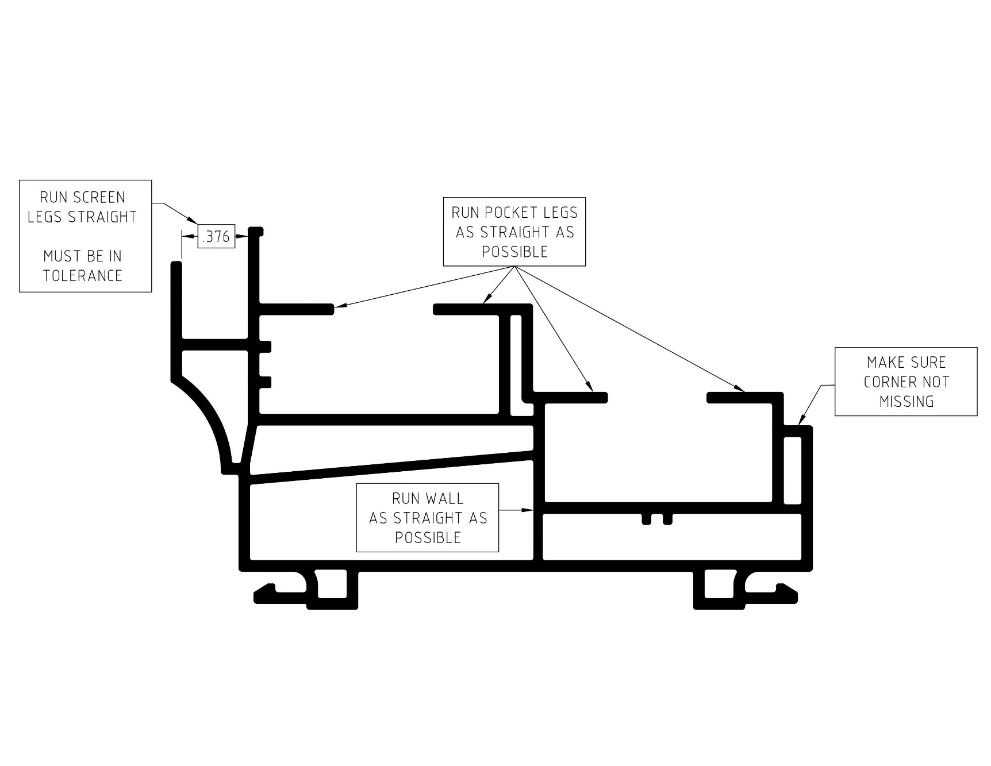

BY SIGNING BELOW, YOU ACKNOWLEDGE THE PROBLEM ABOVE AND AGREE TO MONITOR THIS ISSUE IN FUTURE PRODUCTION RUNS.
DAY SHIFT |  | AFTERNOON SHIFT |  | NIGHT SHIFT
NAME | SIGNATURE | NAME | SIGNATURE | NAME | SIGNATURE

