
QUALITY ALERT

Customer: Energy King Date: Nov 26, 2025
Die: 15296A Colour: Any
Type of Complaint: Customer REJECTED

Q.A # 25-074 NCR: 458 RMA#: N/A

Description: Customer REJECTED due to warped/collapsed pocket, result in failure to assemble.

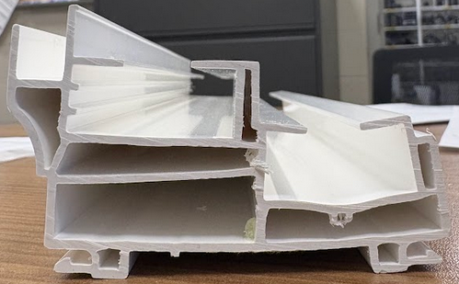

VERIFY POCKET FROM WARPED/DISTORTION SHAPE TO ENSURE PORPER FIT WHEN ASSEMBLING

BY SIGNING BELOW, YOU ACKNOWLEDGE THE PROBLEM ABOVE AND AGREE TO MONITOR THIS ISSUE IN FUTURE PRODUCTION RUNS.
DAY SHIFT |  | AFTERNOON SHIFT |  | NIGHT SHIFT
NAME | SIGNATURE | NAME | SIGNATURE | NAME | SIGNATURE

