
QUALITY ALERT

Customer: Energy King Date: Nov 5, 2025
Die: 15296 Colour: Any
Type of Complaint: Customer Rejected

Q.A # 25-063 NCR: 458 RMA#: N/A

Description: This test is required to verify engagement dimensions and ensure panels lock properly within specified tolerances.
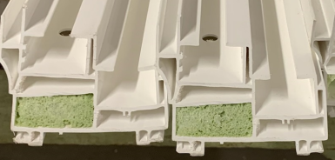

CHECK ENGAGEMENT FIT WITH 3–4FT PANEL TEST. DIMENSIONS MUST MEET SPECIFIED TOLERANCE RANGE BEFORE PACKING

BY SIGNING BELOW, YOU ACKNOWLEDGE THE PROBLEM ABOVE AND AGREE TO MONITOR THIS ISSUE IN FUTURE PRODUCTION RUNS.
DAY SHIFT |  | AFTERNOON SHIFT |  | NIGHT SHIFT
NAME | SIGNATURE | NAME | SIGNATURE | NAME | SIGNATURE
F-006: Quality Alert | Eff.Date: 05/03/2025 | CC# 25-046 | Rev.0

