
QUALITY ALERT

Customer: Seaway Date: Nov 26, 2025
Die: 15301 Colour: Any
Type of Complaint: Customer REJECTED

Q.A # 25-075 NCR: 514 RMA#: N/A

Description: Customer REJECTED due to lock rail and interlock dimensions are out of tolerance. The interlock breaks when trying to punch.
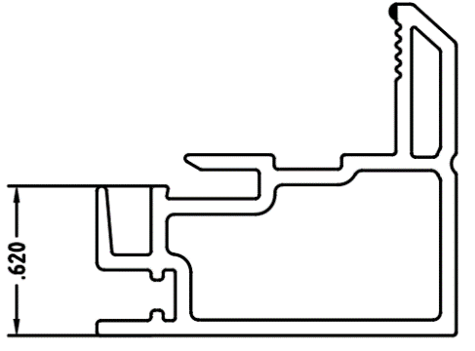
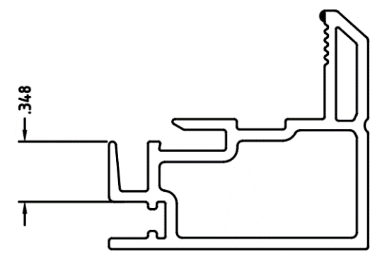



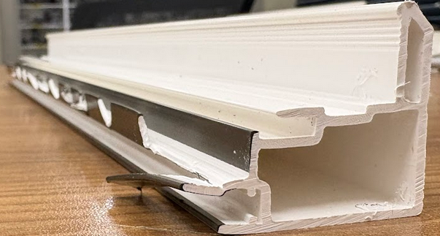

ENSURE ALL DIMENSIONS ARE WITHIN ACCEPTABLE TOLERANCE AND INTERLOCK IS NOT BREAKING UNDER DECENT FORCE (TEST WITH PLIER FOR BEST RESULT)

BY SIGNING BELOW, YOU ACKNOWLEDGE THE PROBLEM ABOVE AND AGREE TO MONITOR THIS ISSUE IN FUTURE PRODUCTION RUNS.
DAY SHIFT |  | AFTERNOON SHIFT |  | NIGHT SHIFT
NAME | SIGNATURE | NAME | SIGNATURE | NAME | SIGNATURE

