
QUALITY ALERT

Customer: Energy King / Oran Date: June 11, 2020
Die: 15302 Colour: WH-136
Type of Complaint: Customer Complaint

Q.A # Q.I.R # CUSTOMER NCR #

Description: Tower is off square and top is not flat making it difficult to lock when hardware is installed
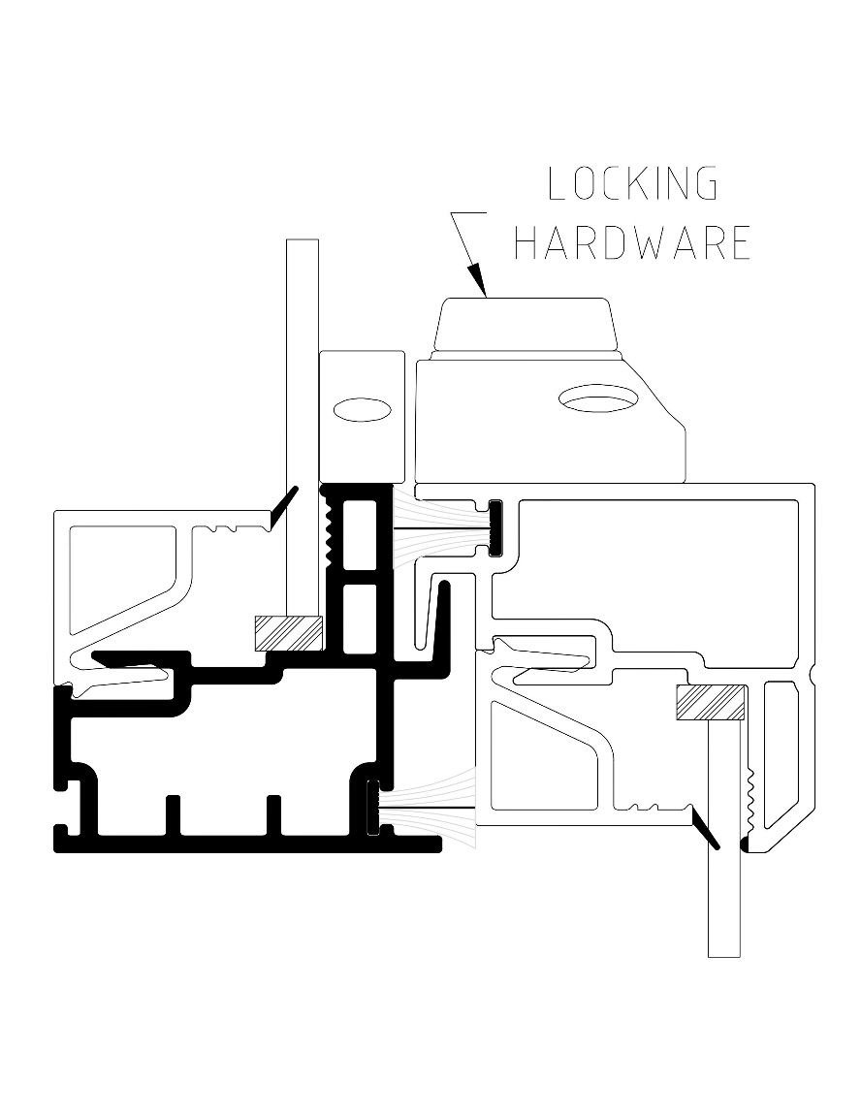
TOP OF TOWER
MUST BE FLAT
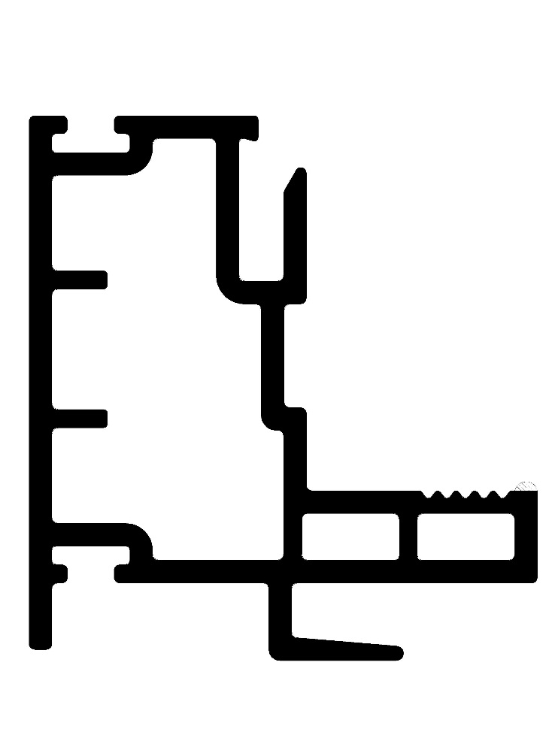

TOWER
MUST BE SQUARE

BY SIGNING BELOW, YOU ACKNOWLEDGE THE PROBLEM ABOVE AND AGREE TO MONITOR THIS ISSUE IN FUTURE PRODUCTION RUNS.
DAY SHIFT |  | AFTERNOON SHIFT |  | NIGHT SHIFT
NAME | SIGNATURE | NAME | SIGNATURE | NAME | SIGNATURE

