
QUALITY ALERT

Customer: Seaway Date: April 11, 2023
Die: 15347/15348/15349/15350/15351/15352/15354/15768 Colour: ALL SEAWAY CAPSTOCK
Type of Complaint: Seaway Complaint

Q.A # Q.I.R # CUSTOMER NCR #

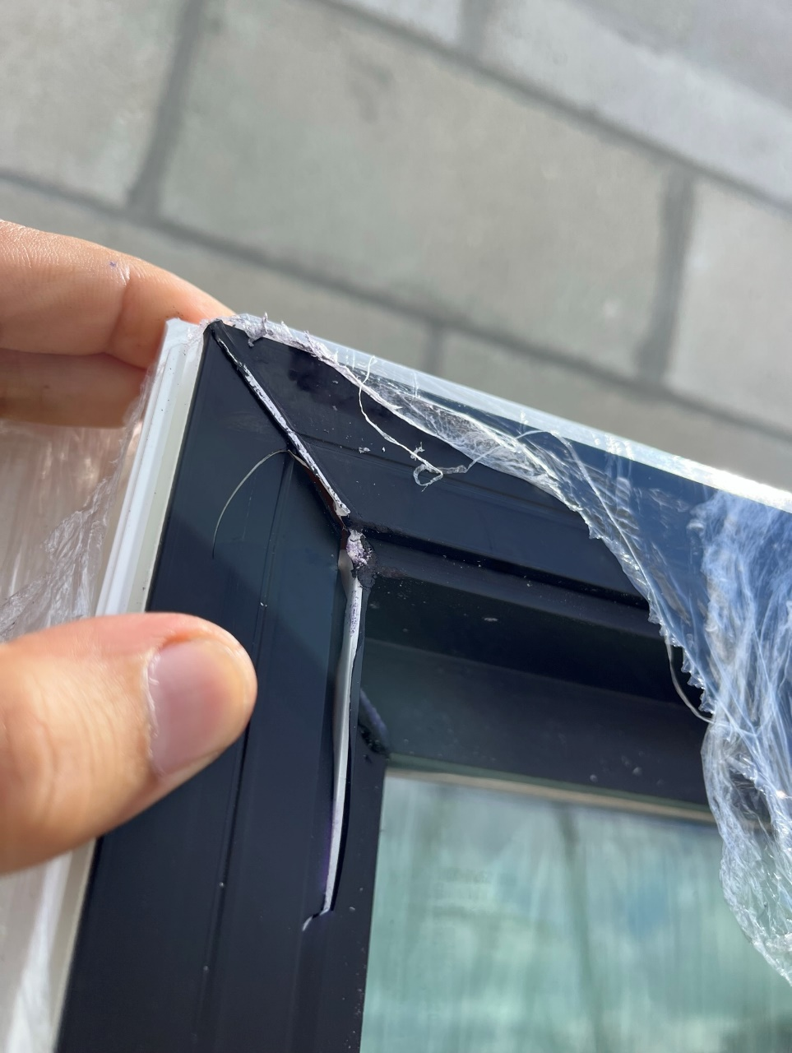
Description: Customer COMPLAINT material is easily cracking.
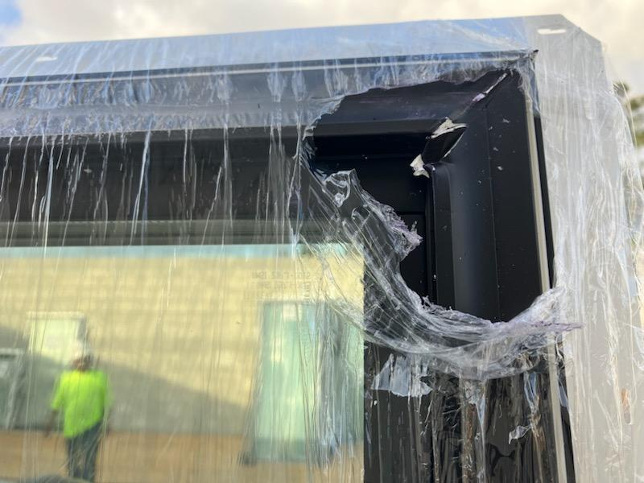

PLEASE MAKE SURE GOOD IMPACT 2 TIMES EVERY SHIFT
BY SIGNING BELOW, YOU ACKNOWLEDGE THE PROBLEM ABOVE AND AGREE TO MONITOR THIS ISSUE IN FUTURE PRODUCTION RUNS.
DAY SHIFT |  | AFTERNOON SHIFT |  | NIGHT SHIFT
NAME | SIGNATURE | NAME | SIGNATURE | NAME | SIGNATURE

