
QUALITY ALERT

Customer: Seaway Date: March 24, 2022
Die: 15350 Colour: All
Type of Complaint: Seaway Complaint

Q.A # Q.I.R # CUSTOMER NCR #

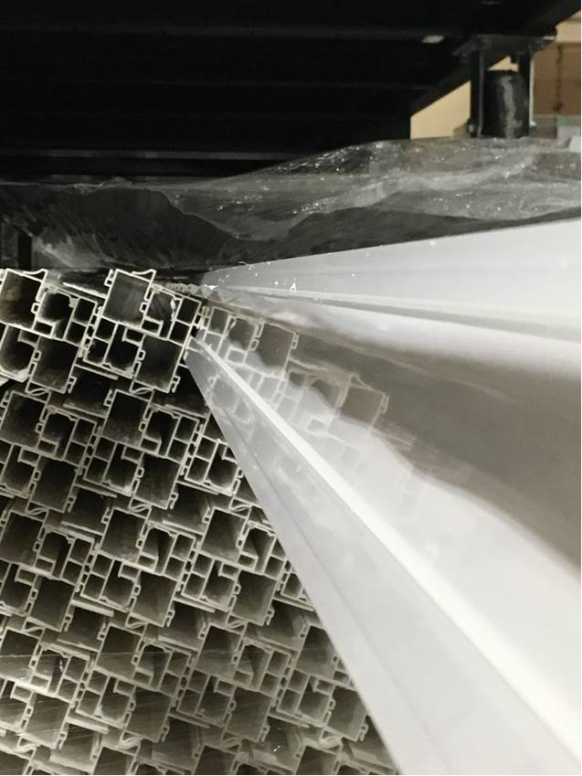
Description: Customer COMPLAINT material due to the nailing fin is waving
PLEASE MAKE SURE THE NAIL FIN IS STRAIGHT
BY SIGNING BELOW, YOU ACKNOWLEDGE THE PROBLEM ABOVE AND AGREE TO MONITOR THIS ISSUE IN FUTURE PRODUCTION RUNS.
DAY SHIFT |  | AFTERNOON SHIFT |  | NIGHT SHIFT
NAME | SIGNATURE | NAME | SIGNATURE | NAME | SIGNATURE

