
QUALITY ALERT

Customer: ORAN Date: May 24, 2022
Die: 15353 Colour: All
Type of Complaint: ORAN REJECTED

Q.A # Q.I.R # CUSTOMER NCR #

Description: Customer REJECTED glazing bead due to the leg is too SHORT / out of dimesion
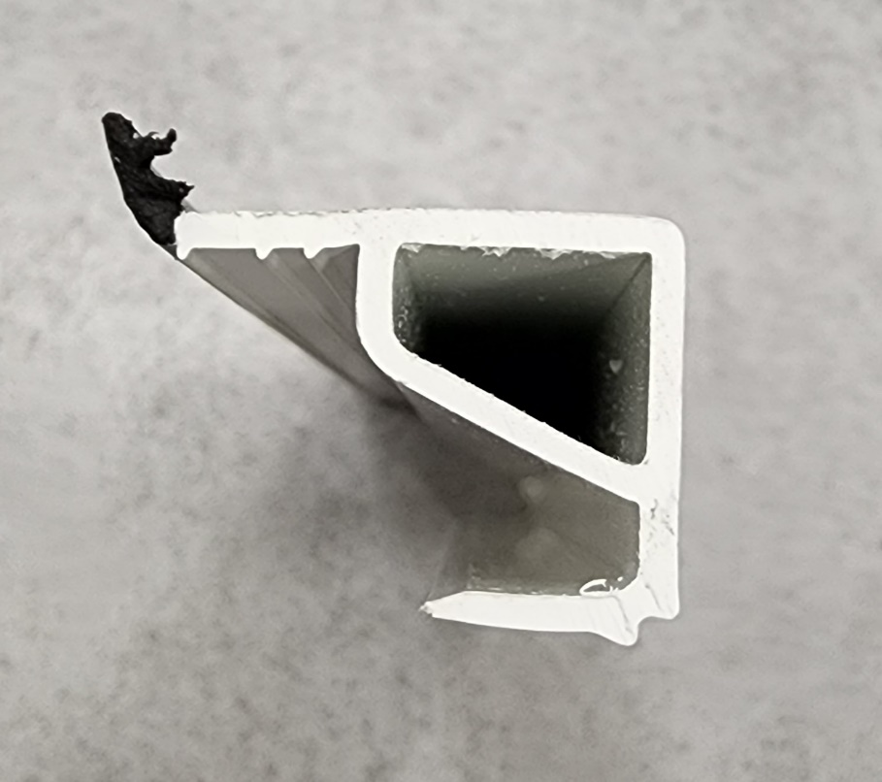
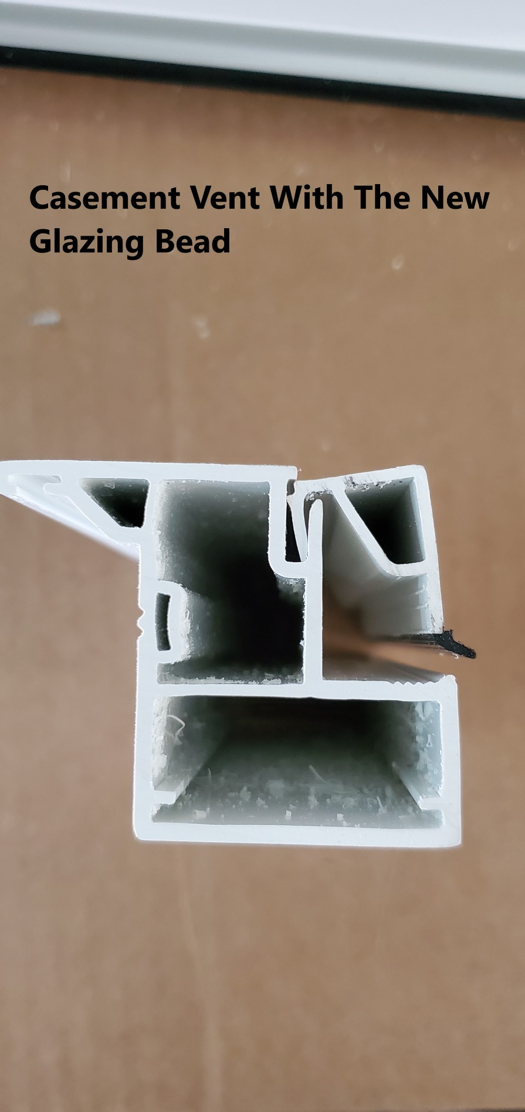

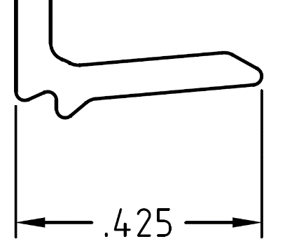

BY SIGNING BELOW, YOU ACKNOWLEDGE THE PROBLEM ABOVE AND AGREE TO MONITOR THIS ISSUE IN FUTURE PRODUCTION RUNS.
DAY SHIFT |  | AFTERNOON SHIFT |  | NIGHT SHIFT
NAME | SIGNATURE | NAME | SIGNATURE | NAME | SIGNATURE

