DIE# 15392– Anlin (EXTRUDER SIDE)
Pack on Green Buggy – Wrap arms in cardboard
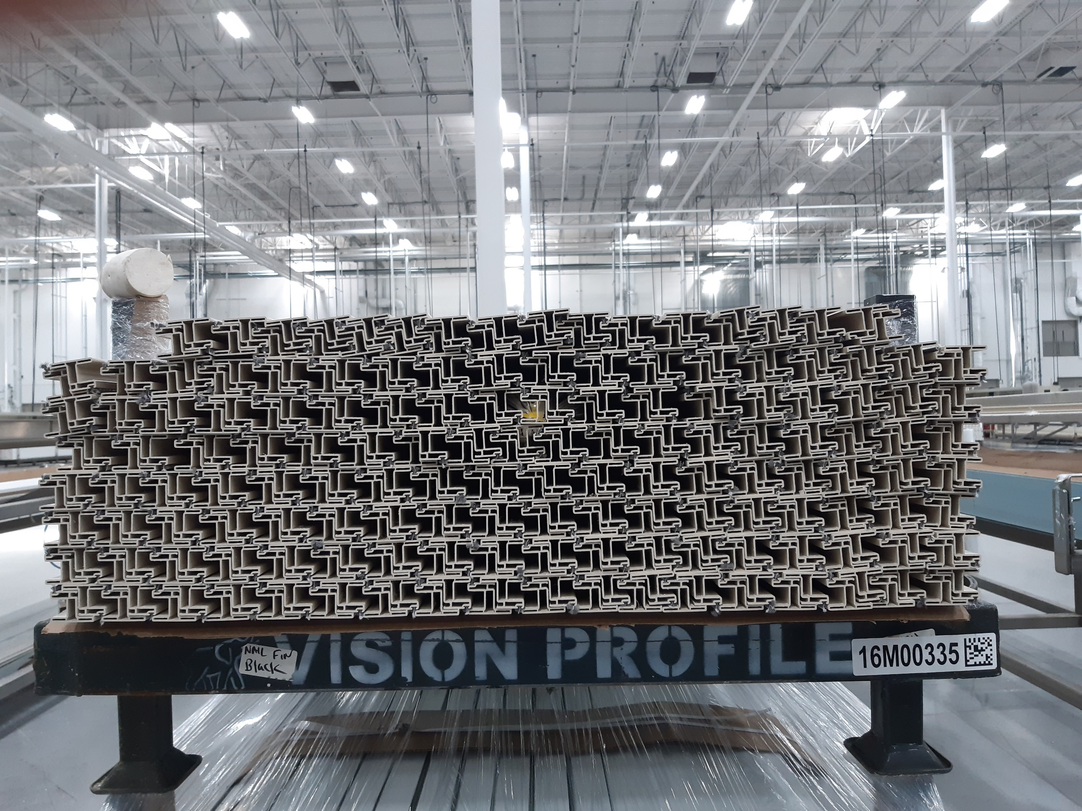
NO FOAM

