DIE# 15398A– Anlin (EXTRUDER SIDE)
Pack on Green Buggy – Wrap arms in cardboard
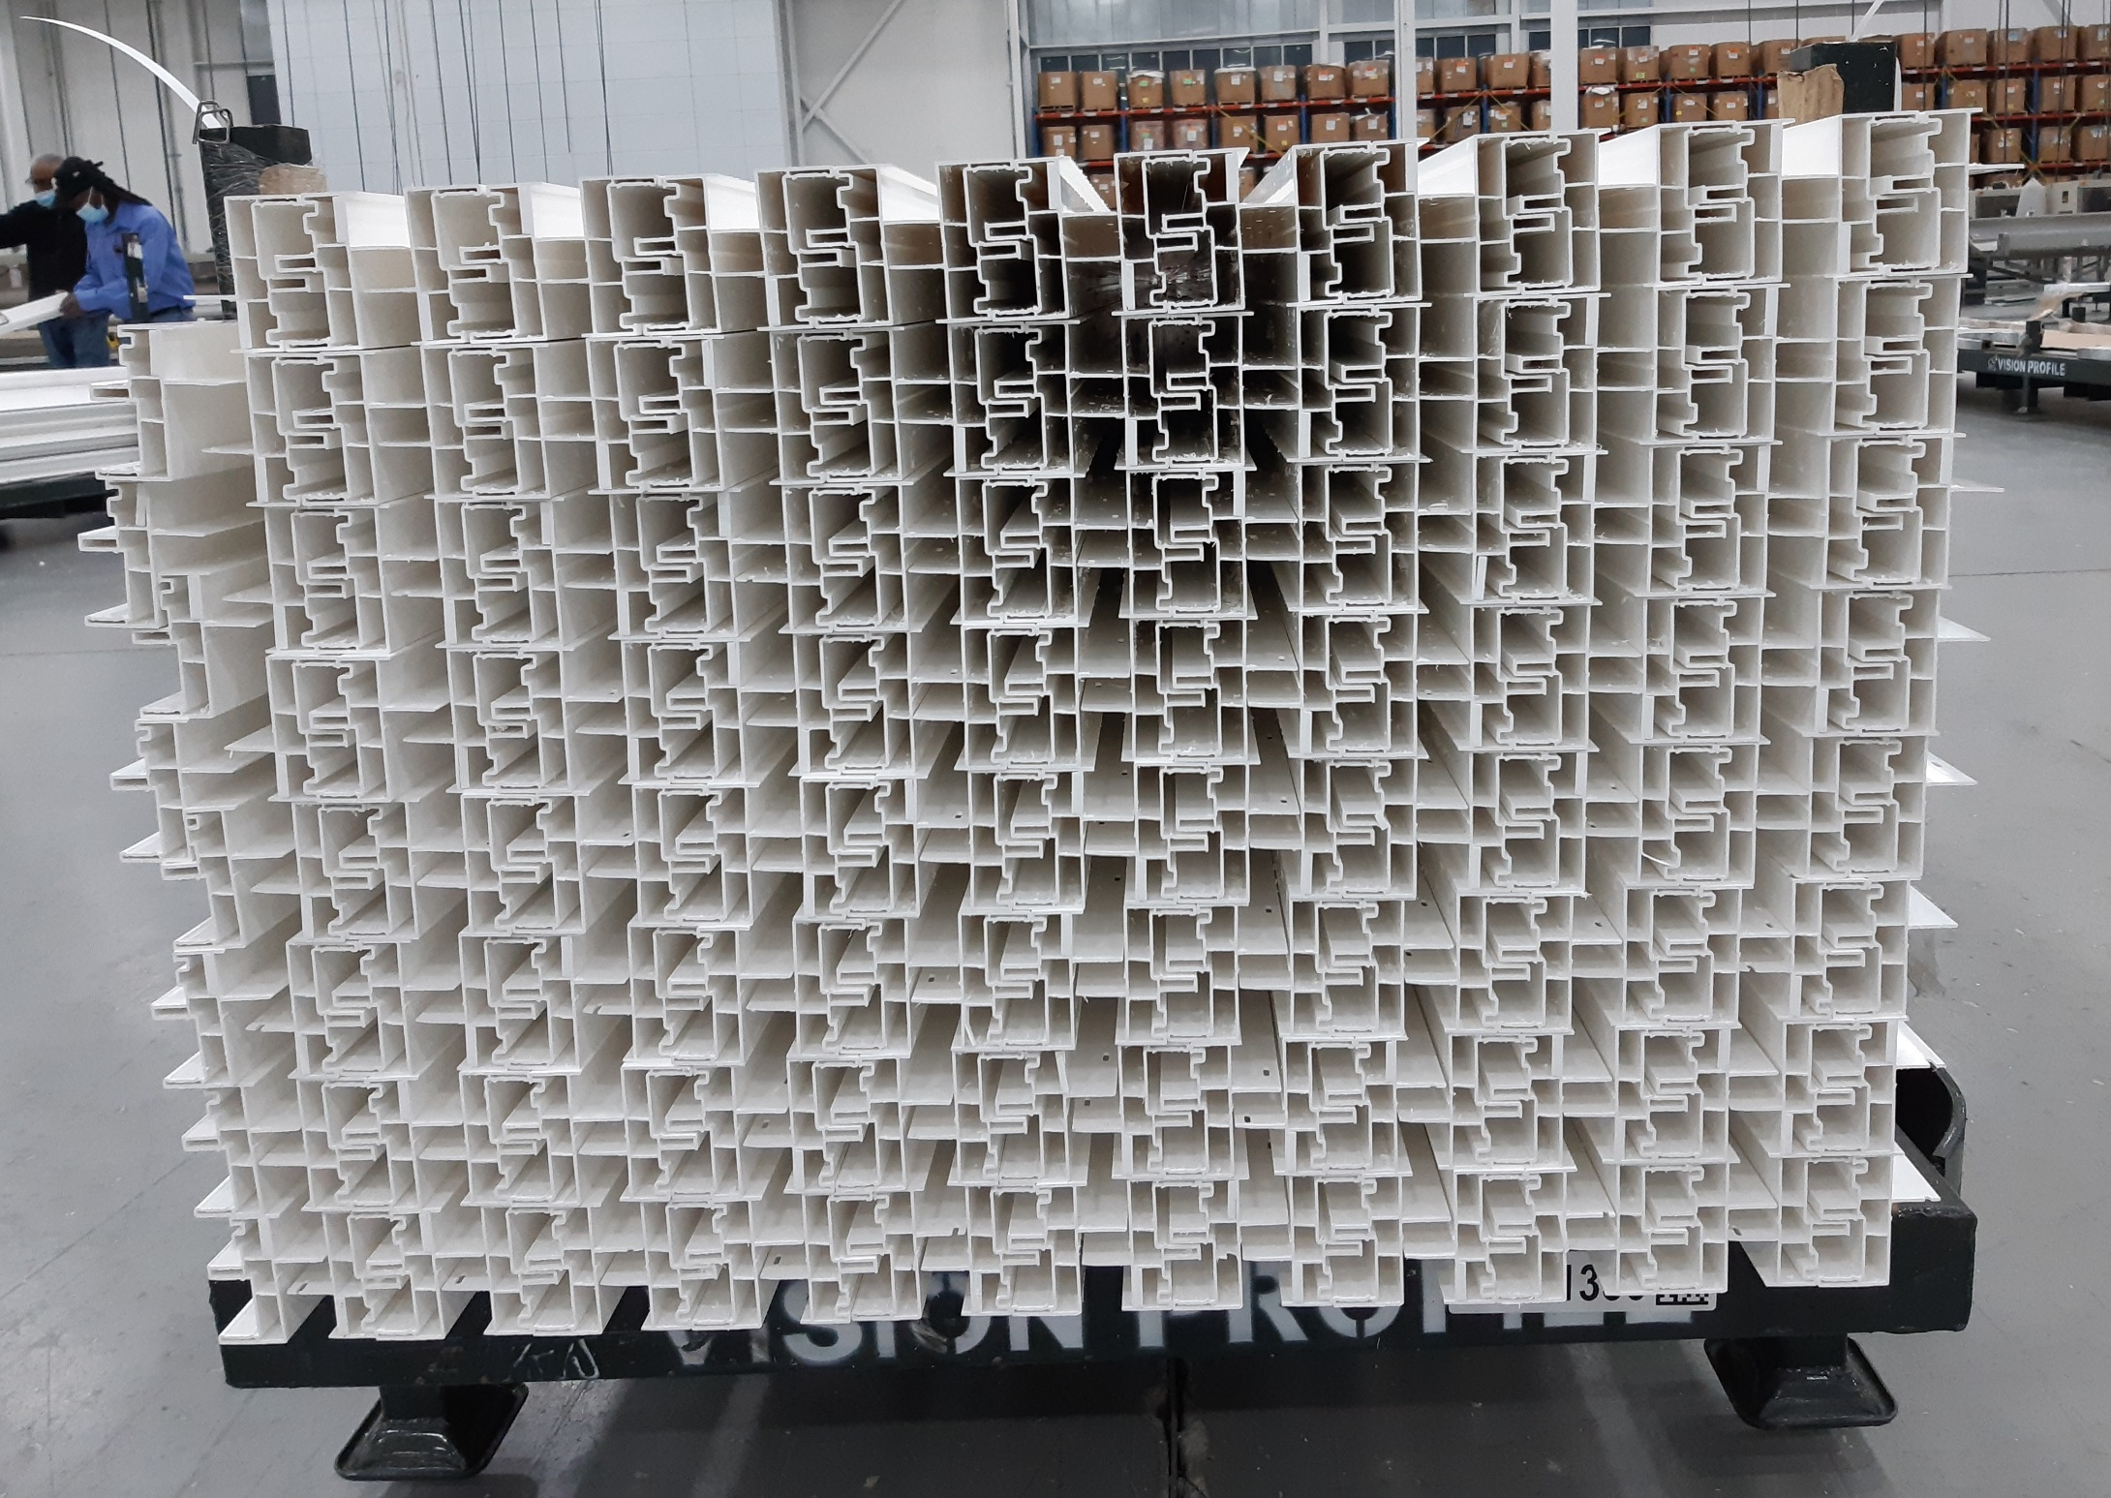
No Foam

