DIE# 15399D– Anlin (EXTRUDER SIDE)
Pack on Green Buggy – Wrap arms in cardboard
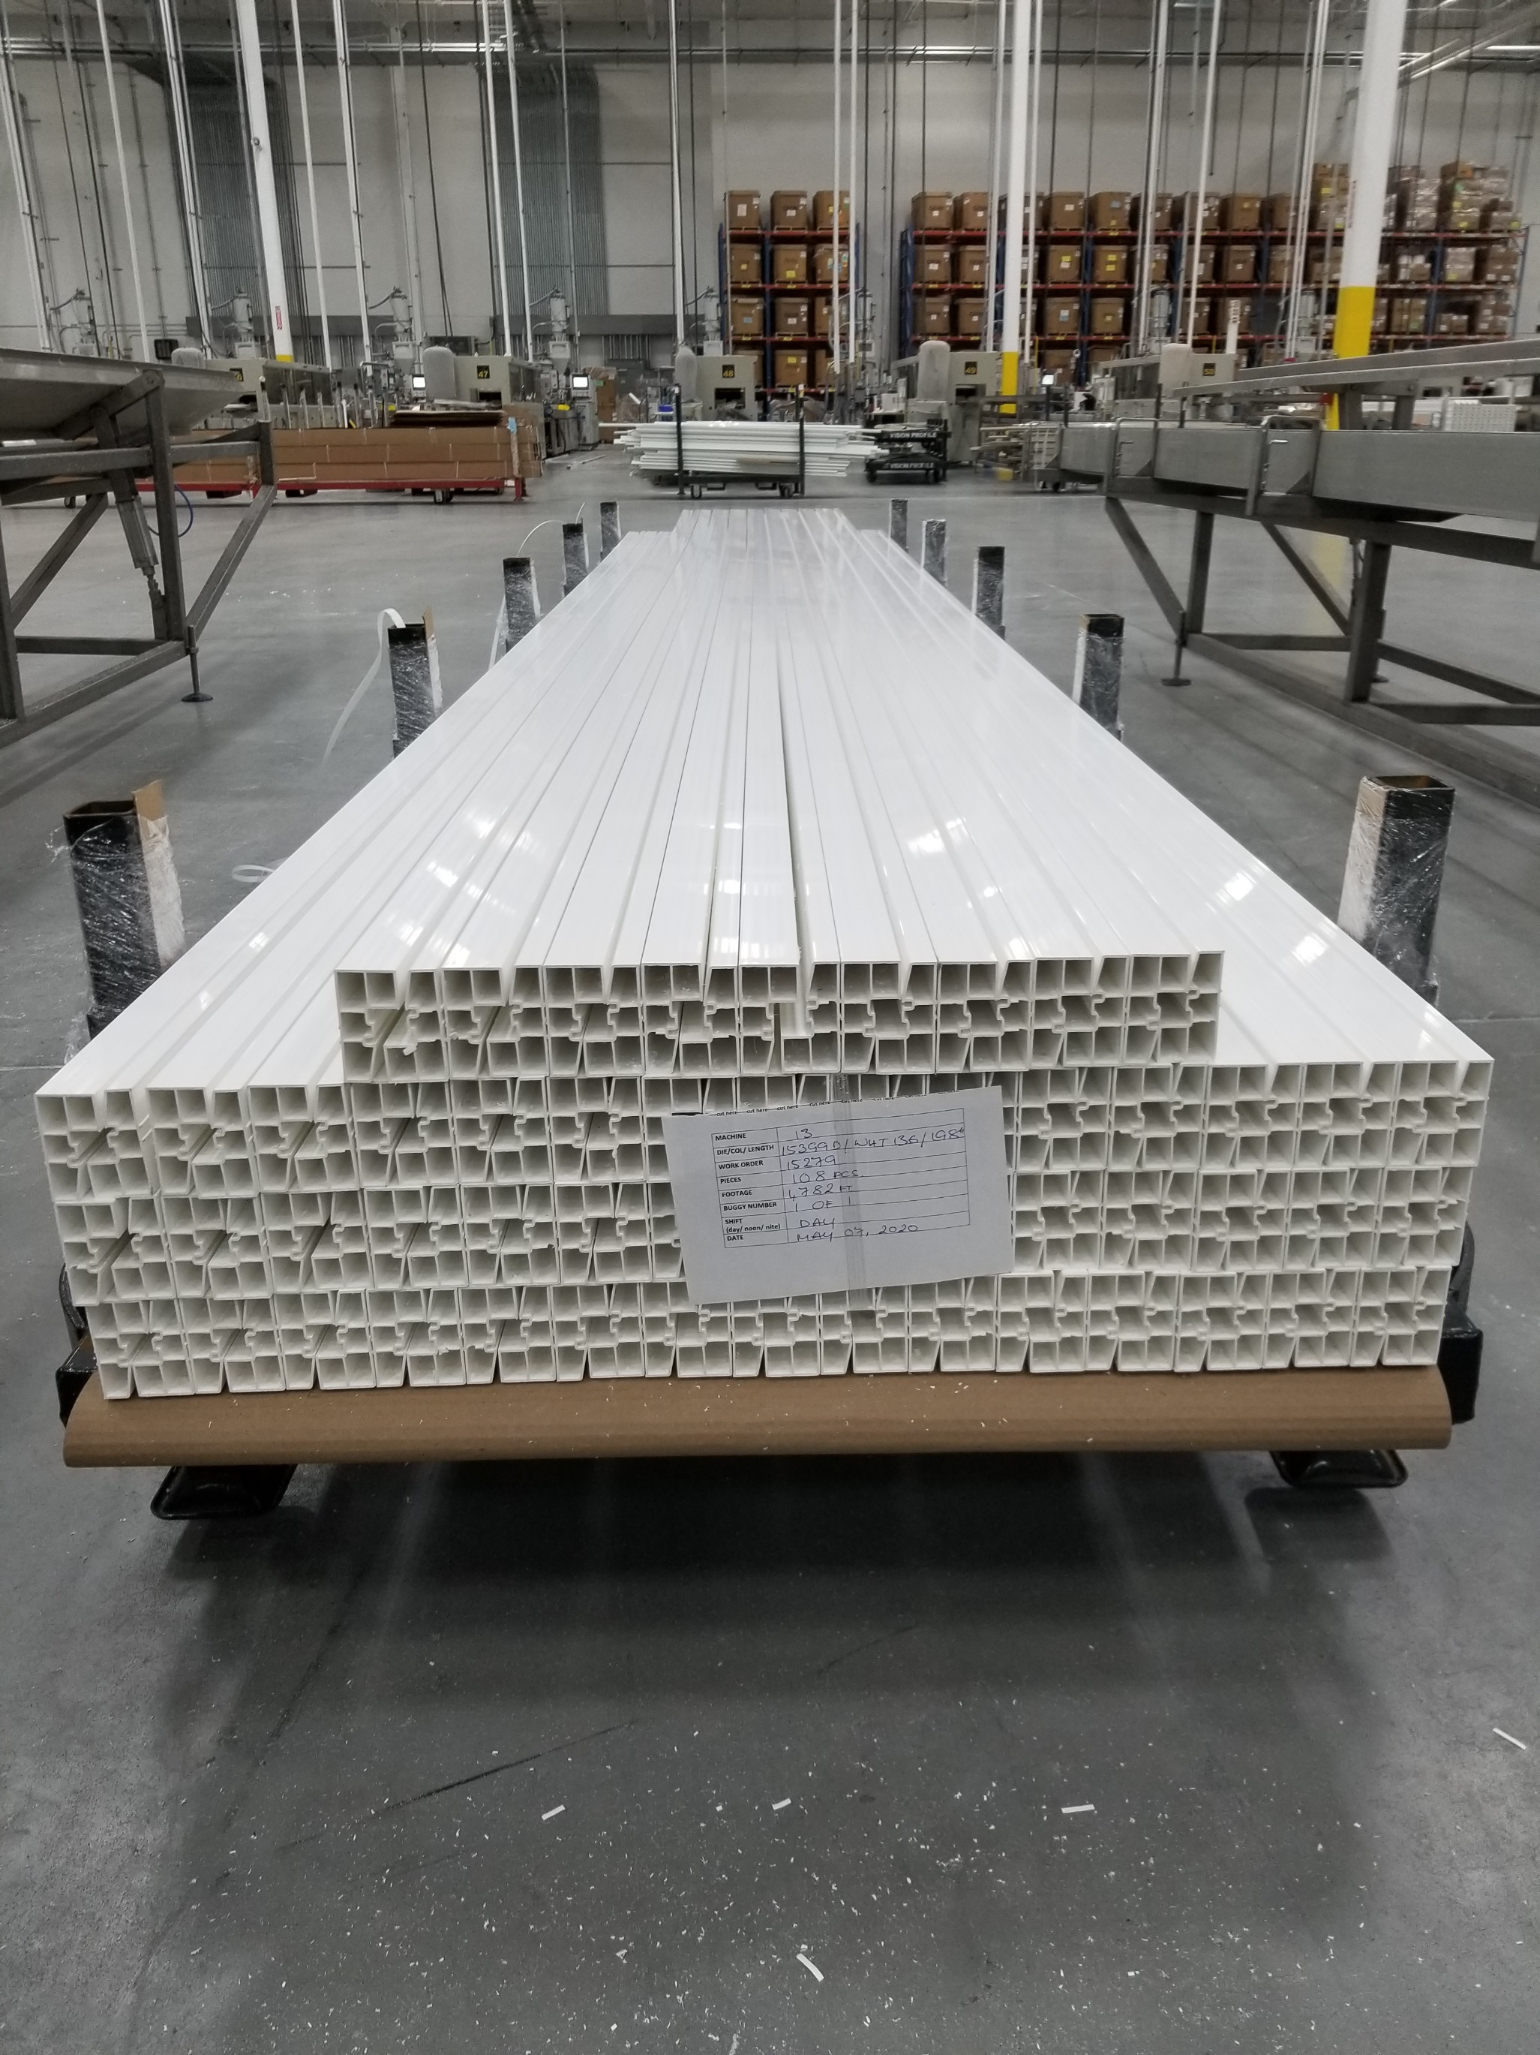
Small Foam on 1 Side

