DIE# 15400 – Anlin (EXTRUDER SIDE)
Pack on Green Buggy – Wrap arms in cardboard
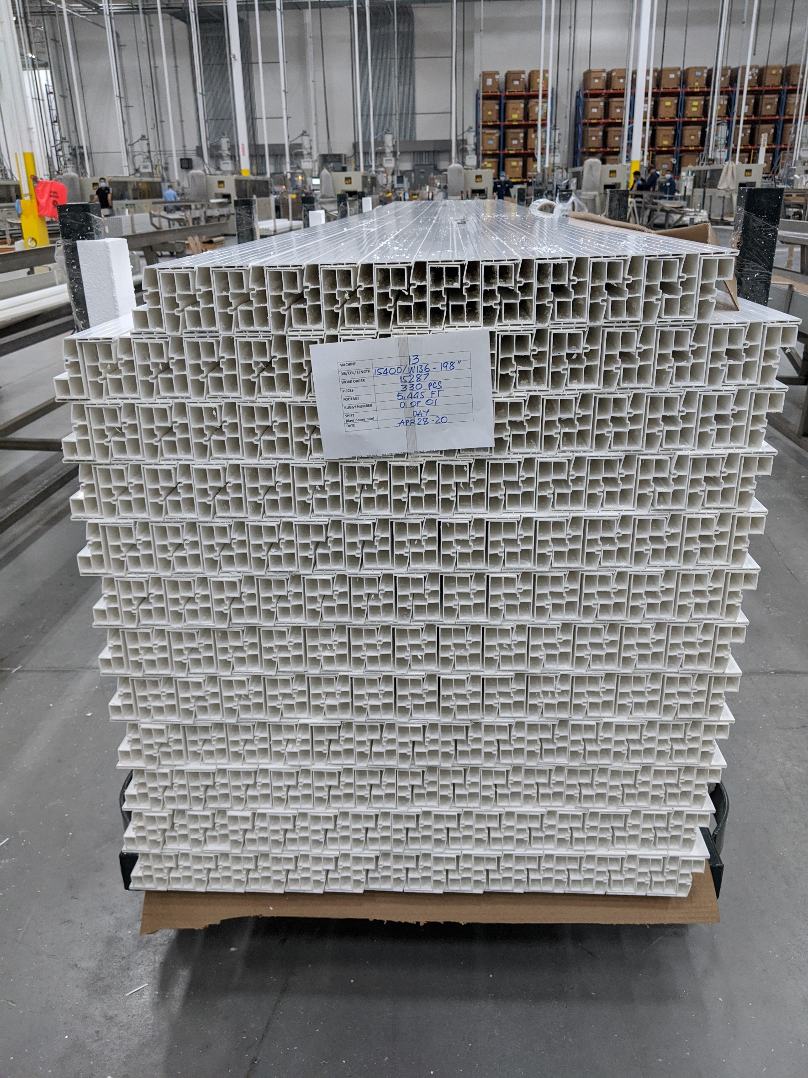
Small Foam on 1 side

