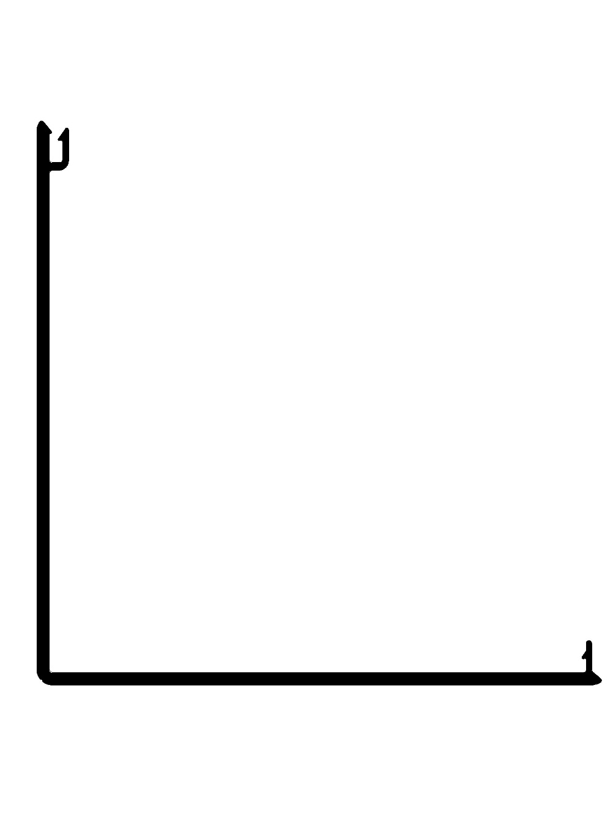


Vision Building System
DIE# 15415
7.000" (SQUARE) SPLIT COLUMN WRAP

