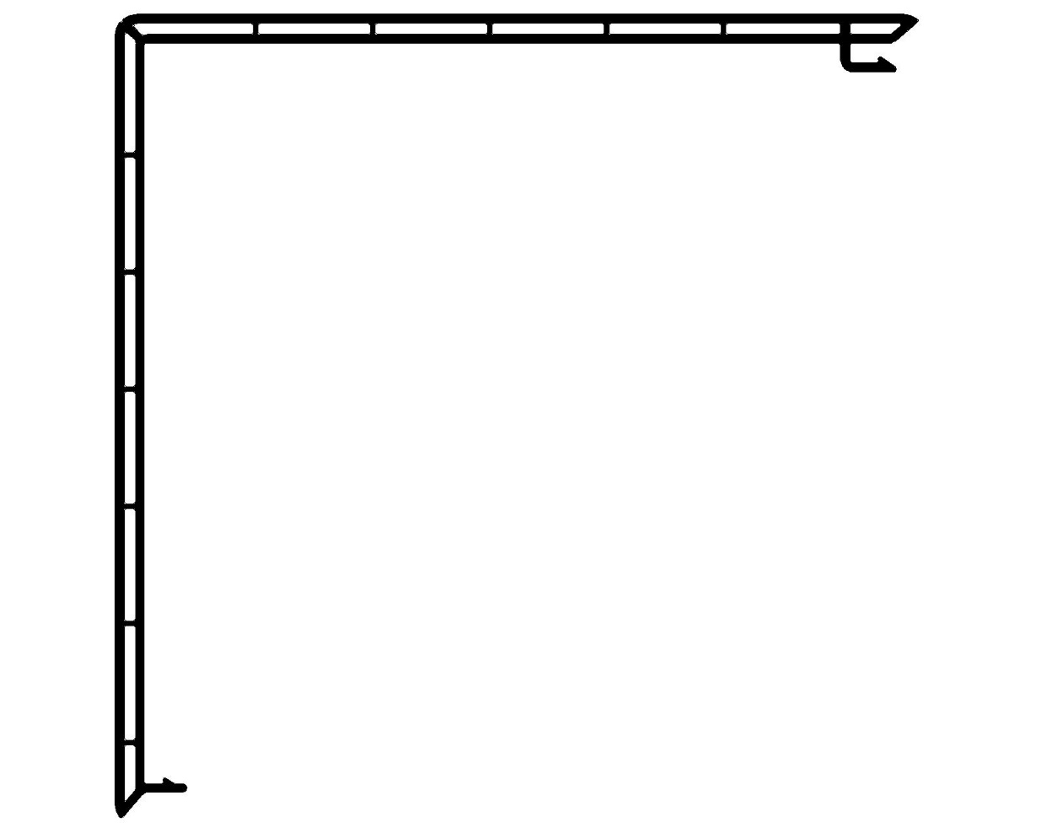

CRITICAL
Tolerance Length:
-0.000 / +0.750

Vision Building System
DIE# 15415C NEW
7.000" (SQUARE) SPLIT COLUMN

