15601 – Golden (EXTRUDER SIDE)
Pack on Green Buggy – Wrap arms in cardboard
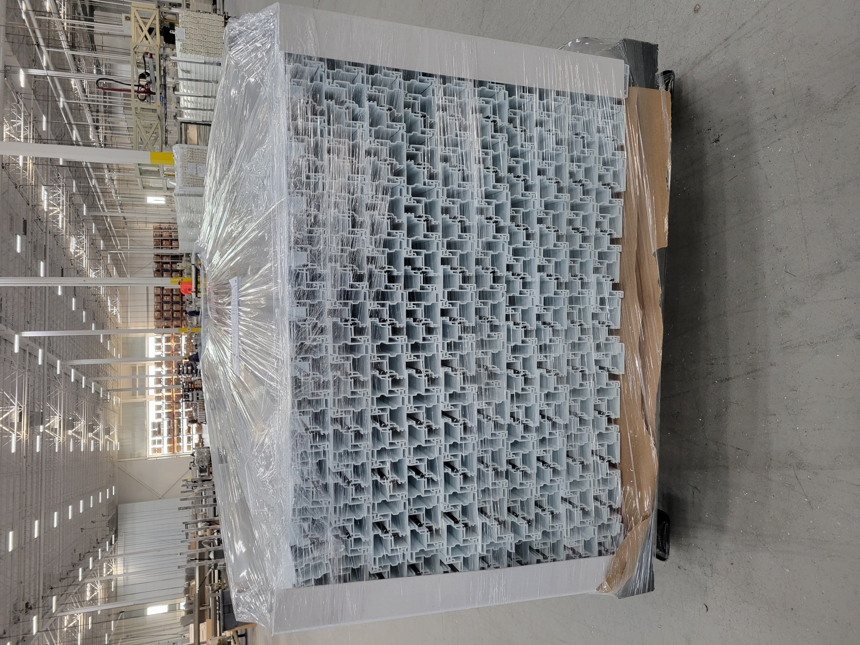
NEED NEW PICTURE WITHOUT WRAPPING

