
QUALITY ALERT

Customer: Golden Date: January 21, 2022
Die: 15602 - 15603 Colour: WH -141
Type of Complaint: Golden REJECT

Q.A # Q.I.R # CUSTOMER NCR #

Description: Customer REJECTS – Pieces is bowing and bending and pieces cannot be used

CHECK BENDING AND BOWING ON 3 SIDES – MUST BE STRAIGHT
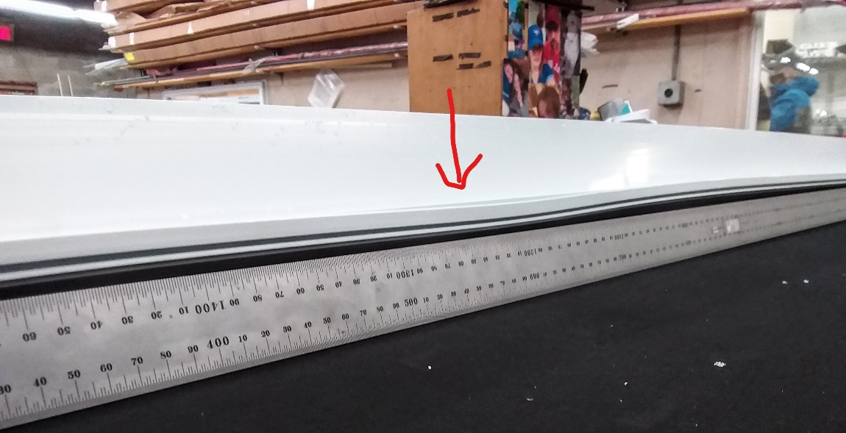
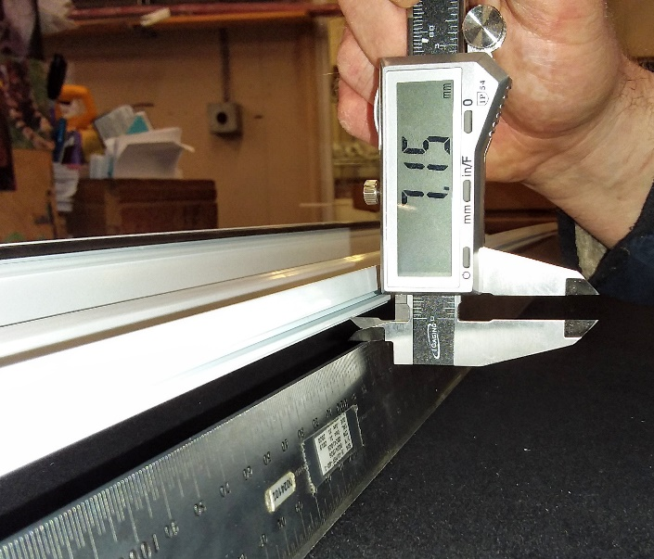
PUT 1 FULL LENGTH TO CHECK OVERALL BENDING

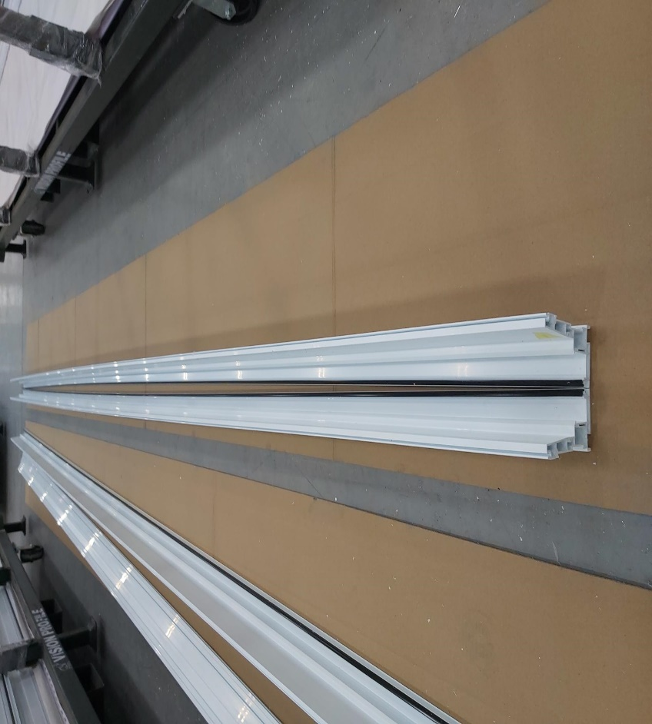

BY SIGNING BELOW, YOU ACKNOWLEDGE THE PROBLEM ABOVE AND AGREE TO MONITOR THIS ISSUE IN FUTURE PRODUCTION RUNS.
DAY SHIFT |  | AFTERNOON SHIFT |  | NIGHT SHIFT
NAME | SIGNATURE | NAME | SIGNATURE | NAME | SIGNATURE

