
QUALITY ALERT

Customer: Golden Date: January 14, 2022
Die: 15603 Colour: WH -141
Type of Complaint: Golden Complaint

Q.A # Q.I.R # CUSTOMER NCR #

Description: The surface on top with the glazing bead IS NOT FLAT causing the glass opening to appear too short.
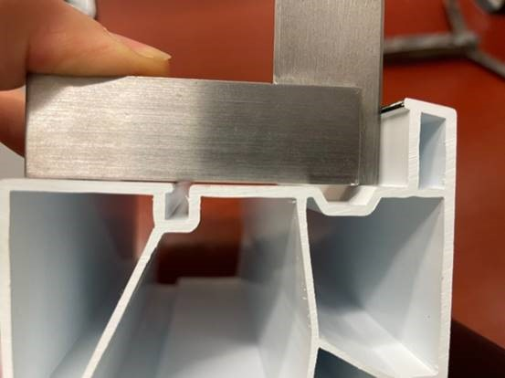

THESE AREA MUST RUN FLAT.

BY SIGNING BELOW, YOU ACKNOWLEDGE THE PROBLEM ABOVE AND AGREE TO MONITOR THIS ISSUE IN FUTURE PRODUCTION RUNS.
DAY SHIFT |  | AFTERNOON SHIFT |  | NIGHT SHIFT
NAME | SIGNATURE | NAME | SIGNATURE | NAME | SIGNATURE

