
QUALITY ALERT

Customer: Golden Date: April 13, 2024
Die: 15607 Colour: WH -141
Type of Complaint: Golden REJECT

Q.A # Q.I.R # CUSTOMER NCR #

Description: The wall collapsed/bent at multiple area causing the balance shoes get stuck in channel and the punch not fit properly. (red marks)
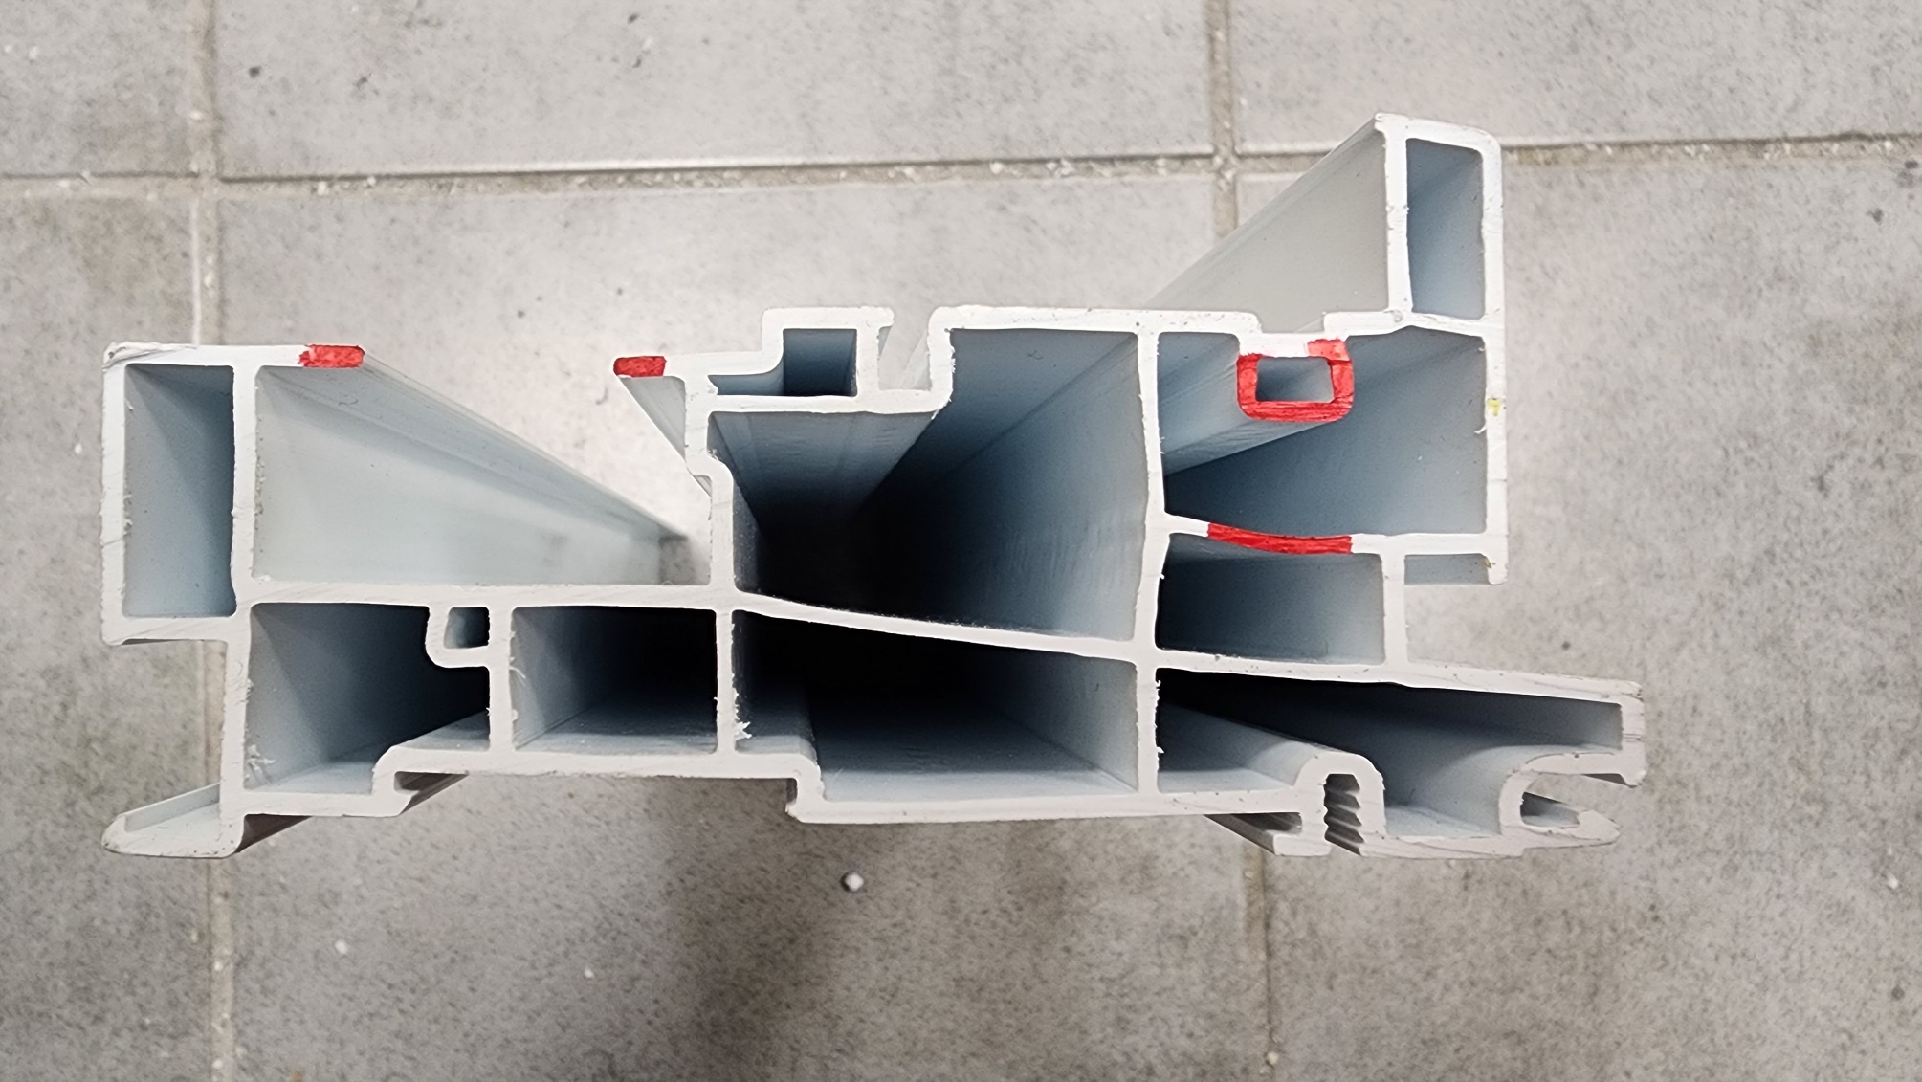

HOLE TOO BIG

v

GAP IS CLOSE

WALL BENT DOWN

BY SIGNING BELOW, YOU ACKNOWLEDGE THE PROBLEM ABOVE AND AGREE TO MONITOR THIS ISSUE IN FUTURE PRODUCTION RUNS.
DAY SHIFT |  | AFTERNOON SHIFT |  | NIGHT SHIFT
NAME | SIGNATURE | NAME | SIGNATURE | NAME | SIGNATURE

