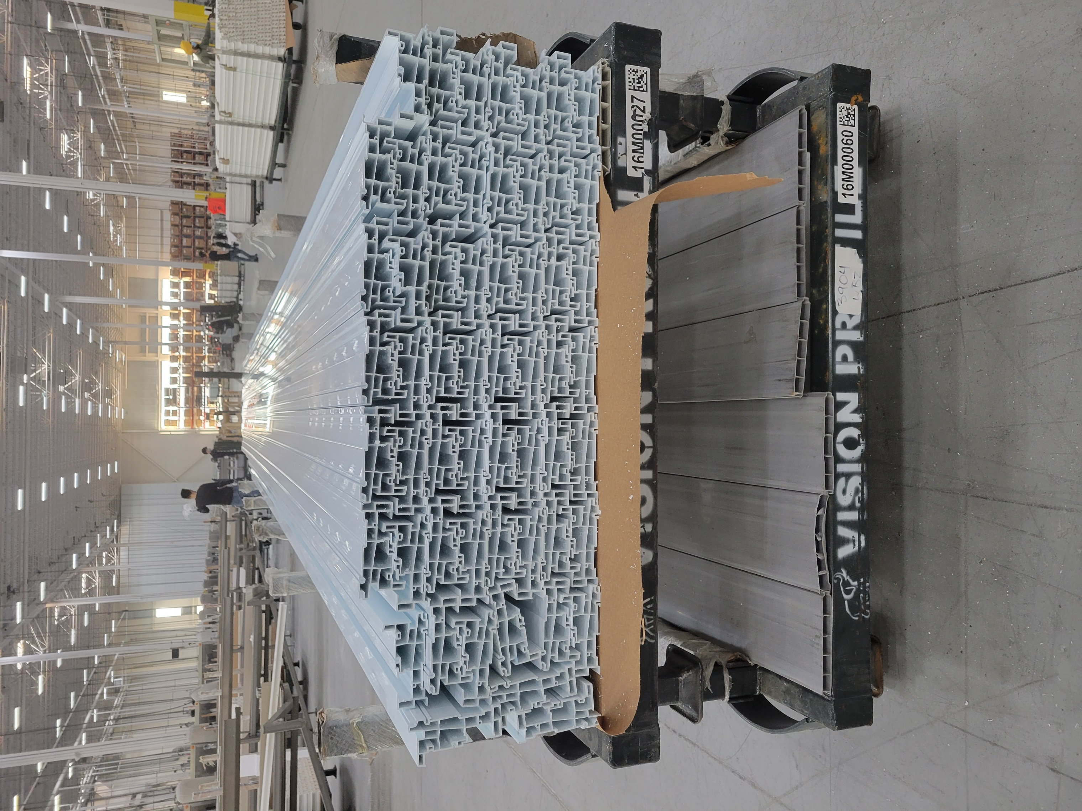
DIE# 15607 (Mini) – Golden (EXTRUDER SIDE)
Green Buggy + Wrap arms with cardboard
NO FOAM

