
QUALITY ALERT

Customer: Golden Date: January 29, 2022
Die: 15608 Colour: WH -141
Type of Complaint: Golden Complaint
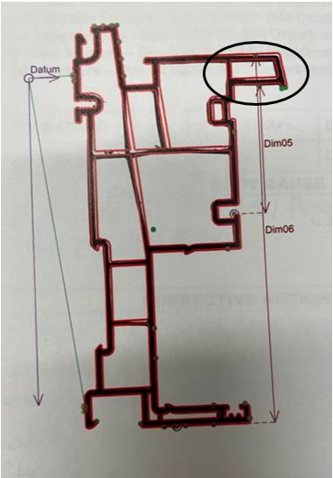
Q.A # Q.I.R # CUSTOMER NCR #

Description: The tower is NOT SQUARE, which causes the dimensions to be out of spec.

THIS TOWER MUST BE RUN SQUARE.

BY SIGNING BELOW, YOU ACKNOWLEDGE THE PROBLEM ABOVE AND AGREE TO MONITOR THIS ISSUE IN FUTURE PRODUCTION RUNS.
DAY SHIFT |  | AFTERNOON SHIFT |  | NIGHT SHIFT
NAME | SIGNATURE | NAME | SIGNATURE | NAME | SIGNATURE

