
QUALITY ALERT

Customer: Centennial Date: June 10, 2022
Die: 15649 Colour: All
Type of Complaint: REJECT

Q.A # Q.I.R # CUSTOMER NCR #

Description: Customer REJECT – The pocket dimension – 0.770 is TOO TIGHT for the latch.
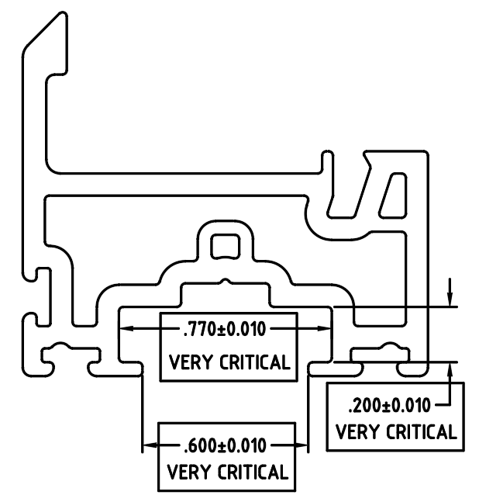

MAKE SURE THE 3 DIMENSIONS ABOVE MUST RUN IN TOLERENCES

BY SIGNING BELOW, YOU ACKNOWLEDGE THE PROBLEM ABOVE AND AGREE TO MONITOR THIS ISSUE IN FUTURE PRODUCTION RUNS.
DAY SHIFT |  | AFTERNOON SHIFT |  | NIGHT SHIFT
NAME | SIGNATURE | NAME | SIGNATURE | NAME | SIGNATURE

