
QUALITY ALERT

Customer: ChamClad Date: May 16, 2022
Die: 15744 Color: Any
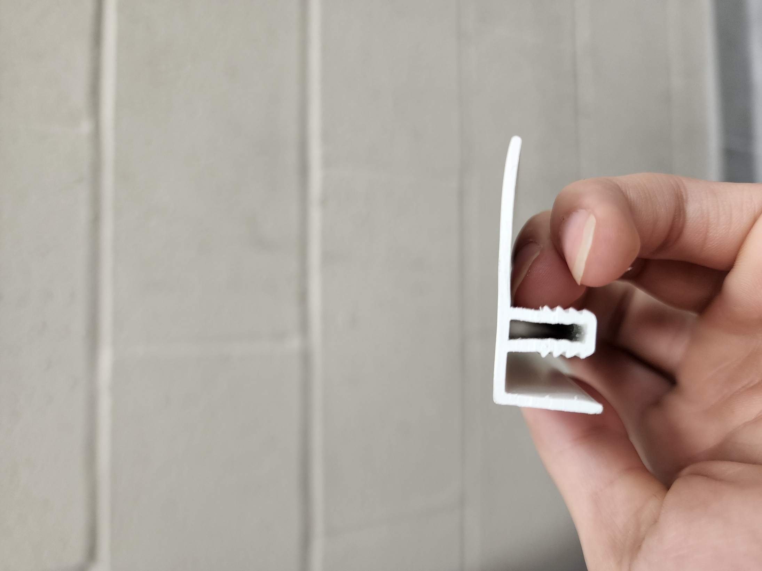
Type of Complaint: ChamClad REJECT Customer NCR:

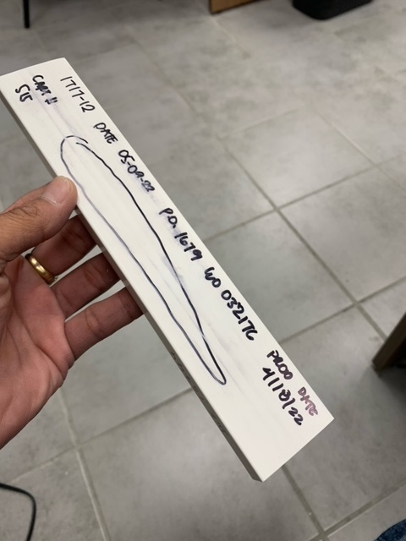
Description: ChamClad REJECT – the surface has a sink line – REJECTED SAMPLEs

PLEASE CHECK CAREFULLY THE PIECE TO AVOID THIS ISSUE
BY SIGNING BELOW, YOU ACKNOWLEDGE THE PROBLEM ABOVE AND AGREE TO MONITOR THIS ISSUE IN FUTURE PRODUCTION RUNS.
DAY SHIFT |  | AFTERNOON SHIFT |  | NIGHT SHIFT
NAME | SIGNATURE | NAME | SIGNATURE | NAME | SIGNATURE

