
QUALITY ALERT

Customer: ChamClad Date: April 06, 2023
Die: 15747 Color: Any
Type of Complaint: ChamClad REJECT Customer NCR:

Description: ChamClad REJECT – Part was OUT OF DIMENSION – too short causing the lamination process won’t work (see picture next page)
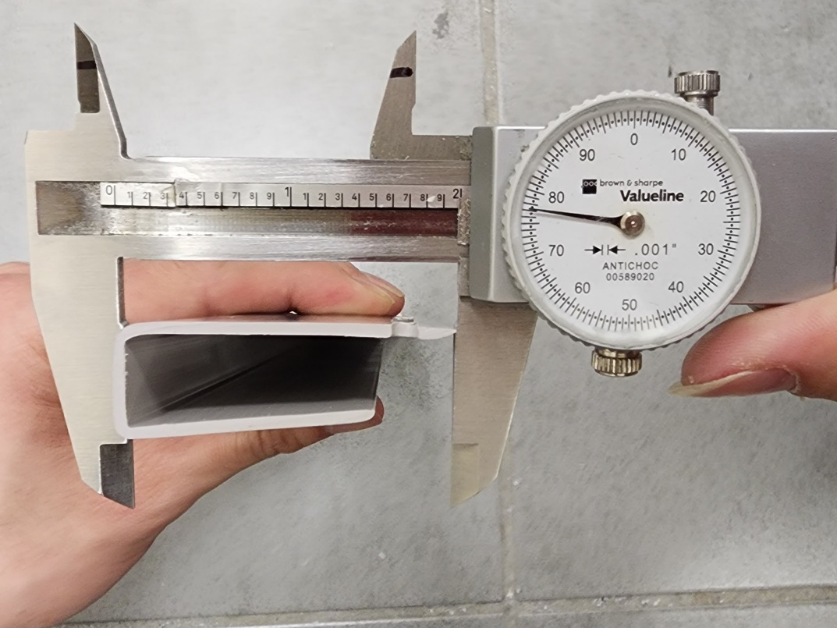
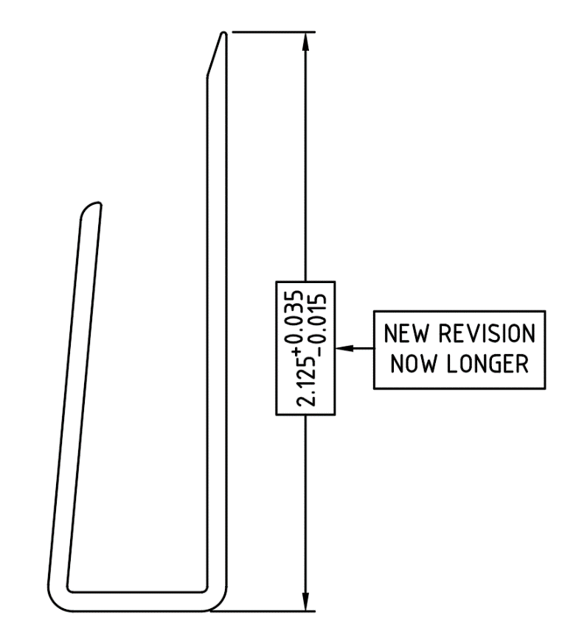

REJECTED

PLEASE MAKE SURE THE DIMENSION IN TOLERENCE
BY SIGNING BELOW, YOU ACKNOWLEDGE THE PROBLEM ABOVE AND AGREE TO MONITOR THIS ISSUE IN FUTURE PRODUCTION RUNS.
DAY SHIFT |  | AFTERNOON SHIFT |  | NIGHT SHIFT
NAME | SIGNATURE | NAME | SIGNATURE | NAME | SIGNATURE

