
QUALITY ALERT

Customer: ChamClad Date: January 25, 2024
Die: 15748 Color: ALL
Type of Complaint: ChamClad REJECT Customer NCR:
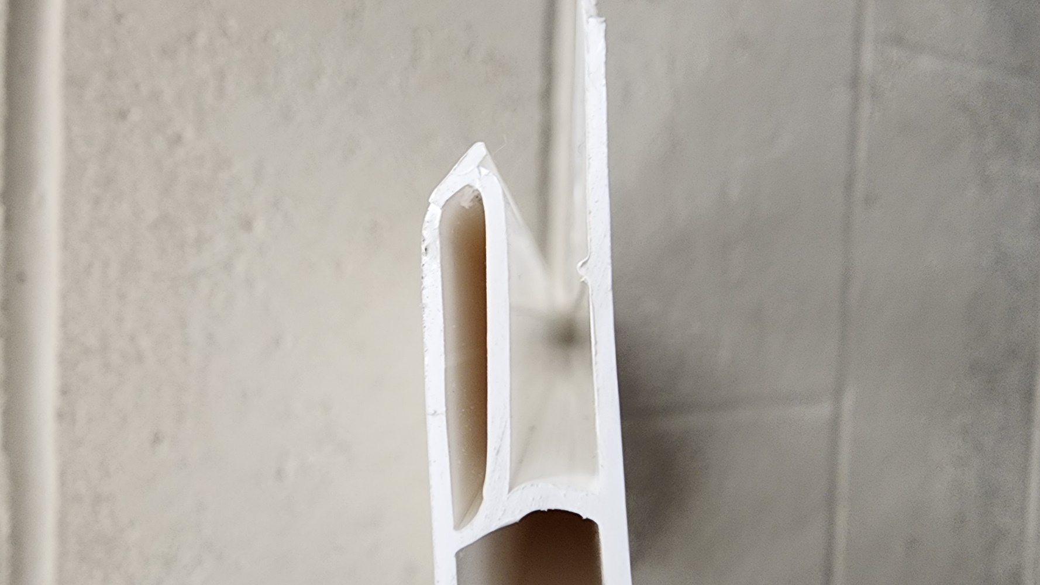
Description: ChamClad REJECT – Material was missing nip / out of shape.
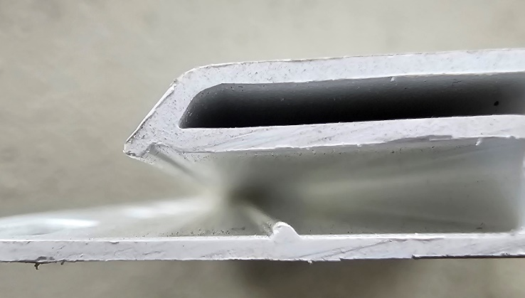

20240318_094841.jpg

GOOD

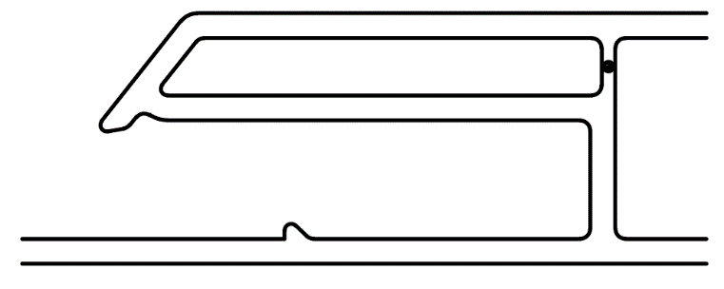
BAD

PLEASE CHECK CAREFULLY TO AVOID THIS ISSUE
BY SIGNING BELOW, YOU ACKNOWLEDGE THE PROBLEM ABOVE AND AGREE TO MONITOR THIS ISSUE IN FUTURE PRODUCTION RUNS.
DAY SHIFT |  | AFTERNOON SHIFT |  | NIGHT SHIFT
NAME | SIGNATURE | NAME | SIGNATURE | NAME | SIGNATURE

