
QUALITY ALERT

Customer: ChamClad Date: August 4, 2022
Die: 15750 Customer NCR:
Type of Complaint: ChamClad REJECT

Description: ChamClad REJECT – Material was missing the nib that allows for the U-groove channel
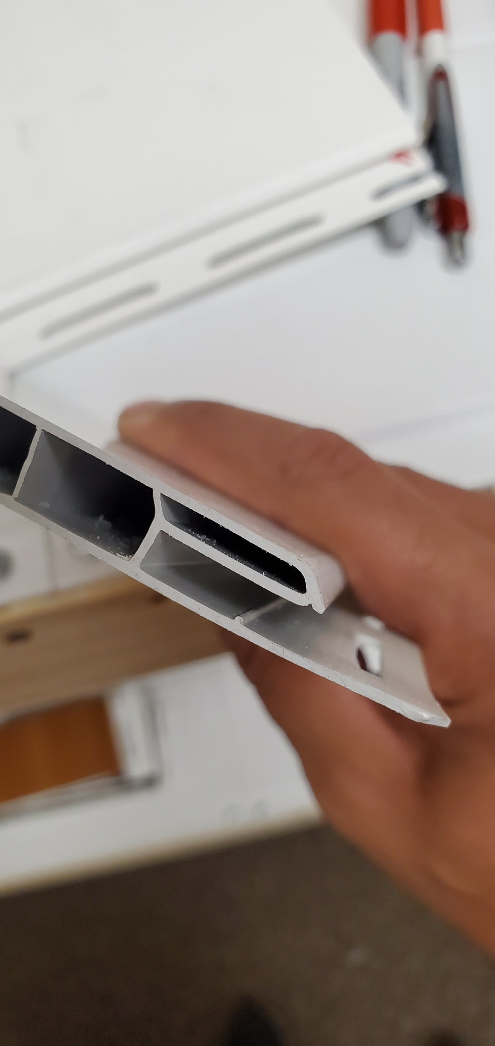
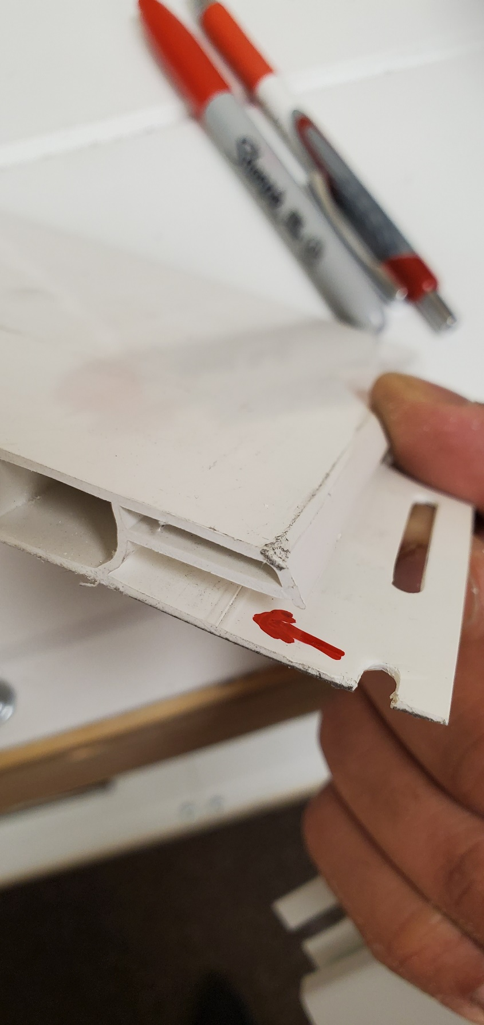

GOOD

BAD

PLEASE CHECK CAREFULLY TO AVOID THIS ISSUE
BY SIGNING BELOW, YOU ACKNOWLEDGE THE PROBLEM ABOVE AND AGREE TO MONITOR THIS ISSUE IN FUTURE PRODUCTION RUNS.
DAY SHIFT |  | AFTERNOON SHIFT |  | NIGHT SHIFT
NAME | SIGNATURE | NAME | SIGNATURE | NAME | SIGNATURE

