
QUALITY ALERT

Customer: Chamclad Date: Sep 29, 2025
Die: 15750 Colour: Any
Type of Complaint: Customer REJECTED

Q.A # 25-052 NCR: 352 RMA#: 454

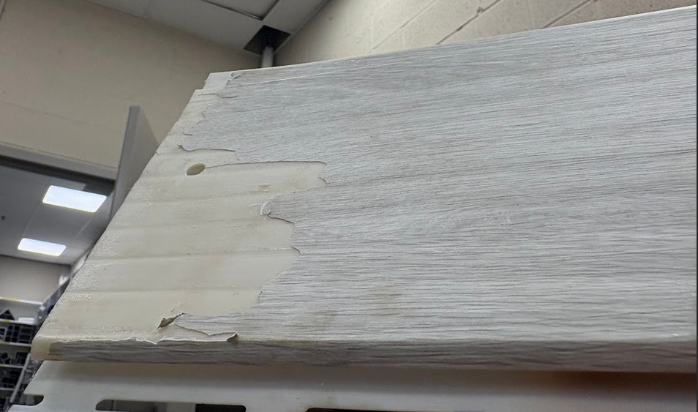
Description: Customer REJECTED due to deep groove lines on surface that affect lamination process.

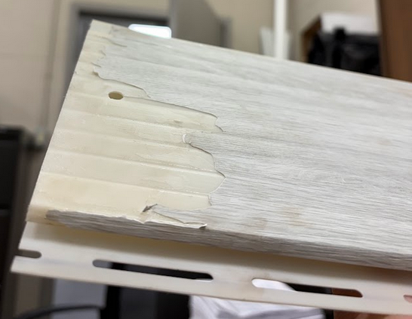

ENSURE MATERIAL ARE THOROUGHLY INSPECTED BEFORE PACKING. NO DEEP GROOVE LINES ARE ALLOWED AS THEY WILL AFFECT LAMINATION PROCESS

BY SIGNING BELOW, YOU ACKNOWLEDGE THE PROBLEM ABOVE AND AGREE TO MONITOR THIS ISSUE IN FUTURE PRODUCTION RUNS.
DAY SHIFT |  | AFTERNOON SHIFT |  | NIGHT SHIFT
NAME | SIGNATURE | NAME | SIGNATURE | NAME | SIGNATURE

