15750 – 15766 NEW BUGGY TYPE PACKAGING REQUIREMENTS

Affected Stock Codes & Quantity Changes
Stock Code | 16” Short Arm Buggy Qty | Seaway Buggy Qty
15750-245-192-12-0000 | 270 pcs | 425 pcs

Other Stock Codes MUST BE CONFIRMED with Supervisors/Managers before packing.

Buggy:
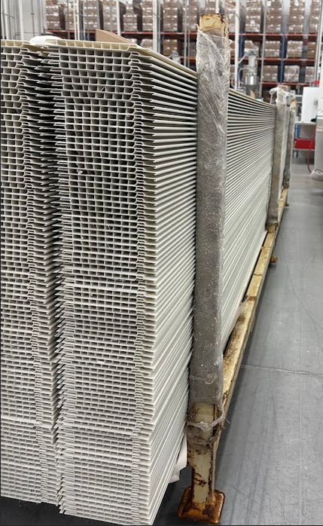
- SEAWAY BUGGIES ONLY.

SEAWAY BUGGY

Loading Instructions:
- Material must be filled no higher than 6–8 inches from the top of the buggy arms.
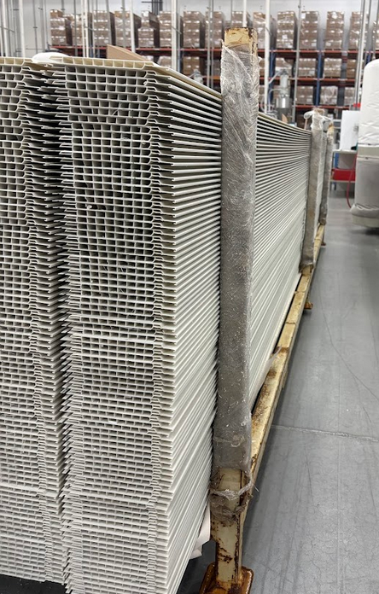
DO NOT OVERPACK MATERIAL

- Secure each loaded buggy using shrink wrap and zip ties.
- Follow standard packaging requirements
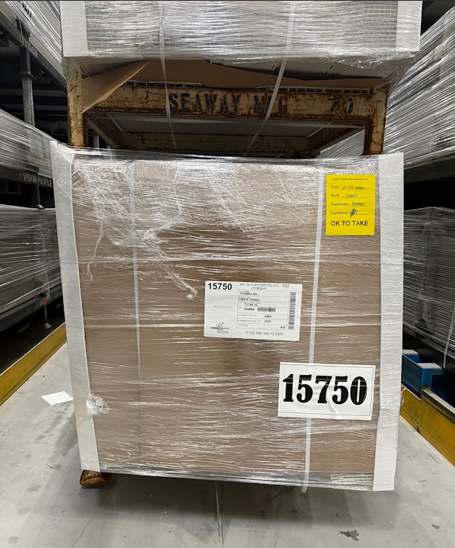

Stacking Instruction:
- Ensure the wheels of the upper buggy DO NOT touch the material below.
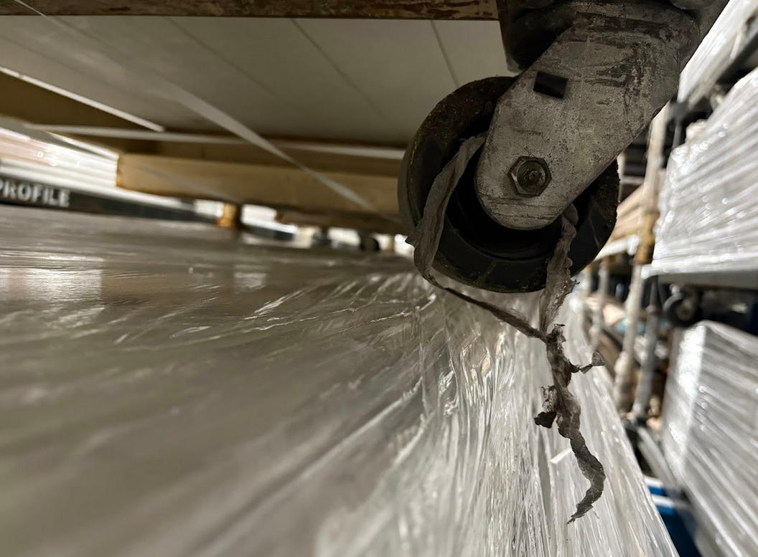
- Leave a clear gap to prevent damage.
MUST LEAVE A GAP WHEN STACKING THE BUGGIES, MAKE SURE NO MATERIAL WILL BE DAMAGED AFTER STACKING

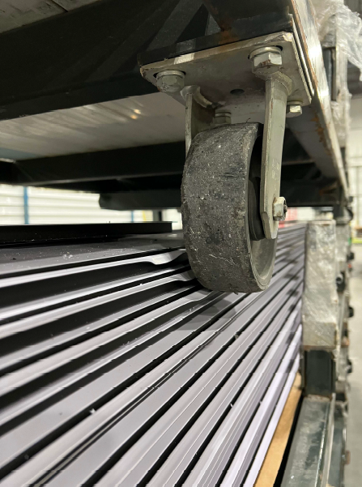

OVERLOADED MATERIAL GETS DAMAGED WHEN STACK WITH OTHER BUGGIES


