DIE# 15750 – ChamClad (EXTRUDER SIDE)
See workorder for packing info
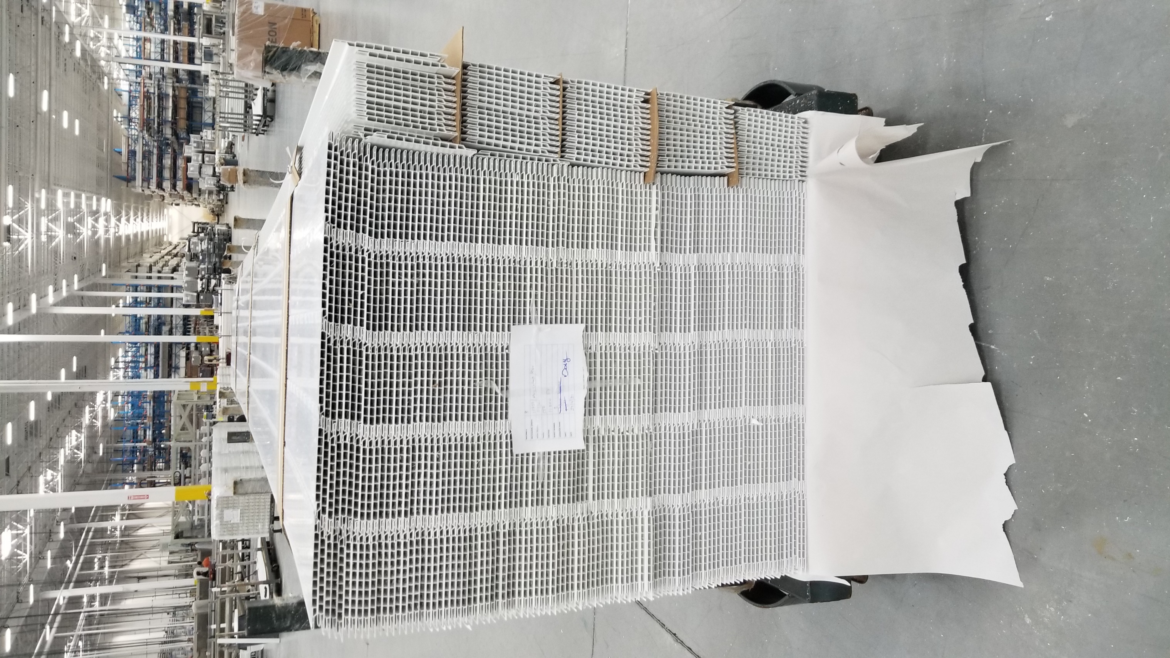
NO FOAM

