
QUALITY ALERT

Customer: ChamClad Date: Oct 25, 2022
Die: 15751 Color: ANY
Type of Complaint: ChamClad REJECT Customer NCR:

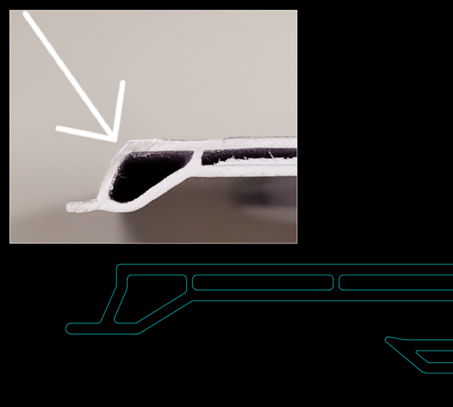
Description: ChamClad REJECT – Material is ROUND corner/OUT OF SHAPE causing big gap when snap in together
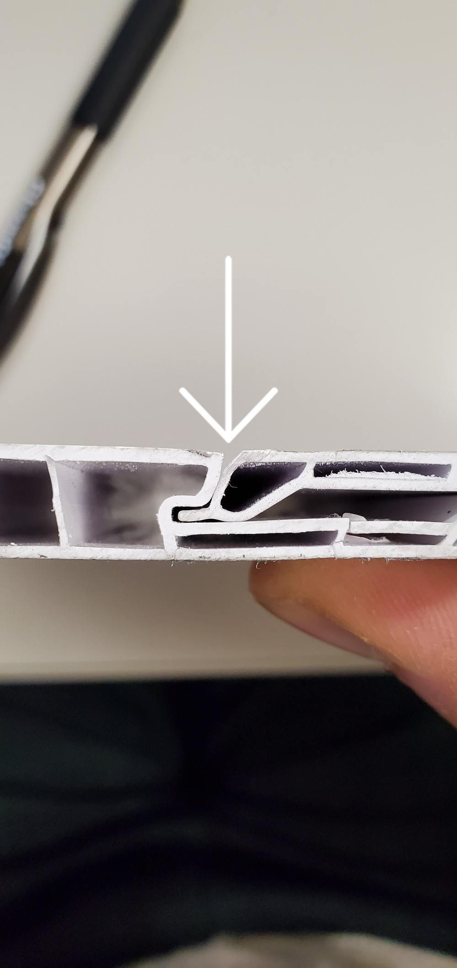

PLEASE CHECK CAREFULLY TO AVOID THIS ISSUE
BY SIGNING BELOW, YOU ACKNOWLEDGE THE PROBLEM ABOVE AND AGREE TO MONITOR THIS ISSUE IN FUTURE PRODUCTION RUNS.
DAY SHIFT |  | AFTERNOON SHIFT |  | NIGHT SHIFT
NAME | SIGNATURE | NAME | SIGNATURE | NAME | SIGNATURE

