
QUALITY ALERT

Customer: ChamClad Date: November 11, 2021
Die: 15766-16016C Customer NCR:
Type of Complaint: ChamClad REJECTED

Description: ChamClad REJECTED – Punch too close to the edge so the screw does not sit flush in channel and panels cannot slide together properly.
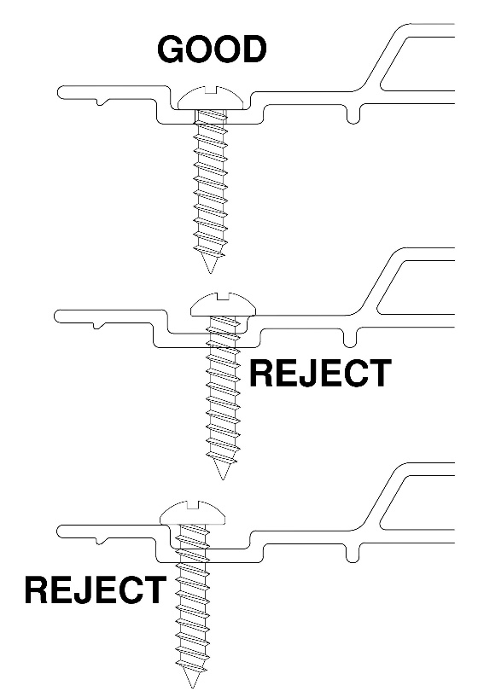
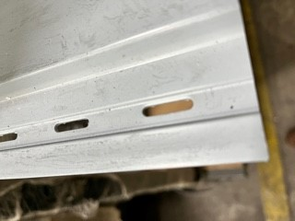
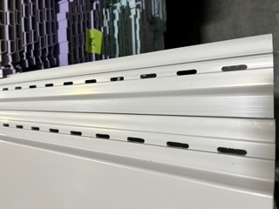

BY SIGNING BELOW, YOU ACKNOWLEDGE THE PROBLEM ABOVE AND AGREE TO MONITOR THIS ISSUE IN FUTURE PRODUCTION RUNS.
DAY SHIFT |  | AFTERNOON SHIFT |  | NIGHT SHIFT
NAME | SIGNATURE | NAME | SIGNATURE | NAME | SIGNATURE
F-006: Quality Alert | Eff.Date: 05/03/2025 | CC# 25-046 | Rev.0

