
QUALITY ALERT

Customer: ChamClad Date: November 11, 2021
Die: 15766 Customer NCR:
Type of Complaint: ChamClad REJECT

Description: ChamClad REJECT – Gap is closed / punched fin bending up making it impossible to be installed
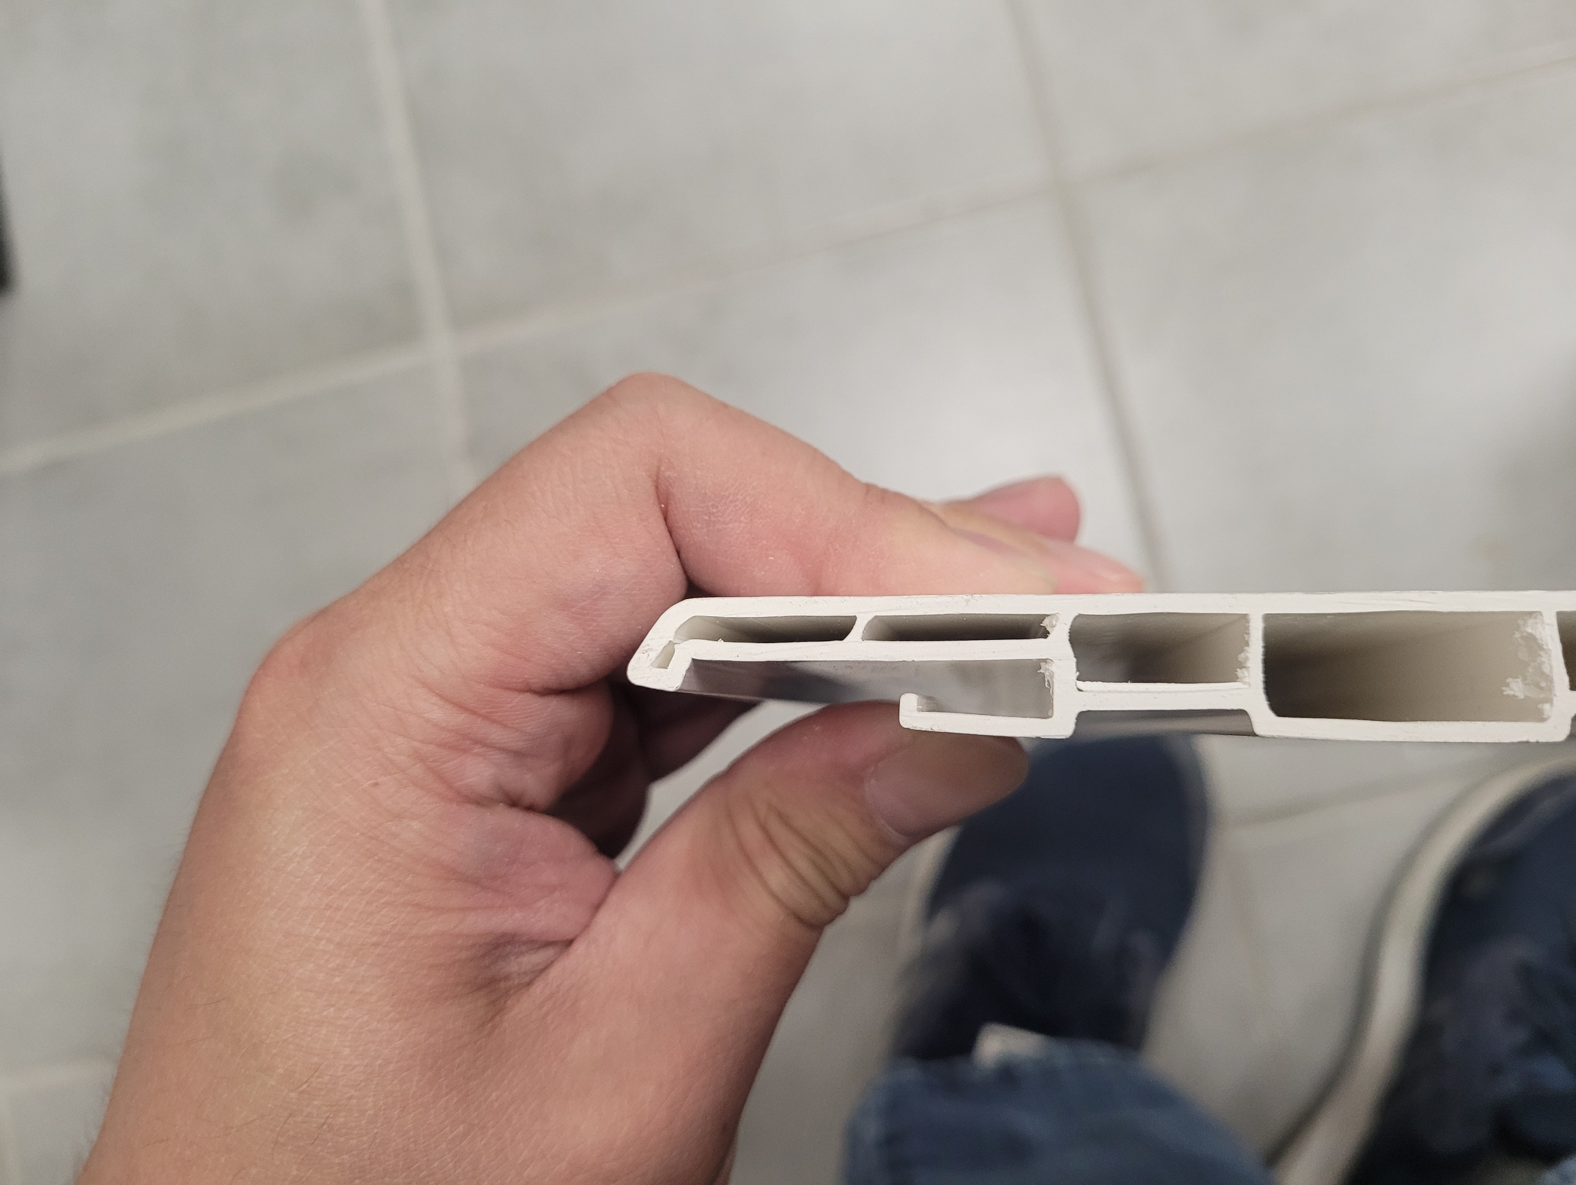
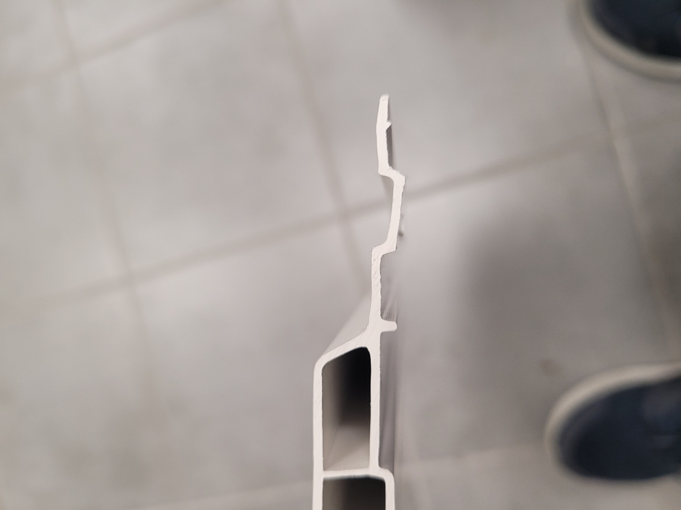

MUST RUN STRAIGHT AND GAP MUST BE IN TOLERANCE

^^^ FIN MUST RUN FLAT AS POSSIBLE ^^^
BY SIGNING BELOW, YOU ACKNOWLEDGE THE PROBLEM ABOVE AND AGREE TO MONITOR THIS ISSUE IN FUTURE PRODUCTION RUNS.
DAY SHIFT |  | AFTERNOON SHIFT |  | NIGHT SHIFT
NAME | SIGNATURE | NAME | SIGNATURE | NAME | SIGNATURE

