
QUALITY ALERT

Customer: Wintech Date: February 23, 2024
Die: 15792 Colour: ALL
Type of Complaint: Wintech REJECT

Q.A # Q.I.R # CUSTOMER NCR #

Description: Customer REJECT – Part is OUT of Shape/ Off-Square affect punching and welding process
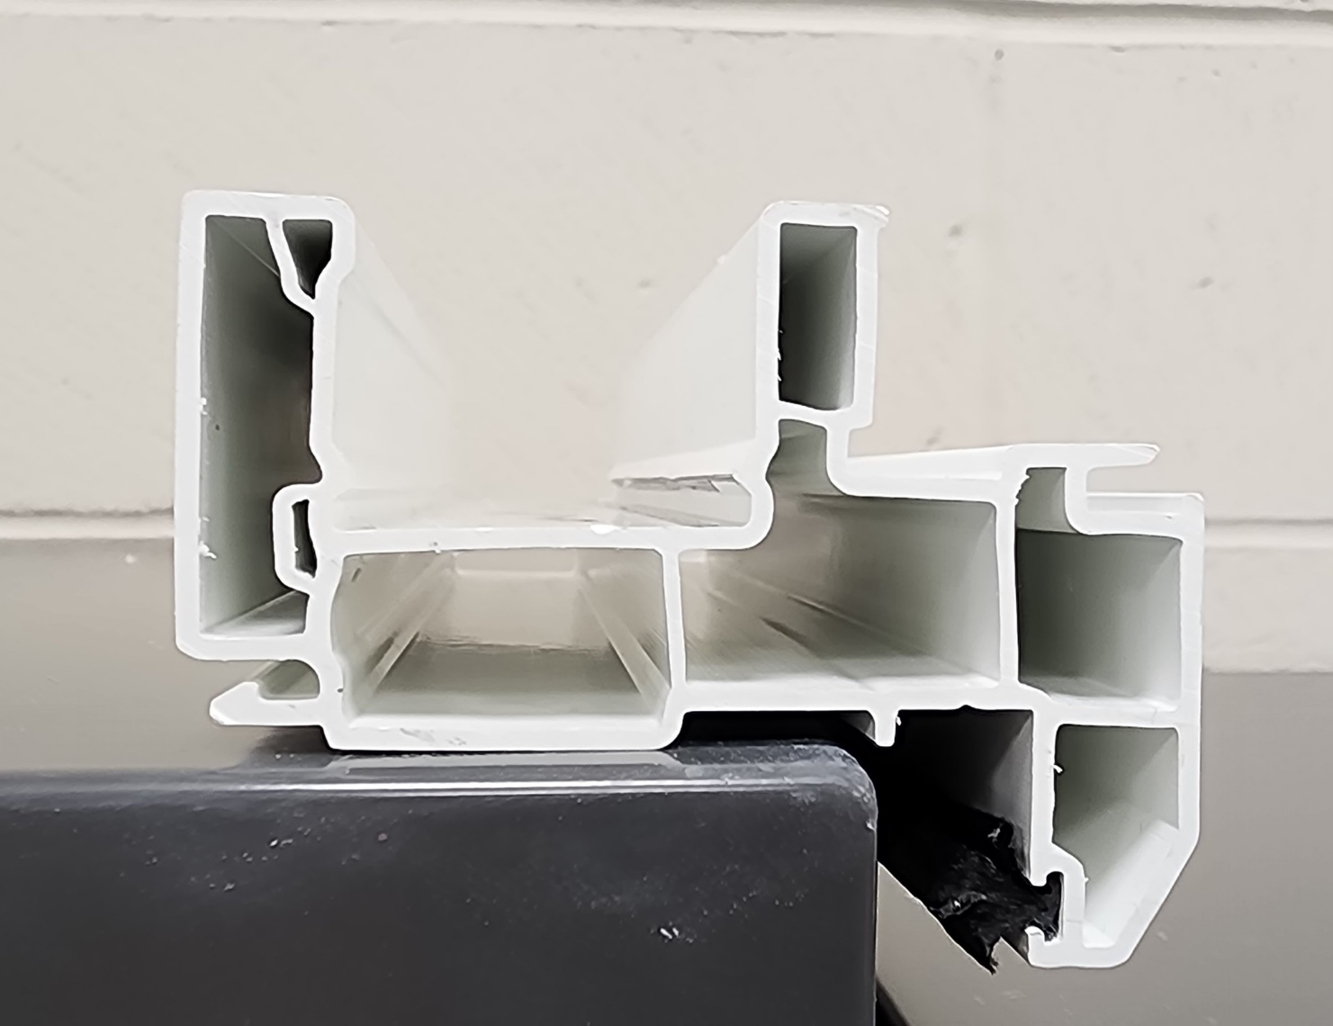

OFF-SQUARE

UNEVEN

BY SIGNING BELOW, YOU ACKNOWLEDGE THE PROBLEM ABOVE AND AGREE TO MONITOR THIS ISSUE IN FUTURE PRODUCTION RUNS.
DAY SHIFT |  | AFTERNOON SHIFT |  | NIGHT SHIFT
NAME | SIGNATURE | NAME | SIGNATURE | NAME | SIGNATURE

