
QUALITY ALERT

Customer: Wintech Date: October 17, 2023
Die: 15799 Colour: ALL
Type of Complaint: Wintech REJECT

Q.A # Q.I.R # CUSTOMER NCR #

Description: Customer REJECT – Screw hole is breaking during fabrication and/or installation

#
PLEASE MAKE SURE SCREW HOLE IN TOLERENCE ±0.010”
&
CHECK WITH
SCREW #8 FREQUENTLY
2 TIMES EVERY SHIFT

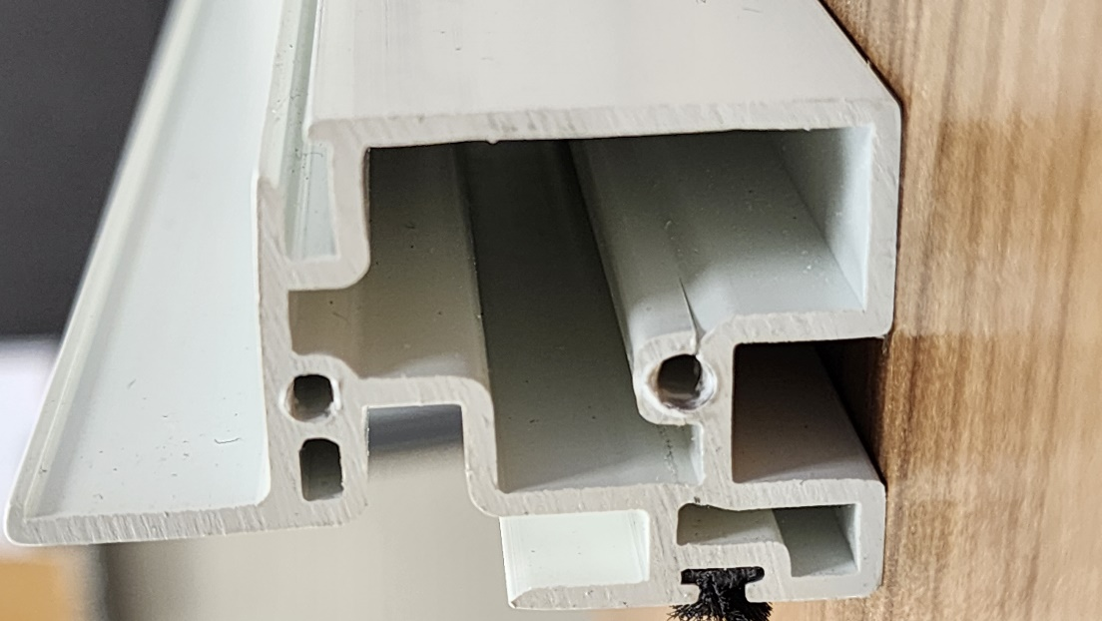
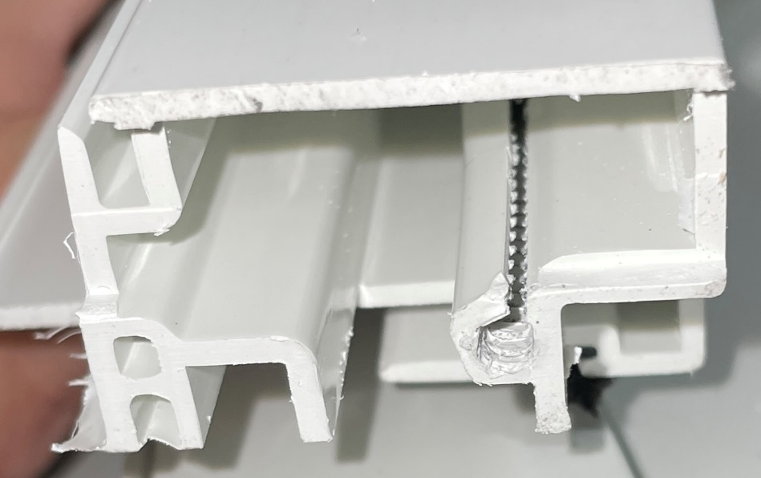

r

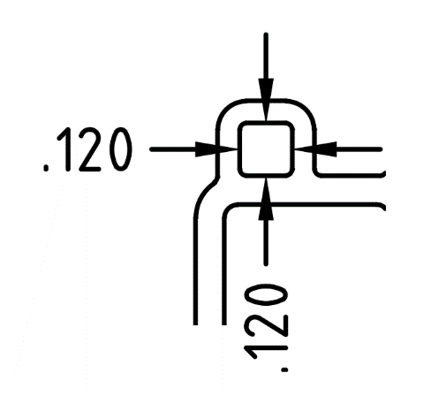

BY SIGNING BELOW, YOU ACKNOWLEDGE THE PROBLEM ABOVE AND AGREE TO MONITOR THIS ISSUE IN FUTURE PRODUCTION RUNS.
DAY SHIFT |  | AFTERNOON SHIFT |  | NIGHT SHIFT
NAME | SIGNATURE | NAME | SIGNATURE | NAME | SIGNATURE

