
FIT & FUNCTION

Customer: Wintech Date: Nov 3, 2025
Die: 15799 Quantity from QC: 1 + 1

F-F: 034

Description: Reinforcement bars must fit loose in material
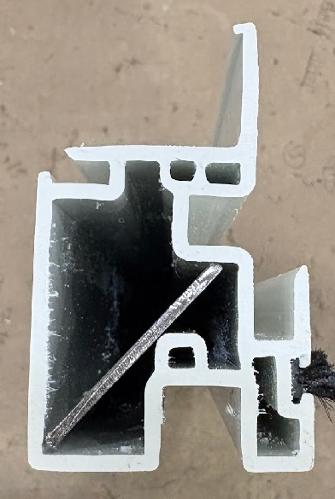
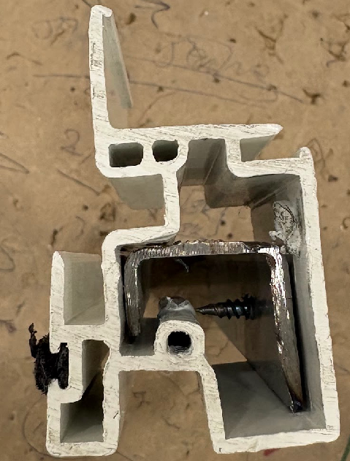
REIN BAR REACHES CLOSE TO THE CORNER

MAKE SURE REIN BAR FITS LOOSE

