
QUALITY ALERT

Customer: Avanti Date: Aug 29, 2025
Die: 15899-15901 Colour: Any
Type of Complaint: Customer REQUIREMENTS

Q.A # 25-041 NCR: 291 RMA#: N/A

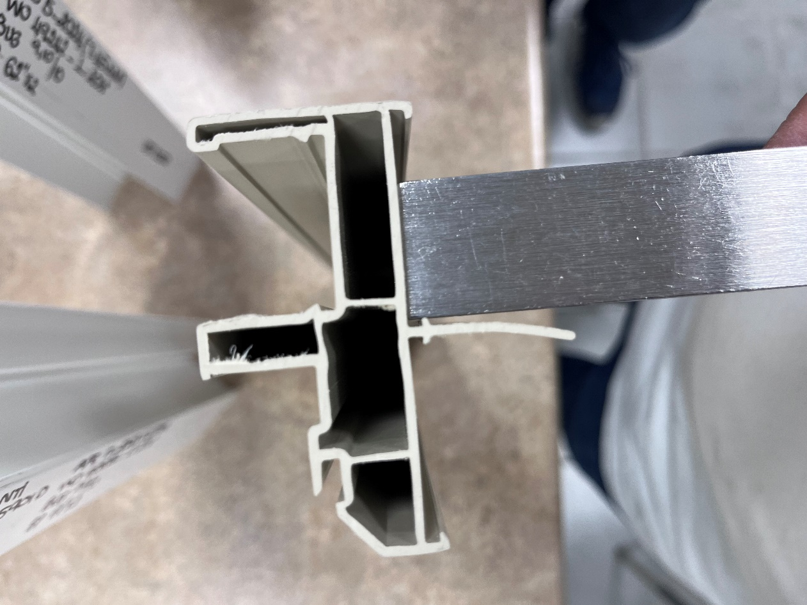
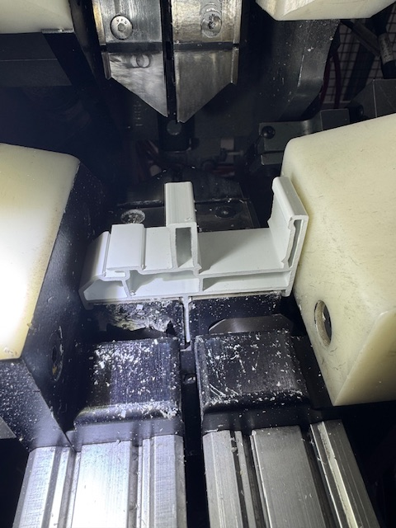
Description: Customer REQUIRED that fin must be straight as possible to prevent jamming in the corner clean machine and offset issues on the weld machine. REPEATED ISSUE !!!




ENSURE FINS ARE CONSISTENTLY STRAIGHT TO AVOID REJECTION FROM CUSTOMER.

BY SIGNING BELOW, YOU ACKNOWLEDGE THE PROBLEM ABOVE AND AGREE TO MONITOR THIS ISSUE IN FUTURE PRODUCTION RUNS.
DAY SHIFT |  | AFTERNOON SHIFT |  | NIGHT SHIFT
NAME | SIGNATURE | NAME | SIGNATURE | NAME | SIGNATURE

