
QUALITY ALERT

Customer: AVANTI Date: June 19, 2023
Die: 15901 Colour: ALL
Type of Complaint: Customer REJECTED

Q.A # Q.I.R # CUSTOMER NCR #

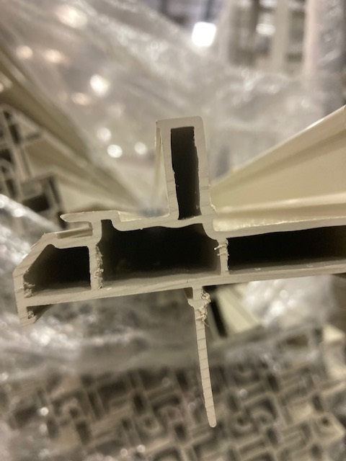
Description: Customer REJECTED the inside wall collapsed causing NOT fit the punches.
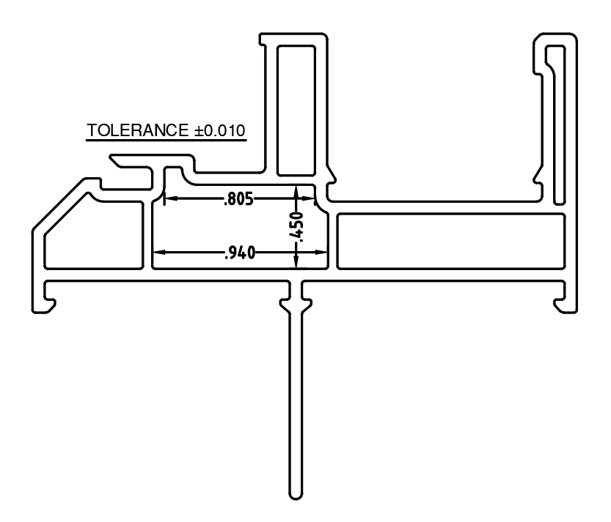

PLEASE MAKE SURE THE ABOVE DIMENSIONS IN TOLERANCE
AS WELL AS THE WALL NOT COLLAPSE / TOO HEAVY

BY SIGNING BELOW, YOU ACKNOWLEDGE THE PROBLEM ABOVE AND AGREE TO MONITOR THIS ISSUE IN FUTURE PRODUCTION RUNS.
DAY SHIFT |  | AFTERNOON SHIFT |  | NIGHT SHIFT
NAME | SIGNATURE | NAME | SIGNATURE | NAME | SIGNATURE

