
QUALITY ALERT

Customer: Ledger Shield Date: July 14, 2025
Die: 16050 Colour: Any
Type of Complaint: Customer COMPLAINED

Q.A # 25-019 NCR: 190 RMA#: N/A

Description: Customer COMPLAINED that the drip edge on several flanges arrived bent, and multiple segments show significant drift in the end cuts, leading to misalignment. This can cause both aesthetic and functional issues during installation.
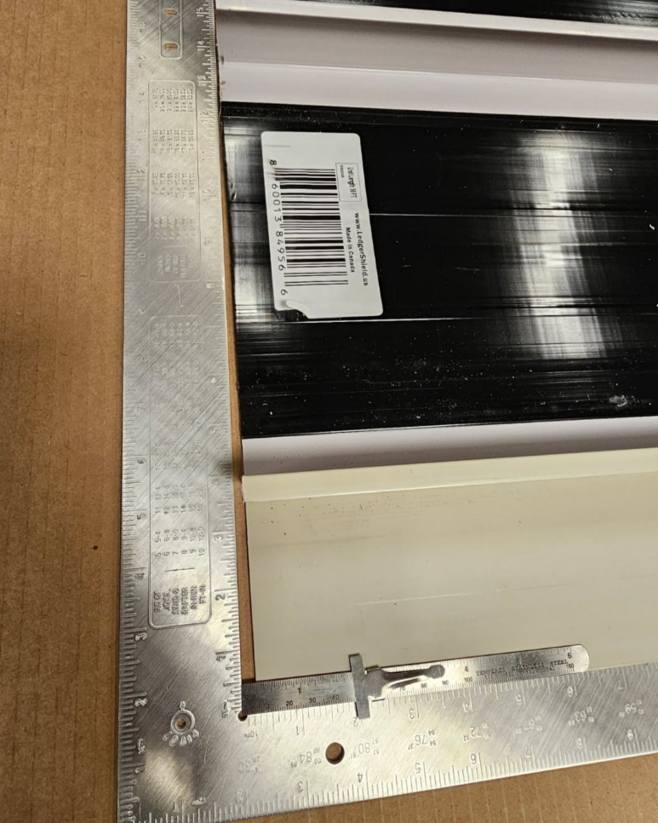
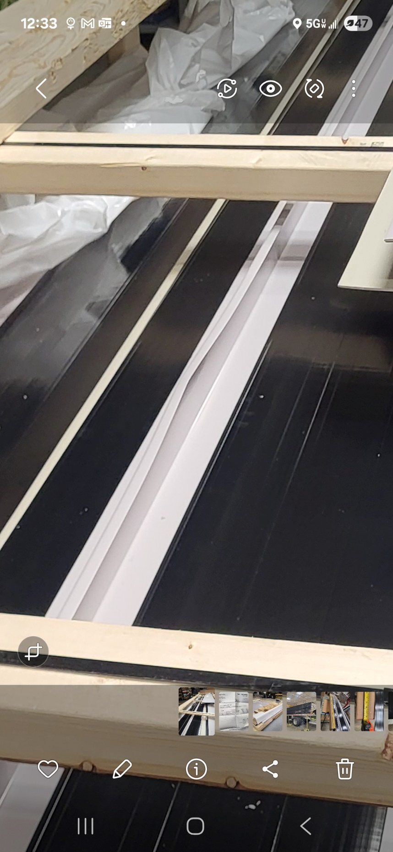

ENSURE PROPER HANDLING AND CUTTING SAW TO PREVENT BENT EDGES AND END CUT MISALIGNMENT.

Ask ChatGPT

BY SIGNING BELOW, YOU ACKNOWLEDGE THE PROBLEM ABOVE AND AGREE TO MONITOR THIS ISSUE IN FUTURE PRODUCTION RUNS.
DAY SHIFT |  | AFTERNOON SHIFT |  | NIGHT SHIFT
NAME | SIGNATURE | NAME | SIGNATURE | NAME | SIGNATURE
F-006: Quality Alert | Eff.Date: 05/03/2025 | CC# 25-046 | Rev.0

