
QUALITY ALERT

Customer: Ledger Shield Date: July 22, 2025
Die: 16050 Colour: White
Type of Complaint: Customer REQUIREMENTS

Q.A # 25-039 NCR: N/A RMA#: N/A

Description: Customer REQUIRES that pieces must not be bent (exceed gap tolerance), as bending makes them unusable and causes gaps when joined.
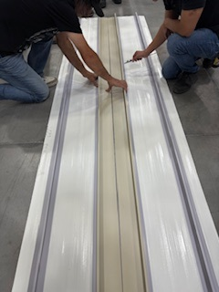
PUT 2 PIECES TOGETHER, GAP MUST NOT EXCEED:
LENGTH MAXIMUM GAP
6 FT = 0.300 INCH
10 FT = 0.400 INCH

ENSURE MATERIAL IS STRAIGHT AND FREE FROM BENDING TO PREVENT POOR FIT AND APPEARANCE.

BY SIGNING BELOW, YOU ACKNOWLEDGE THE PROBLEM ABOVE AND AGREE TO MONITOR THIS ISSUE IN FUTURE PRODUCTION RUNS.
DAY SHIFT |  | AFTERNOON SHIFT |  | NIGHT SHIFT
NAME | SIGNATURE | NAME | SIGNATURE | NAME | SIGNATURE

