
QUALITY ALERT

Customer: Ledger Shield Date: Aug 29, 2025
Die: 16050 Colour: Any
Type of Complaint: Customer REQUIREMENTS

Q.A # 25-039 NCR: N/A RMA#: N/A

Description: Customer REQUIRES that pieces must be cut 90 degrees straight (with +- 1/16 inch as tolerance)
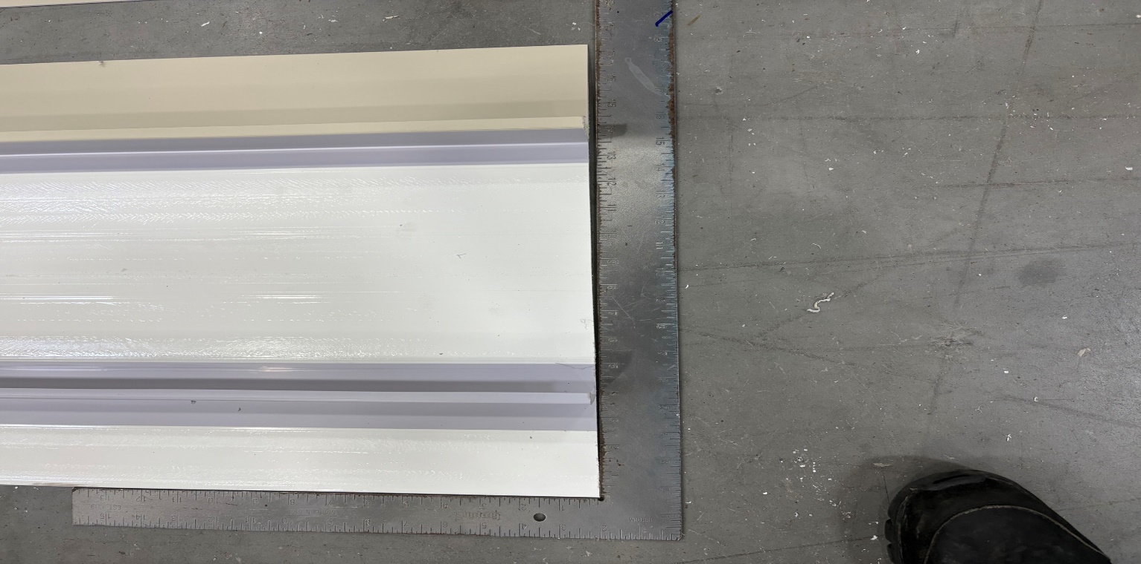
MUST NOT EXCEED +- 1/16 INCH

ENSURE MATERIAL IS CUT SQUARE AT A 90-DEGREE ANGLE

BY SIGNING BELOW, YOU ACKNOWLEDGE THE PROBLEM ABOVE AND AGREE TO MONITOR THIS ISSUE IN FUTURE PRODUCTION RUNS.
DAY SHIFT |  | AFTERNOON SHIFT |  | NIGHT SHIFT
NAME | SIGNATURE | NAME | SIGNATURE | NAME | SIGNATURE

