
QUALITY ALERT

Customer: LEDGER SHIELD Date: Sep 08, 2025
Die: 16050 Colour: Any
Type of Complaint: Customer REQUIREMENT

Q.A # 25-047 NCR: 301 RMA#: N/A

Description: Customer REQUIRES that material must be flat as possible, no waving allowed.

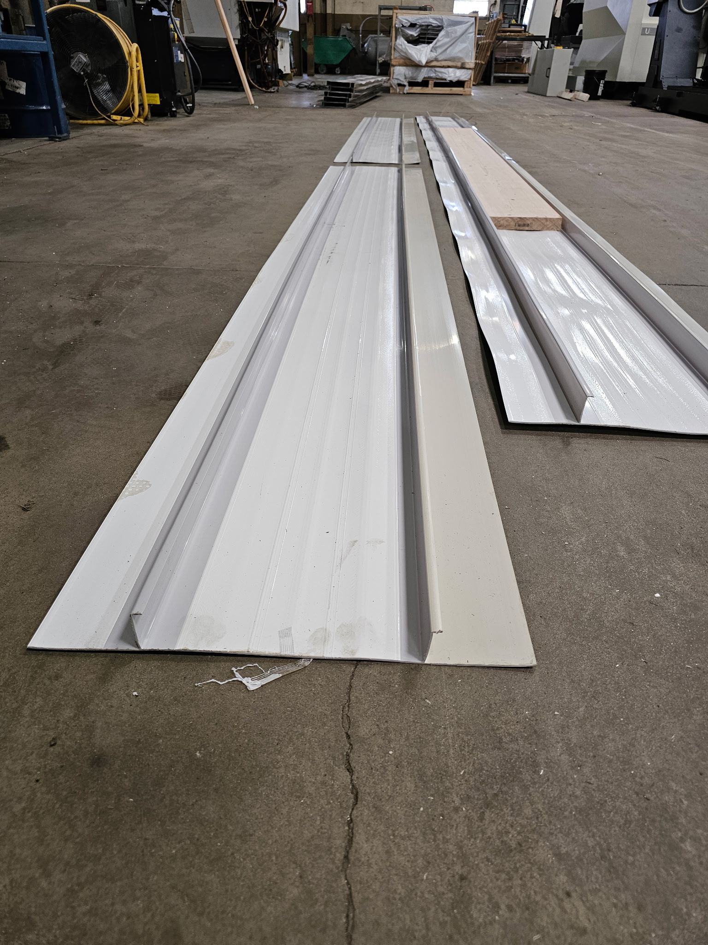
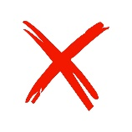

ENSURE EXTRUSION IS STRAIGHT, FLAT, AND NOT WAVING.

BY SIGNING BELOW, YOU ACKNOWLEDGE THE PROBLEM ABOVE AND AGREE TO MONITOR THIS ISSUE IN FUTURE PRODUCTION RUNS.
DAY SHIFT |  | AFTERNOON SHIFT |  | NIGHT SHIFT
NAME | SIGNATURE | NAME | SIGNATURE | NAME | SIGNATURE

