
PACKAGING INSTRUCTION

Customer: LEDGER SHIELD Date: September 2, 2025
Die: 16050

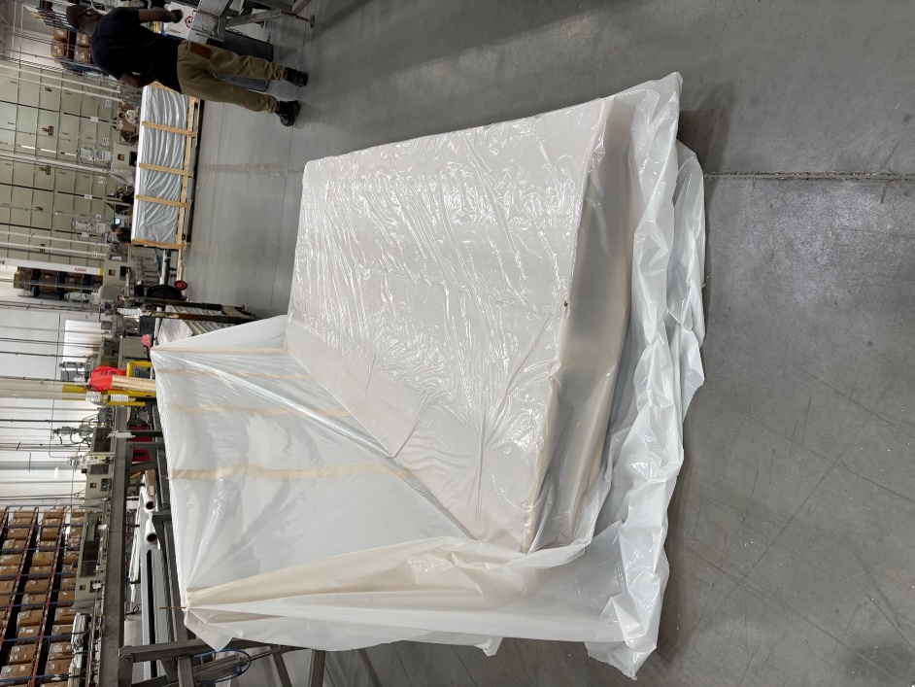
STEP 1: PLACE A PLASTIC COVER AT THE BOTTOM OF THE SKID/PALLET.

STEP 2: LAY THE MATERIAL FACEDOWN, WITH THE WIDE FLAT FACE RESTING EVENLY. STACK UP EACH LAYER BY NESTING TOGETHER
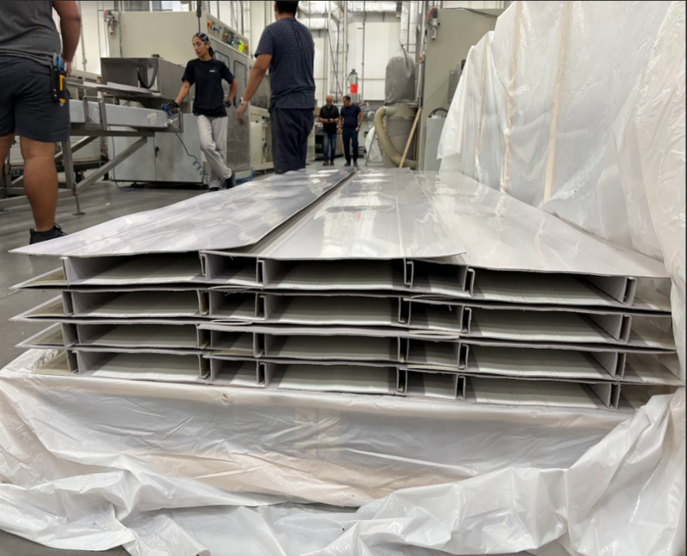
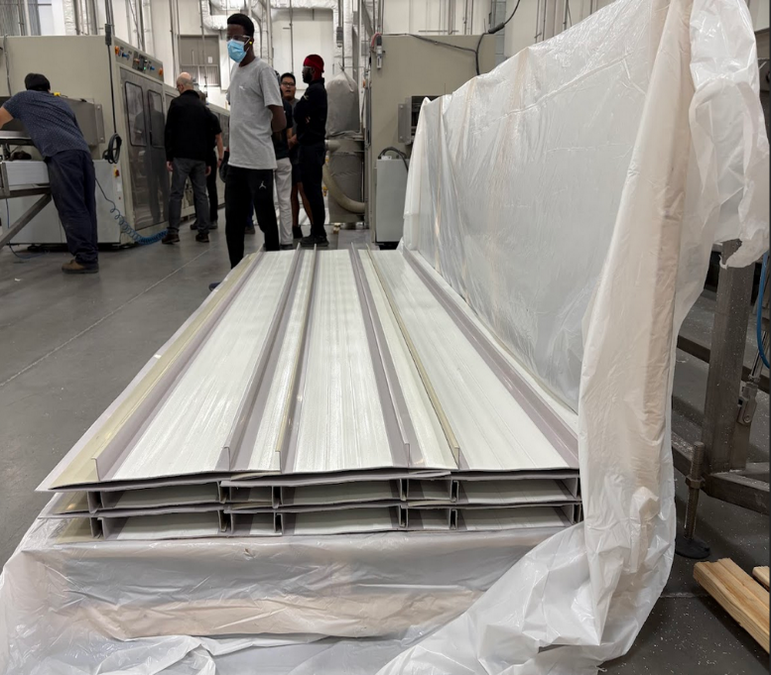

STEP 3: STACK UP LAYERS UNTIL THE REQUESTED AMOUNT IS FULL (COMPARE WITH WORK ORDERS)

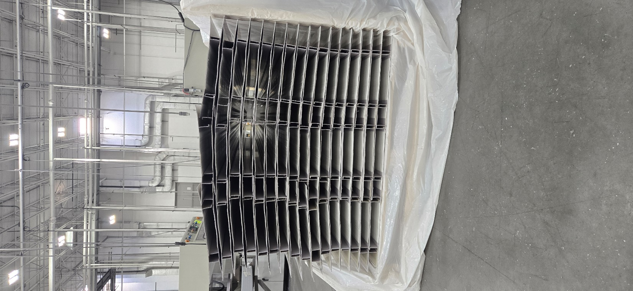

STEP 4: PACK UP ALL 4 SIDES OF THE SKID USING PLASTIC COVER.
NAIL UP THE SKID USING PLYWOOD AS IN PICTURE
