
QUALITY ALERT

Customer: Seaway Date: September 28, 2018
Die: 4686 Colour: All
Type of Complaint: Seaway REJECTED

Q.A # Q.I.R # CUSTOMER NCR #

Description: Seaway REJECT – Profile out of shape makes it not sit properly inside punch causing the leg to push outward and tight in the punch.

Out of Shape & does not sit straight making CHECK WITH GO-NO-GO GAUGE
it hard for customer to punch MUST BE LOOSE
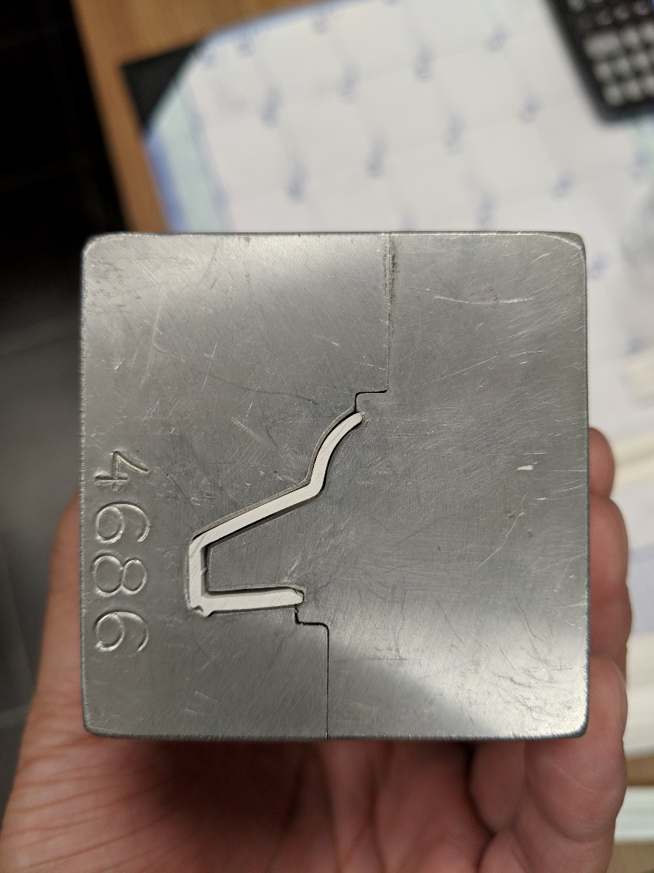
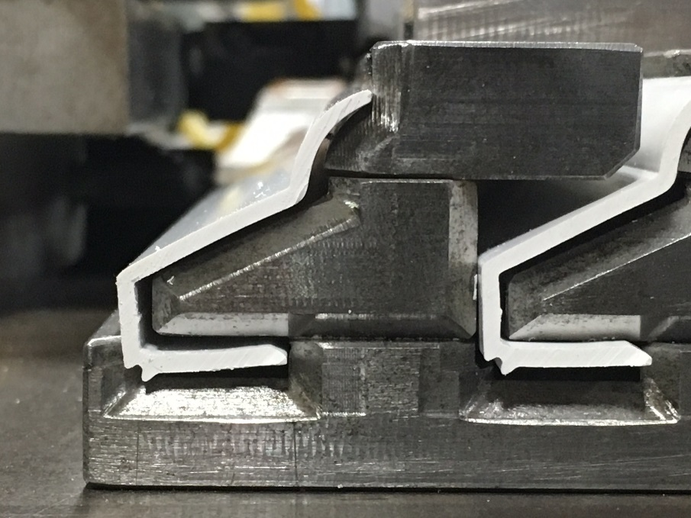

BY SIGNING BELOW, YOU ACKNOWLEDGE THE PROBLEM ABOVE AND AGREE TO MONITOR THIS ISSUE IN FUTURE PRODUCTION RUNS.
DAY SHIFT |  | AFTERNOON SHIFT |  | NIGHT SHIFT
NAME | SIGNATURE | NAME | SIGNATURE | NAME | SIGNATURE

