
QUALITY ALERT

Customer: Windor Date: Sep 26, 2025
Die: 5254 Colour: Any
Type of Complaint: Customer REJECTED

Q.A # 25-050 NCR: 361 RMA#: N/A

Description: Customer REJECTED due to outer walls of the profiles being out of tolerance, makes profile cannot fit in punch after laminated.

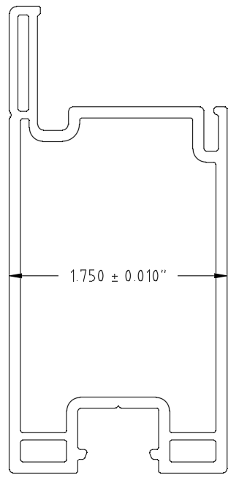
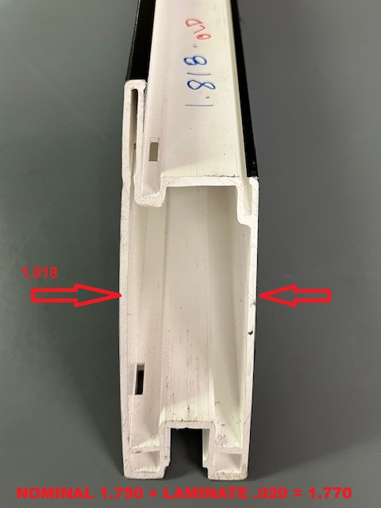

ENSURE OUTER WALL DIMENSIONS ARE WITHIN SPECIFIED TOLERANCE TO PREVENT POOR FIT DURING PUNCHING PROCESS.

BY SIGNING BELOW, YOU ACKNOWLEDGE THE PROBLEM ABOVE AND AGREE TO MONITOR THIS ISSUE IN FUTURE PRODUCTION RUNS.
DAY SHIFT |  | AFTERNOON SHIFT |  | NIGHT SHIFT
NAME | SIGNATURE | NAME | SIGNATURE | NAME | SIGNATURE

