DIE# 5254 – Win-Dor (EXTRUDER SIDE)
Green Buggy + Wrap arms with cardboard
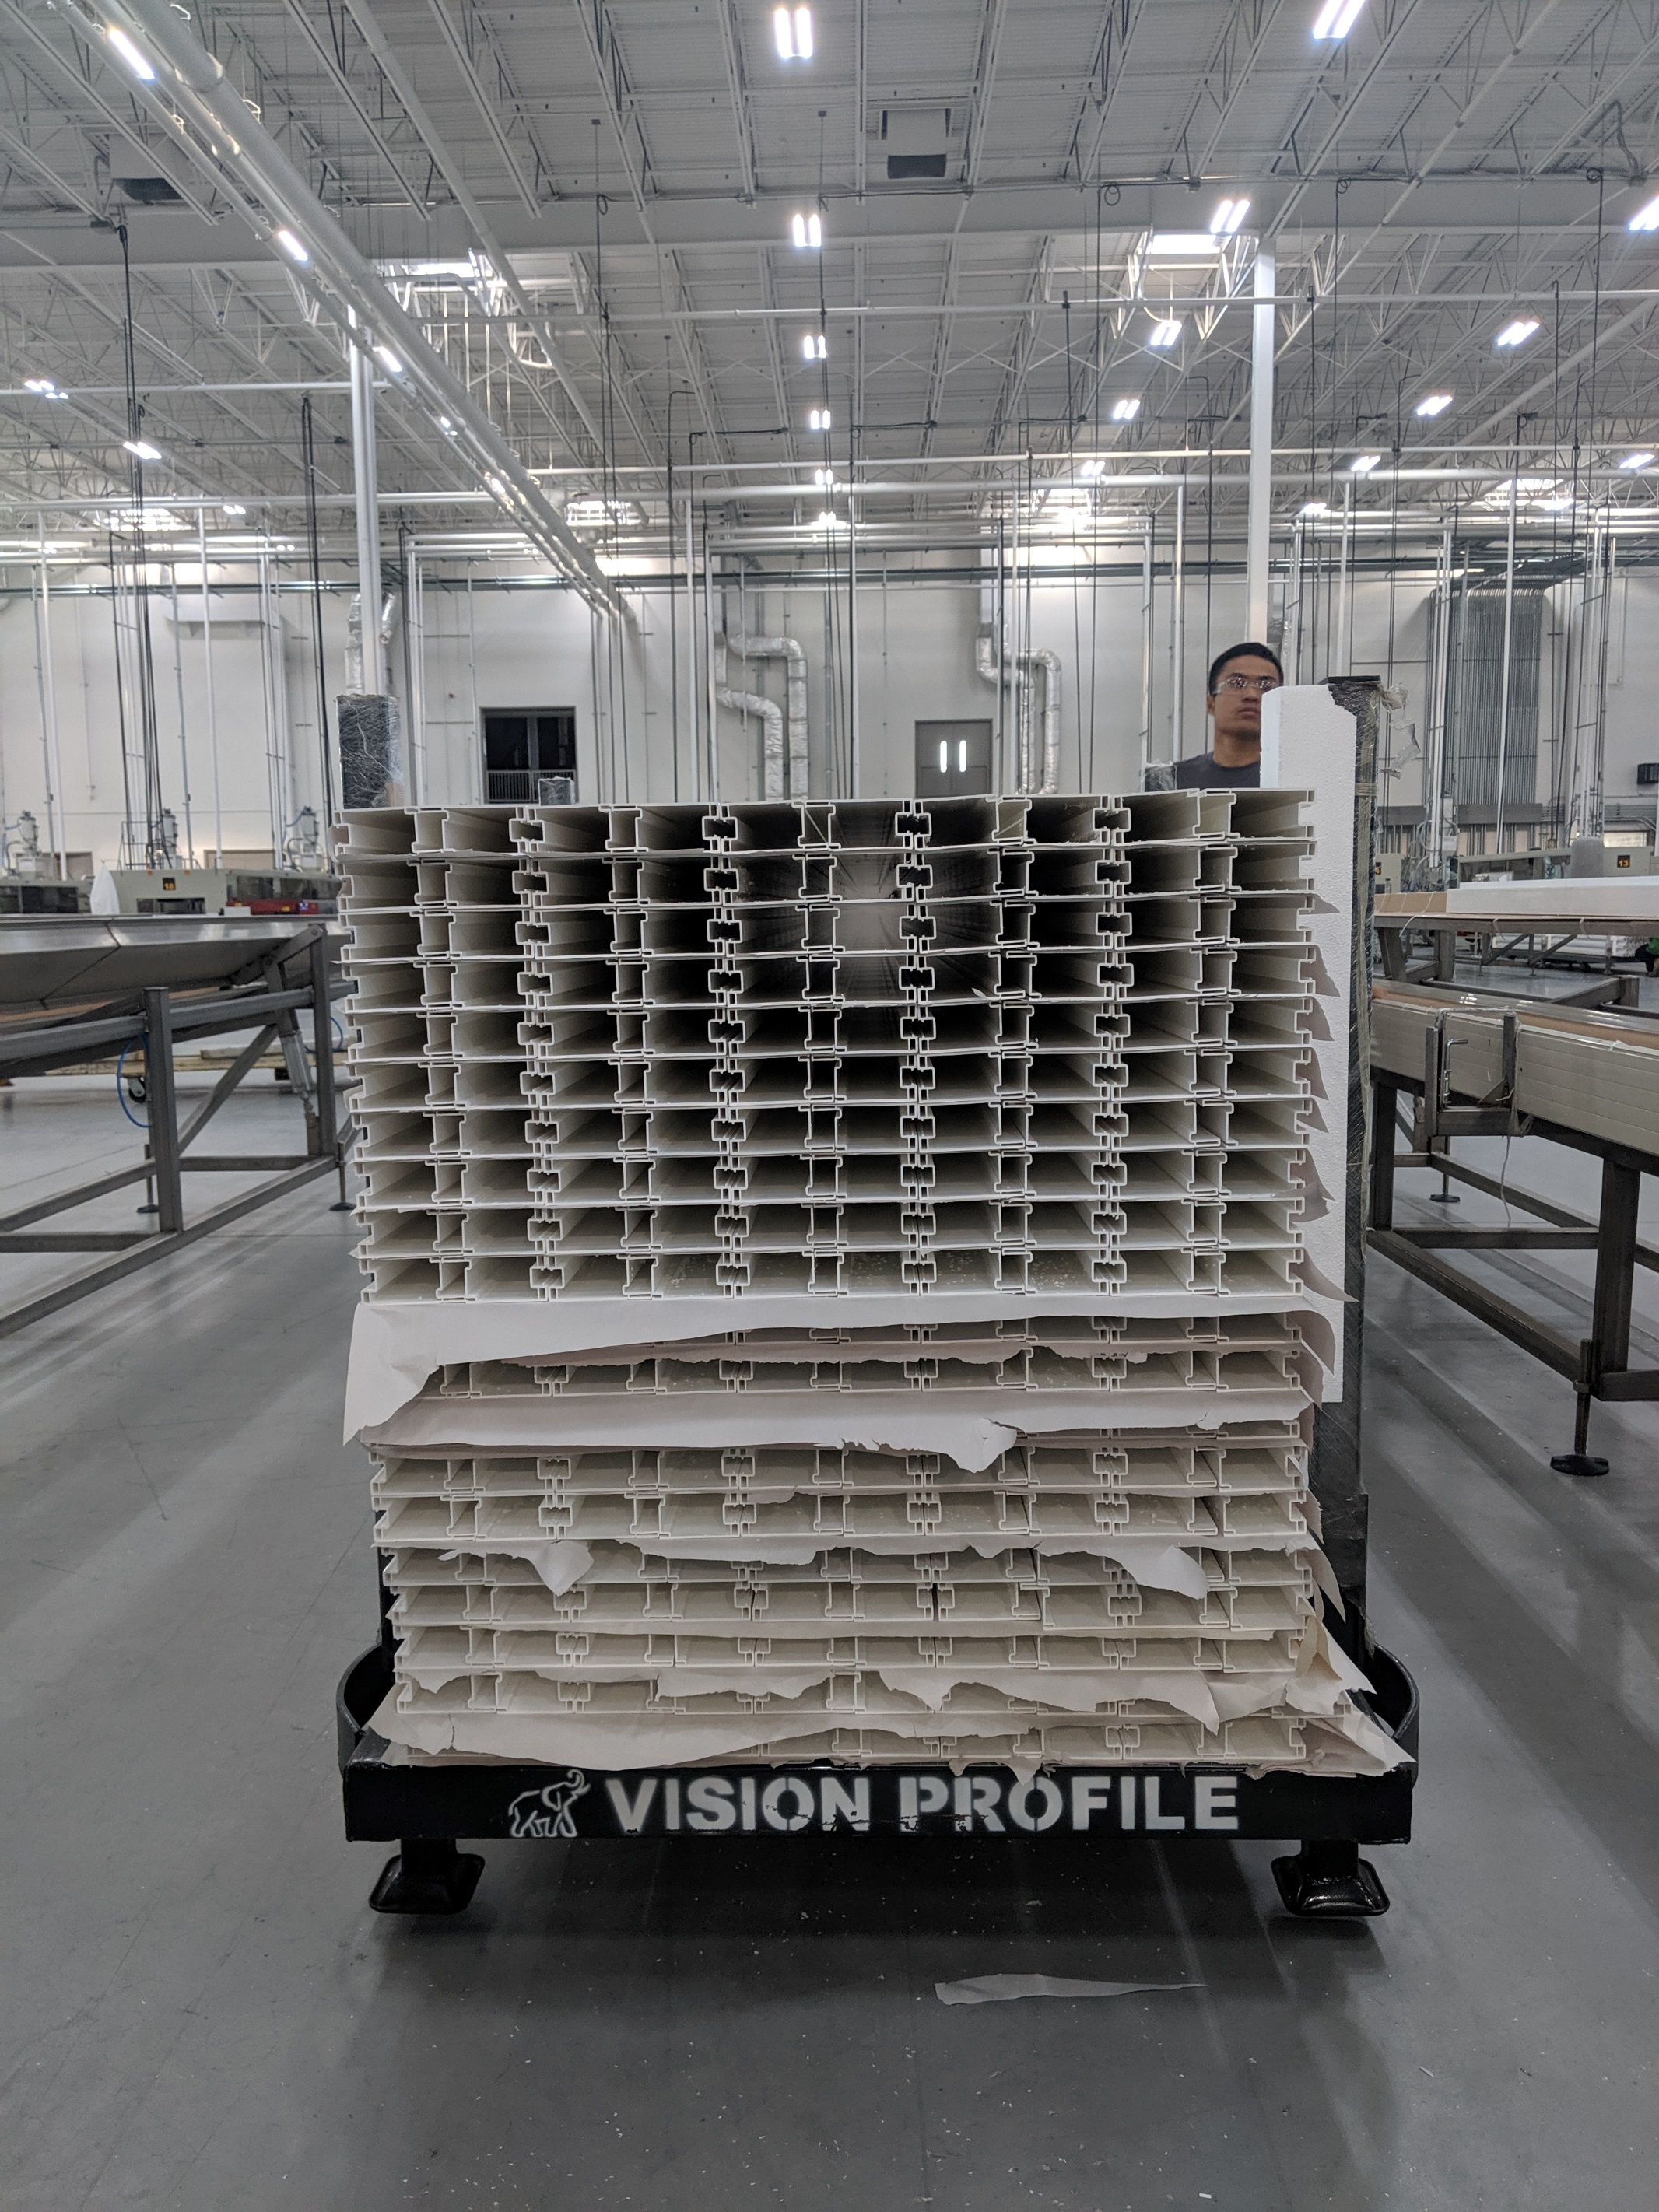
1 Big foam on 1 side / PAPER EVERY ROW

USE 18” PANEL (#15191) AND 16” PANEL (#15192) FOR BASE AND COVER WITH 3 LAYERS OF PAPER
NO CARDBOARD

