Probability is a branch of statistics that calculates the possibility of a given event's occurrence which is expressed as a number between 0 and 1. The probability of 1 for an event represents certainty.  
  
For example, the probability of a coin toss resulting in either "tail" or "head" is 1, because there are no other choices, given that the coin lands are flat.  
  
The probability of 1/2 for an event can be considered to have an equal possibility of happen or not happen. For example, the probability of a coin toss resulting in "tail" is 1/2, because the toss results in "head" with a probability of 1/2.  
  
Probability of 0 for an event can be considered an impossibility. For example, the probability that the coin will land flat because either "tail" or "head" must be facing up.

**📝Probability**  
The probability of an event is a measure of the likelihood that the event will occur.

We defined the "Probability" as to how likely something is to happen. While calculating the probability of an event we use this formula:

**Probability= number of ways it can happen/Total number of outcomes.**

Here there are some basic examples about calculating the probability of an event.

**The probability of getting a "Head" when tossing a coin:**

Number of ways it can happen: 1 (Head)

Total number of outcomes: 2 (Head and Tail)

The probability = 1/2 = 0,5

**The probability of getting a "3"" when rolling a die:**

Number of ways it can happen: 1 ("3")

Total number of outcomes: 6 ("1", "2", "3", "4", "5" and "6")

The probability = 1/6

**The probability of getting a "3" or "5" when rolling a die:**

Number of ways it can happen: 2 ("3" and "5")

Total number of outcomes: 6 ("1", "2", "3", "4", "5" and "6")

The probability = 2/6 = 1/3

**Intersection, Unions and Complements**

Introduction

By using set operations, sets of elements can be combined or changed. Just like the addition or subtraction of real numbers, set operations are defined to do something to the sets involved. The set operations are union, intersection, and complement. In the following pages we will cover **intersection**, **union** and **complement** concepts. The following picture gives an idea about these concepts.

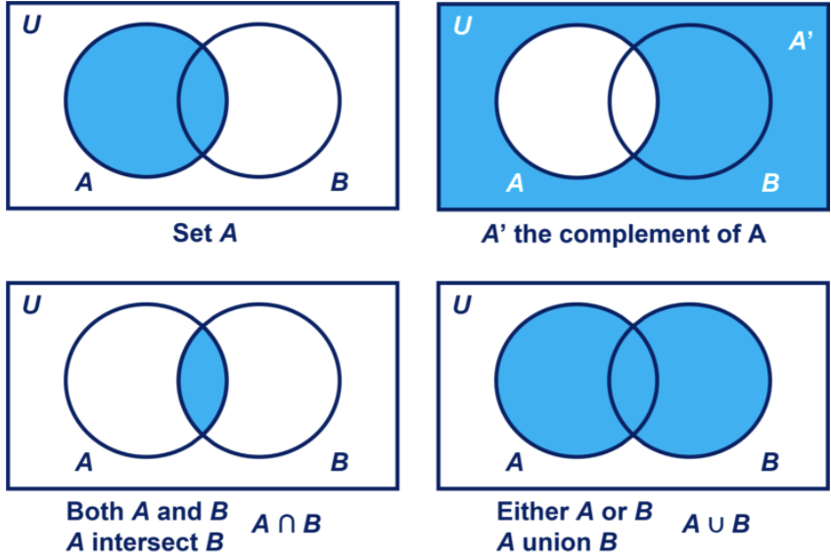

## Intersection, Unions and Complements

### Unions

We will discuss the unions as the first part of the set operations. The union of set A and set B is symbolized "A∪B" and it is the set containing all the elements of set A and set B. It corresponds to combining definitions of the two events using the word “or.”

Example:

Set A = {1, 2, 3}

Set B = {3, 6, 8}

A∪B = {1, 2, 3, 6, 8}

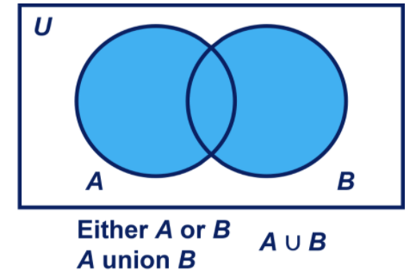

**💡Tips:**

* Due to elements of a set must be unique, we do not repeat the "3" in the union set.

## Intersection, Unions and Complements

### Intersection

The intersection of sets A and B is symbolized by A∩B and it is the set containing all of the elements that are common to both set A and set B. It corresponds to combining definitions of the two events using the word “and.”

Example:  
Set A = {1, 2, 3}  
Set B = {2, 4, 5}  
A ∩ B = {2}

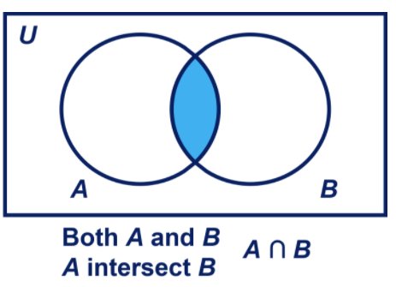

## Intersection, Unions and Complements

### Complements

The complement of a set A is denoted by A' and it is the set of all elements in the universal set that are not in A. The universal set is the set of all elements under consideration, usually denoted by capital U.

Example:  
Set U = {1,2,3,4,5,6,7,8,9,10}  
Set A = {1, 2, 3}  
Set B = {3, 4, 5}  
Set A' = {4,5,6,7,8,9,10}

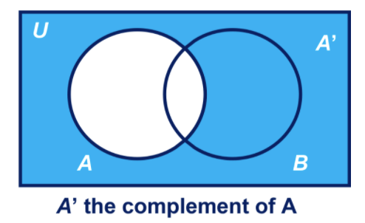

## Permutation and Combination

### Permutation

The permutation is defined as all the possible ways elements in a set can be arranged while considering the order of elements. Let's say there are four balls (blue, pink, green, and white) in a box. And you are going to pick up exactly two balls. How many ways are there of picking up two balls? The first choice can be any of the four colors. There are 3 different second choices for each of these 4 different choices. Therefore we can say there are 4 x 3 = 12 ways of picking up two balls. The following table shows these different ways.

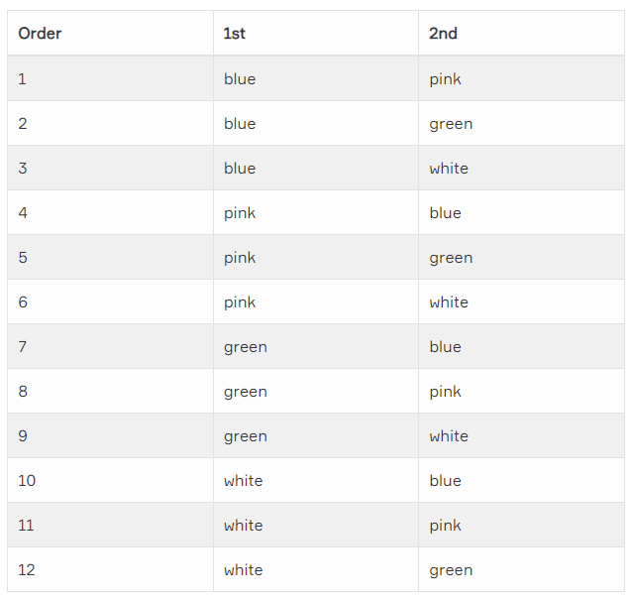

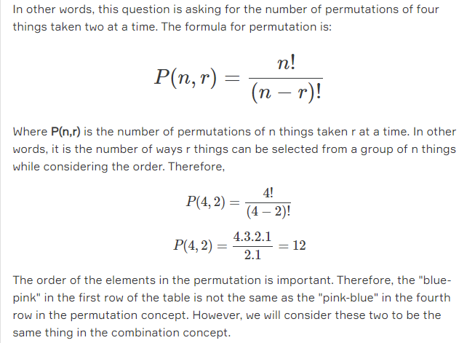

**📝Permutation**  
An arrangement of all or part of a set of objects, with regard to the order of the arrangement.

## Permutation and Combination

### Combination

Combinations are almost similar to permutations but the difference is that the order of elements is not important. Now suppose how many different combinations of two balls would you end up with? In counting combinations, choosing blue and then pink is the same as choosing pink and then blue because in both cases you end up with one blue ball and one pink ball. The order does not count, unlike permutation. The following table based on the previous table but is modified so that repeated combinations are removed. As you can see, there are six combinations of the three colors.

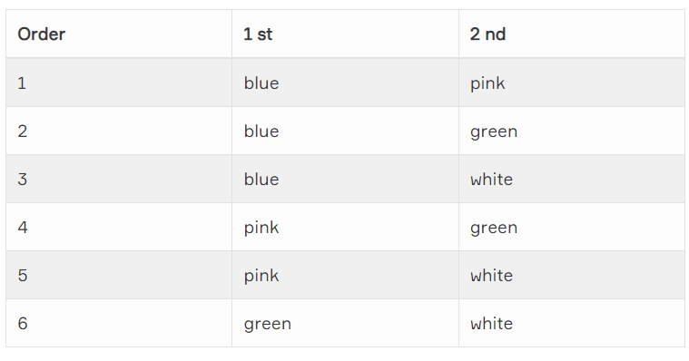

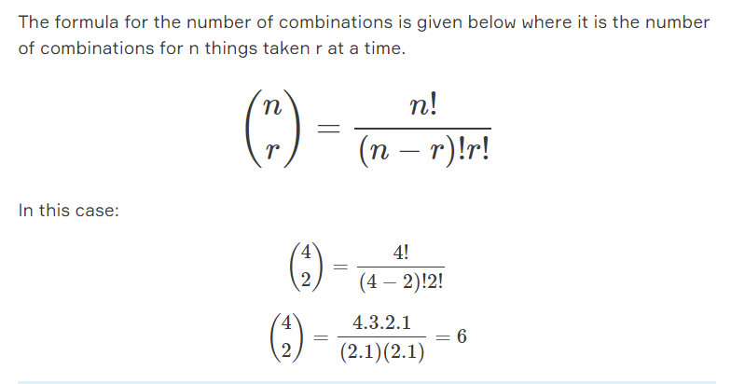

**📝Combination**  
A selection of all or part of a set of objects, without regard to the order in which objects are selected.

## Independent and Dependent Events

### Dependent Events

Sometimes one event's presence or absence tells us something about the next event. We consider events dependent if knowing whether one of them happened tells us something about the other. In other words, when two events are dependent, one event affects the probability of the other event.

For example, suppose you draw 2 cards from a deck. Let's calculate the probability of getting an Ace. For the 1st card, the probability of drawing an Ace is 4 out of 52 or 4/52. But for the 2nd card:

If the 1st card was an Ace, then the 2nd card is less likely to be an Ace, because only 3 of the 51 cards left are Aces. Therefore the probability is 3/51.

If the 1st card was not an Ace, then the 2nd card is more likely to be an Ace, because 4 of the 51 cards left are Ace. This is because we are removing cards from the deck. The probability is 4/51.

Drawing cards from a deck are dependent events. Because the results of the previous one affect the probability of the next event.

## Independent and Dependent Events

### Independent Events

An event is called an independent event if that has no connection to another event's results. In other words, the event does not affect the probability of another event occurring.

For example, suppose you toss a coin five times and it comes up "tails" each time. What is the probability that the next toss will also be a "tail"? The probability is simply 50%, like any other toss of the coin. What happened in the past trials will not affect the current toss. Therefore, the next toss of the coin is independent of any previous tosses.

We can calculate the probability of two or more independent events by multiplying the chances. We use "P" to mean "Probability Of"an event. If A and B are independent events, we calculate the probability of these two events as:

P(A and B)=P(A)×P(B).

Suppose you will roll a die and toss a coin respectively. What is the probability and of getting a "3" and a "tail"?

P(A)= The probability of getting a "3" when rolling a die is 1/6,

P(B)= The probability of getting a "tail" for a coin toss is 1/2.

The formula is P(A and B)=P(A)×P(B). Because these two events are independent, we will multiply the chances to calculate the probability of getting a "3" and a "tail". Therefore,

P(A and B)= The probability of getting a "3" and a "tail" is (1/6)x(1/2)=1/12

Let's give another example of independent events. The probability of getting 4 heads in a row is calculated as:

For each toss of a coin a "Head" has a probability of 1/2:

Probability of getting 2 heads in a row (HHHH) = (1/2)x(1/2)x(1/2)x(1/2) = 1/16.

## Conditional Probability

### Conditional Probability

The conditional probability of an event B is the probability that the event will happen given the knowledge that an event A has already happened. This conditional probability is denoted by P(B|A), the indication for the probability of B given A, or the probability of B under the condition A.

If events A and B are dependent events, the formula for conditional probability is:

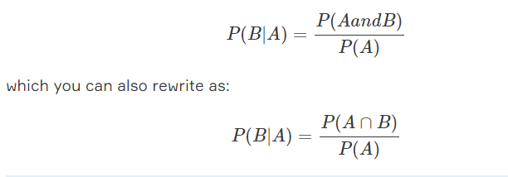

**Tips:**

* If A and B are independent events : P(B|A) = P(B)

## Conditional Probability

### Practice Conditional Probability

In a group of 100 car buyers, 50 bought winter tires, 30 purchased antifreeze, and 20 purchased winter tires and antifreeze. If a randomly chosen car buyer bought winter tires, what is the probability he/she also bought antifreeze?

Here P(A) to buy winter tires and P(B) to buy antifreeze are dependent events. Because buying winter tires before the winter can affect the probability of buying antifreeze. We can say people buying winter tires are more likely to buy antifreeze.

P(A) is given in the question as 50%, or 0.5.

P(A∩B) is the intersection of A and B in other words, both happening together. It’s also given in question 20 out of 100 buyers, or 0,2.

Let's put these values in the formula:

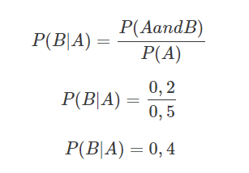

**💡Tips:**

* The probability that any given person buys antifreeze is P(B)=0,3. But the probability of buying antifreeze for someone who has already purchased winter tires is not 0,3. It is described as P(B|A) (Probability of B given A) and equal to 0,4.

## Conditional Probability

### Bayes Theorem

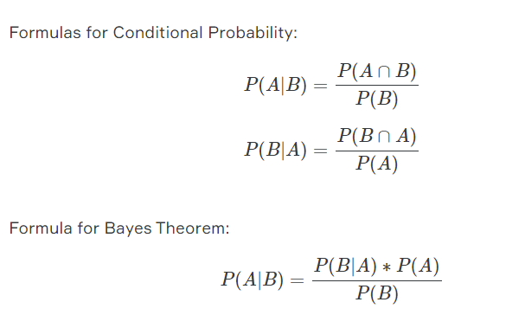

**Tips:**

* P(A∩B)=P(B∩A). They are the same thing.