

**Delphi Electronics & Safety**

**Powertrain Gas Product Line**

**J1939 Software Test Report**

**For**

**Chery JD MT22.3 ETC**

**V1.1**

**Date: 20 January 2016**

Contents

**1. Soft ID 1**

**2. ECU ID 1**

**3. TLA 2**

**4. Active Diagnostic Trouble Codes (DM1) 2**

**5. Previously Active Diagnostic Trouble Codes (DM2) 2**

**6. Diagnostic Data Clear/Reset Of Previously Active DTCs (DM3) 2**

**7. Freeze Frame Parameters (DM4) 3**

**8. Diagnostic Readiness 1 (DM5) 3**

**9. Command Non-Continuously Monitored Test (DM7)、Test Results For Non-Continuously Monitored Systems (DM8) 3**

**10. Diagnostic Data Clear/Reset For Active DTCs (DM11) 3**

**11. Stop Start Broadcast (DM13) 4**

# Soft ID

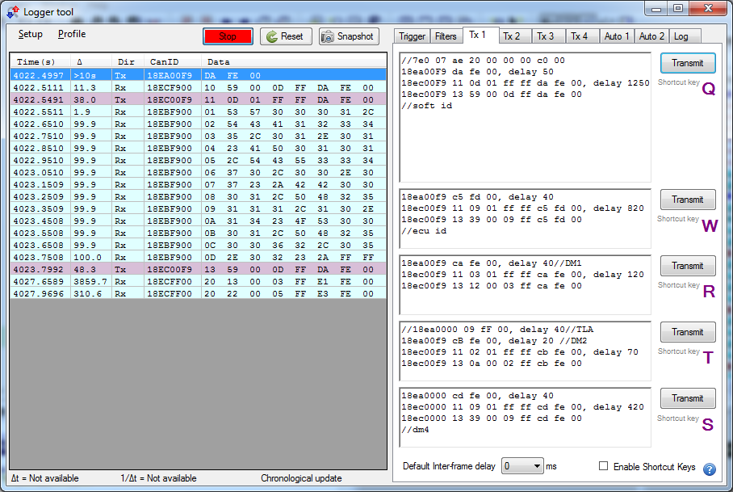

**SoftID**=”**SW0001,TCA12345,01.01#AP0101,TCU33470,00.07#*BB0001,PH25111,10.14#OS0001,PH250062,05.02#\***”

# ECU ID

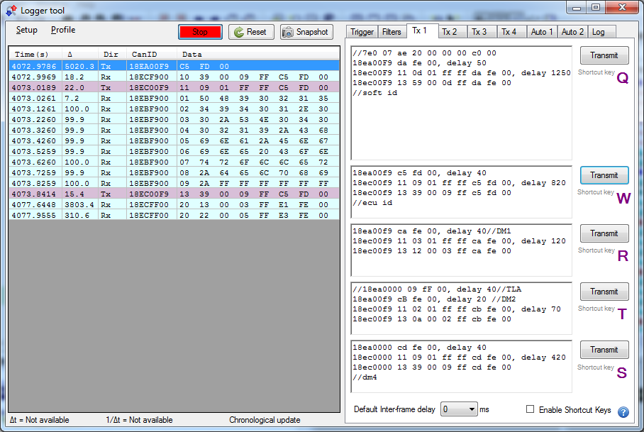

**ECU ID= “PH90215494,01.00*SN0400219*China*Engine Controller*delphi*”**

# TLA

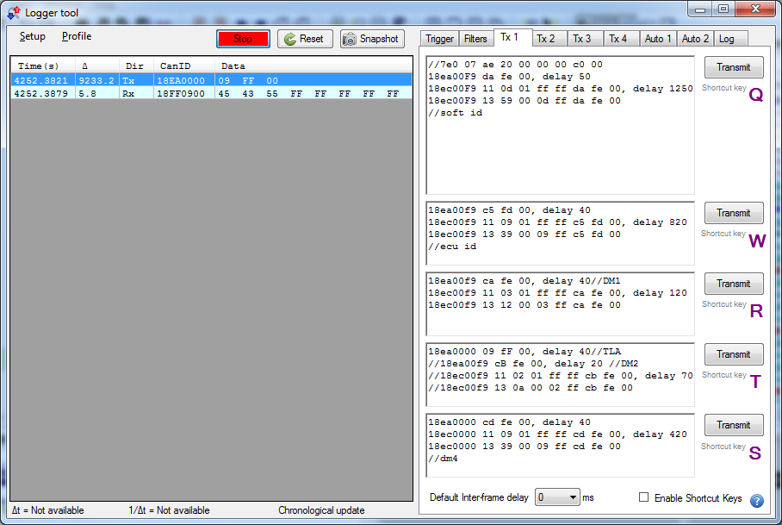

**TLA = “ECU”**

# Active Diagnostic Trouble Codes (DM1)

**Set J1939_DM1_Message[J1939_DM1_BUFFER_SIZE] =**

**{ 0x00, 0xFF, 0x00, 0xFE, 0xCA, 0x00, 0x00, 0x97, 0x03, 0x8a, 0x00,**

**0x51, 0x63, 0x8a};**

**Number of current DTC =0**

**Set J1939_DM1_DTCs=0**

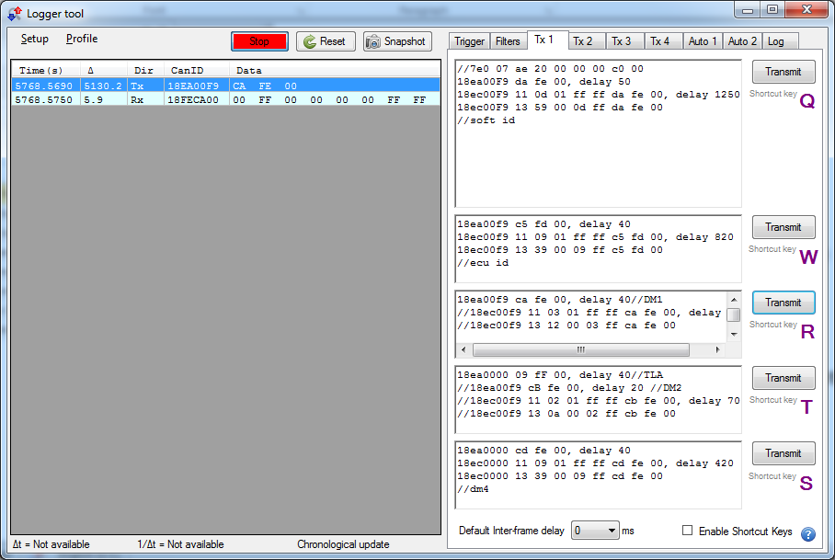

**Number of current DTC =1,2,3**

**Set J1939_DM1_DTCs=1**

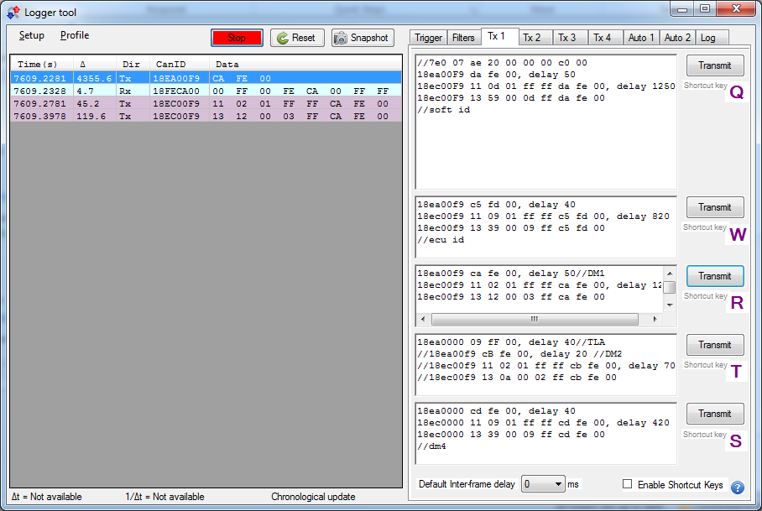

**Set J1939_DM1_DTCs=2**

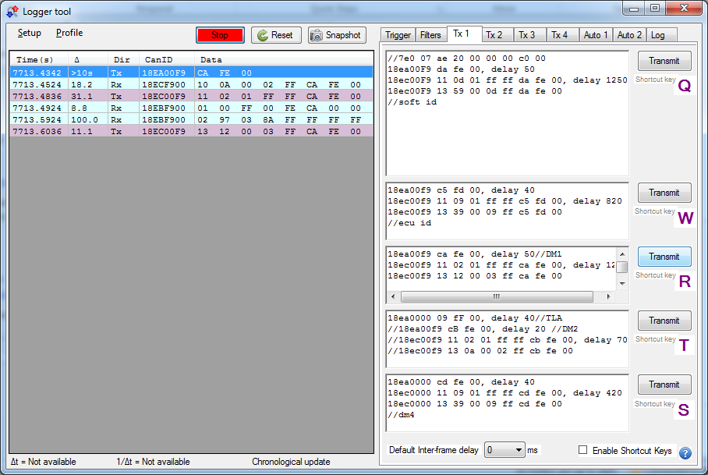

**Set J1939_DM1_DTCs=3**

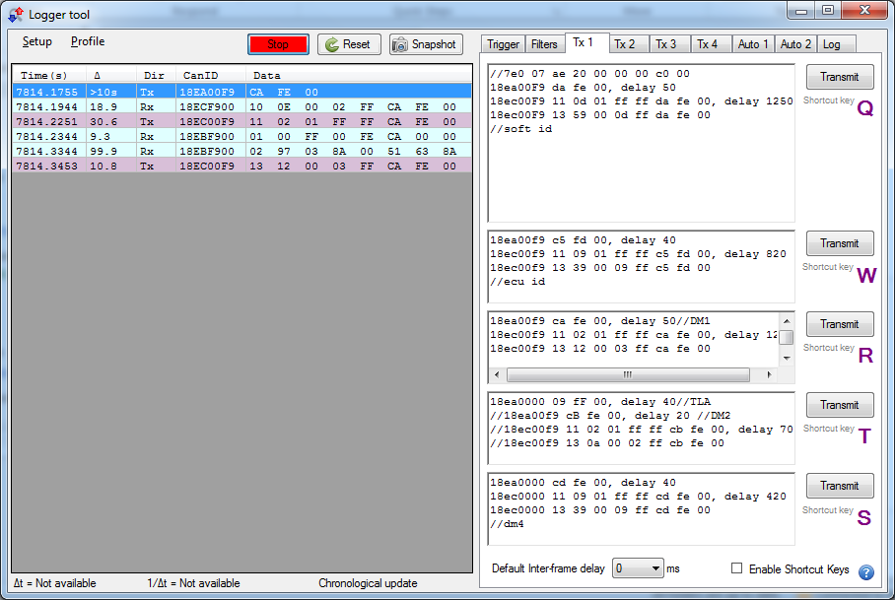

# Previously Active Diagnostic Trouble Codes (DM2)

**Set J1939_DM2_Message[J1939_DM2_BUFFER_SIZE] =**

**{ 0x00, 0xFF, 0x00, 0xFE, 0xCA, 0x00, 0x00, 0x97, 0x03, 0x8a, 0x00,**

**0x51, 0x63, 0x8a};**

**Number of previous DTC =0**

**Set NumOfPreActiveDTCs=0**

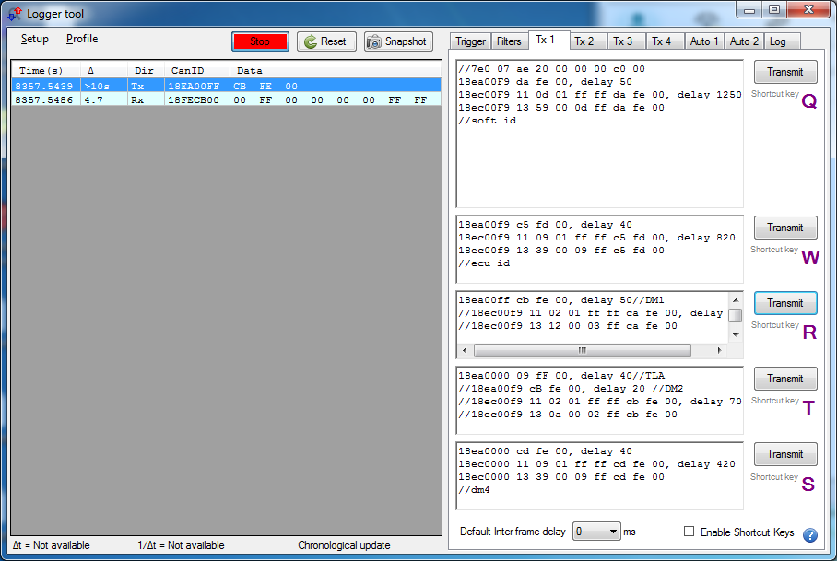

**Number of previous DTC =1,2,3**

**Set NumOfPreActiveDTCs=1,2,3**

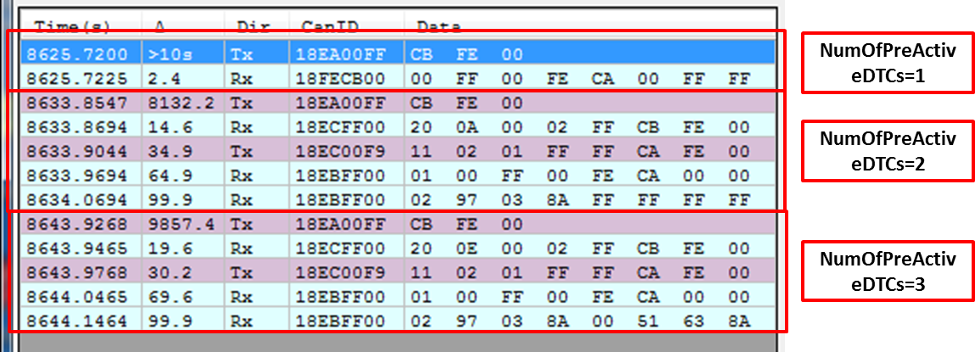

# Diagnostic Data Clear/Reset Of Previously Active DTCs (DM3)

* 1. **Set J1939_DM3_Clr_PreActive_Dtcs =false**

//means preactive DTCs was not cleared

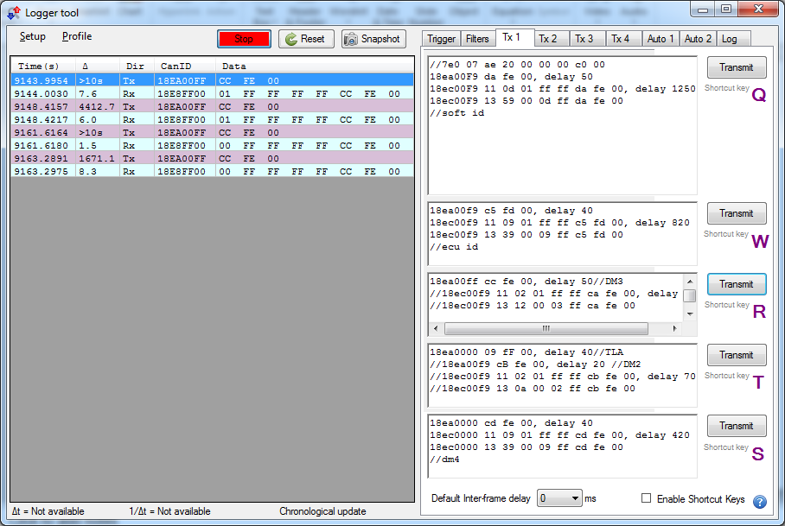

* 1. **Set J1939_DM3_Clr_PreActive_Dtcs =true**

// means preactive DTCs was cleared

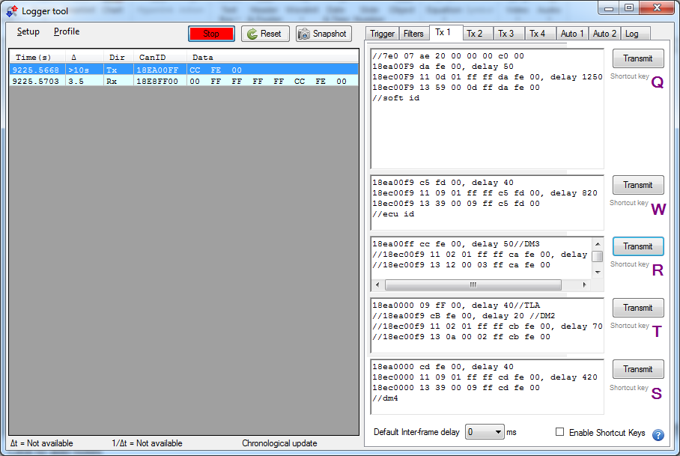

# Freeze Frame Parameters (DM4)

* 1. **No fault**

**Set DTC_Number_DM4 =0** // the number of DTC

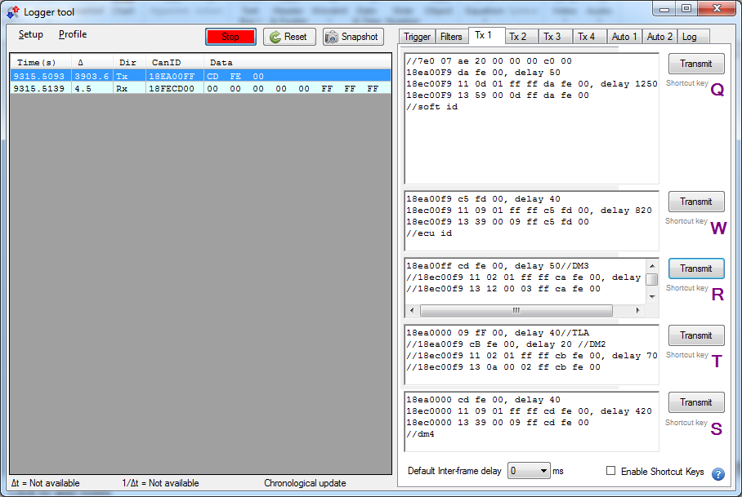

* 1. **Fault active**

**Set DTC_Number_DM4 =1,2,3**

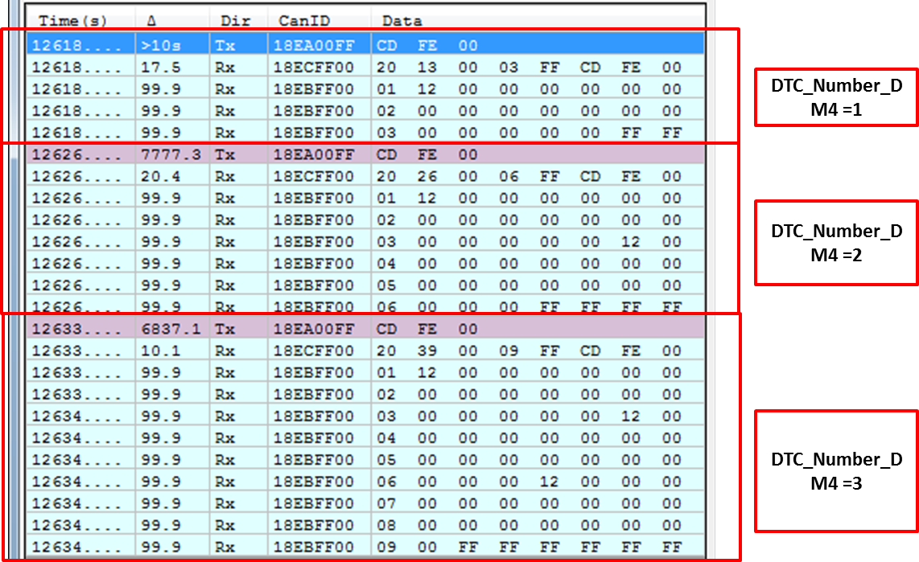

# Diagnostic Readiness 1 (DM5)

**Set the J1939_73_dm5={1,2,3,4,5,6,7,8}**

Reports the diagnostics information that relates to diagnostic readiness.

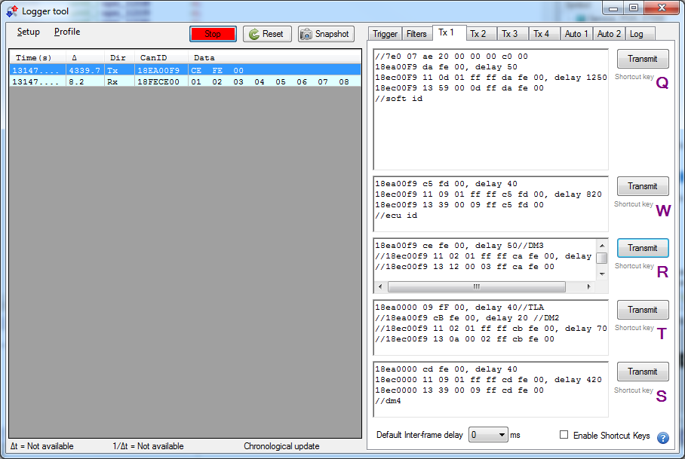

# Command Non-Continuously Monitored Test (DM7)、Test Results For Non-Continuously Monitored Systems (DM8)

Request injector1 open:

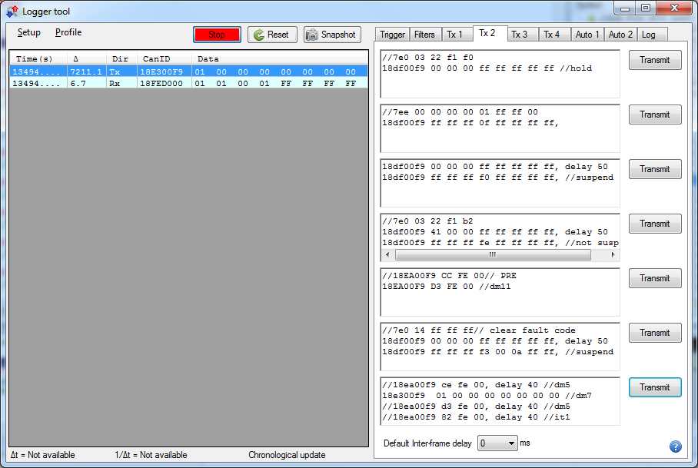

1. J1939_73_dm7 was set as {1,0,0,0,0,0,0,0}
2. B_Inj0Req was set to 1 after the message

# Diagnostic Data Clear/Reset for Active DTCs (DM11)

* 1. **J1939_DM11_Clr_Active_Dtcs =false // means active DTCs was not cleared**
  2. **J1939_DM11_Clr_Active_Dtcs =true // means active DTCs was cleared**

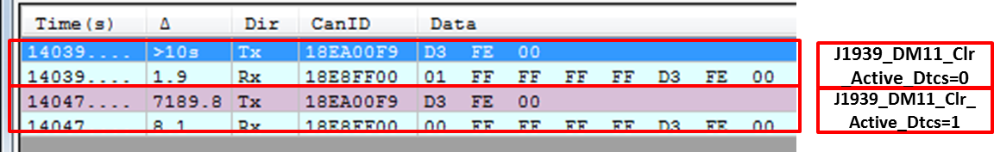

# Stop Start Broadcast (DM13)

* 1. **Hold**

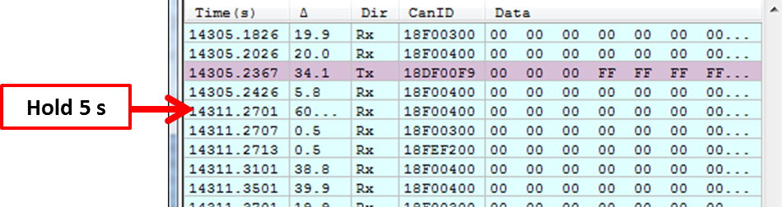

* 1. **Suspend**

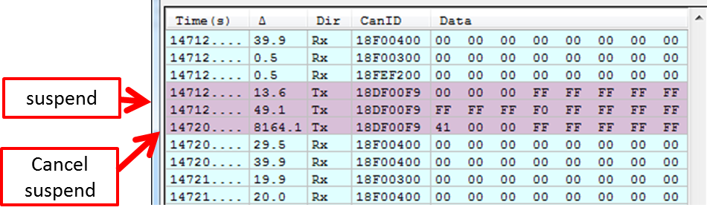

* 1. **Temporary suspend**

