

User Manual
People & Workplace
Portal..
End-user guide — HR, CRM and PMC project management

DOCUMENT NUMBER | HML-MAN-0001
ISSUE DATE | 2026
OWNER | Humiley Group Inc.
APPROVAL | Tony Nguyen, CEO
DISTRIBUTION | All staff
CONFIDENTIALITY | Internal

01 | Document Information

DOCUMENT INFORMATION
Document title | Humiley Portal — User Manual
Document number | HML-MAN-0001
Revision | 01.0 (initial release)
Issue date | 2026
Owner | Humiley Group Inc.
Approval | Tony Nguyen, CEO
Distribution | All staff
Confidentiality | Internal
ABOUT THIS DOCUMENT
This manual is a practical, screen-by-screen guide to the Humiley People & Workplace Portal. Screenshots are taken from the live demonstration dataset. It covers signing in, access levels, HR self-service, the PMC project workspace, CRM, payroll and administration.

02 | Signing in & access levels

HOW TO SIGN IN
- Open the portal URL in your browser.
- Click “Sign in with Microsoft 365” and choose your Humiley account.
- You land on the dashboard for your access level.
Access is governed by five cumulative levels — each can do everything the level before it can, plus more. Your administrator sets your level under Access & Permissions.

Level | Can do
User | Self-service: own profile, attendance, leave, claims, training, plus CRM & assigned projects.
Contributor | + approve team requests, People/HR modules, and create projects.
Approver | + view Payroll & Finance.
Editor | + run / edit Payroll.
Admin | + Access & Permissions (assign levels).
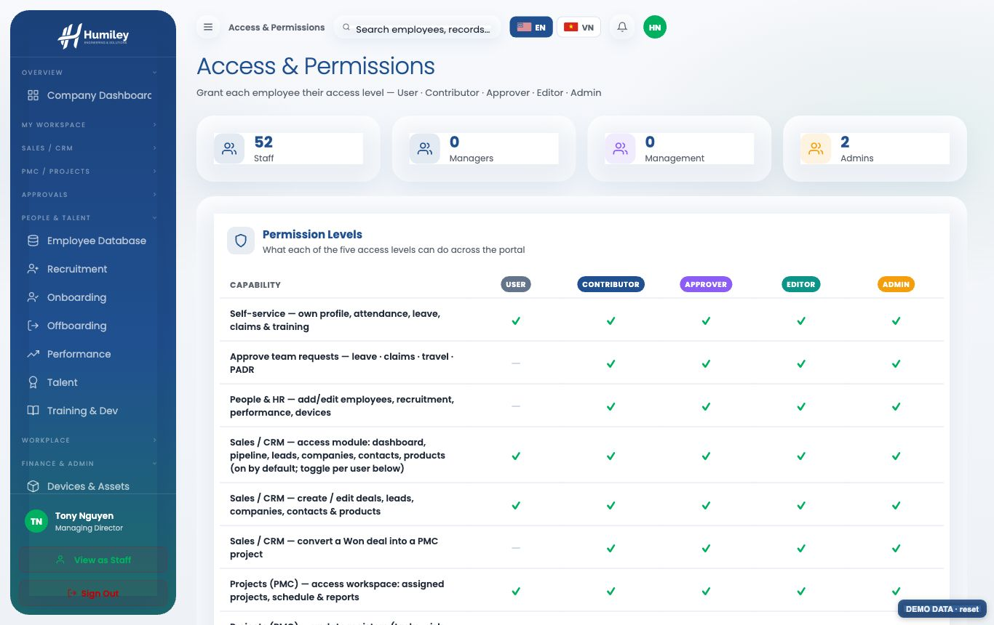

03 | Your dashboard & self-service

The dashboard is a live snapshot of the organisation — headcount, attendance, leave, recruitment and performance — with PowerBI-style charts that update from real data and a department filter. Export the current view to a branded PDF at any time.
- Check in / out and view your attendance.
- Request leave, submit travel-expense claims, set goals and complete training.
- Everything you submit routes to your direct manager for approval.
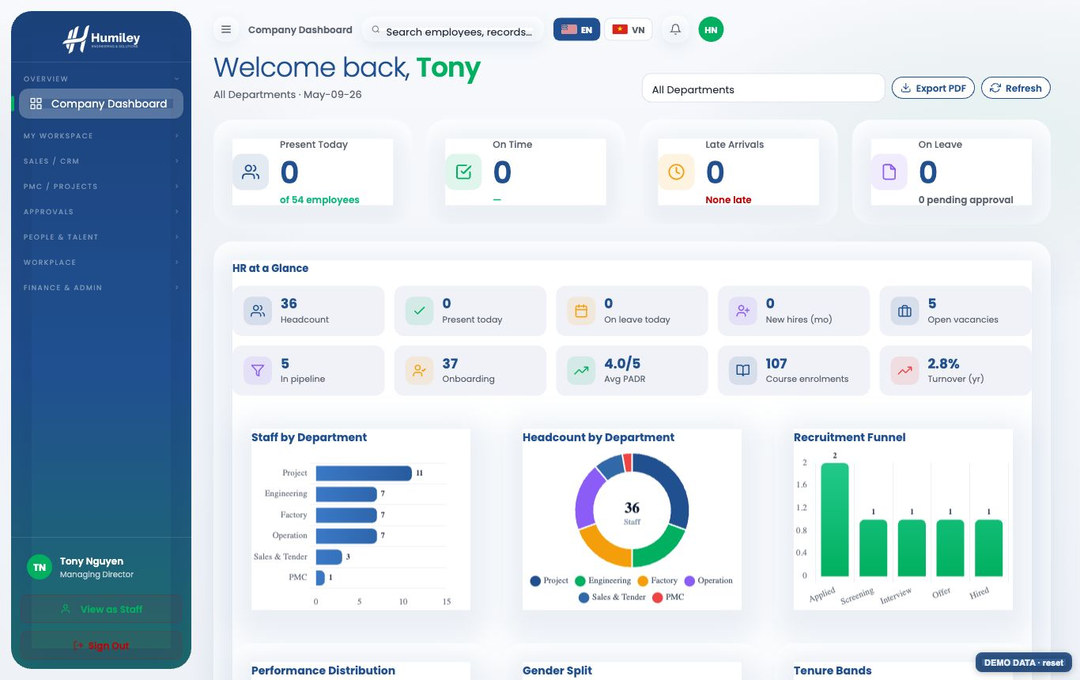

04 | People & HR

Managers and HR maintain the full employee record — role, department, assigned devices and documents — and run recruitment, onboarding, performance (PADR) and talent reviews.
- Add or edit employees; import a batch from Excel/CSV; export for reporting.
- Onboarding checklists sync to the employee’s My Training.
- Sensitive HR data (reviews, talent, exits) is visible to managers only.
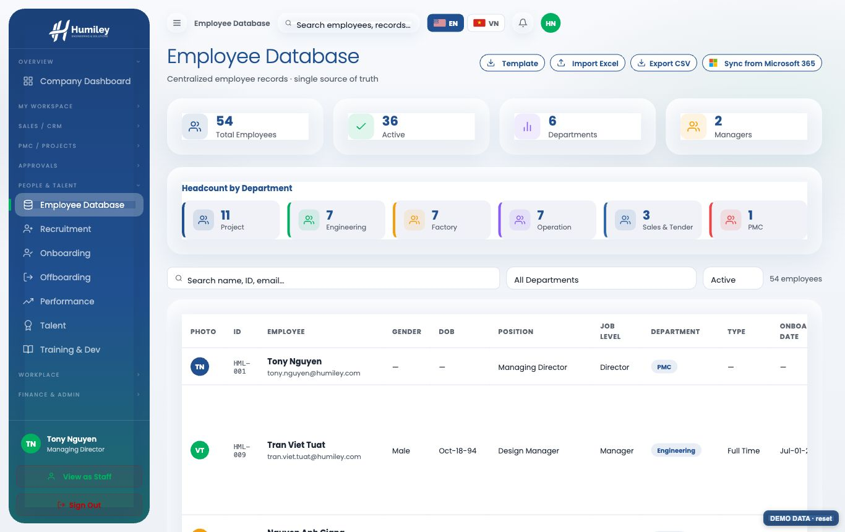

05 | Payroll & finance

Payroll computes monthly pay runs with personal income tax, social insurance and employer cost automatically, and keeps history from 2024 for trend analysis.
- Viewing payroll requires Approver level or above.
- Only Editor / Admin can run or edit a pay run.
- Every figure is exportable to a branded report.
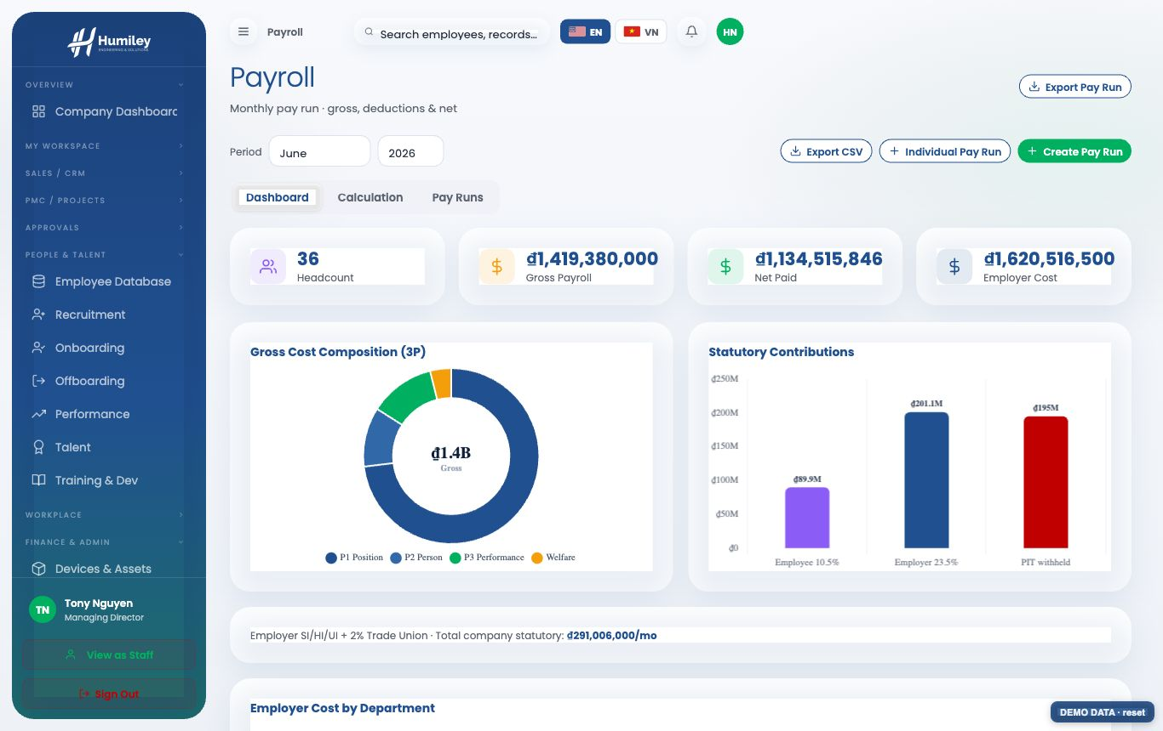

06 | PMC — project portfolio & workspace

The PMC suite manages projects to PMBOK practice. The portfolio shows every project at a glance — contract value, health (RAG), CPI/SPI and milestones. Open a project to enter its workspace, organised into tabs.
Staff see only the projects they are assigned to; managers see the whole portfolio.
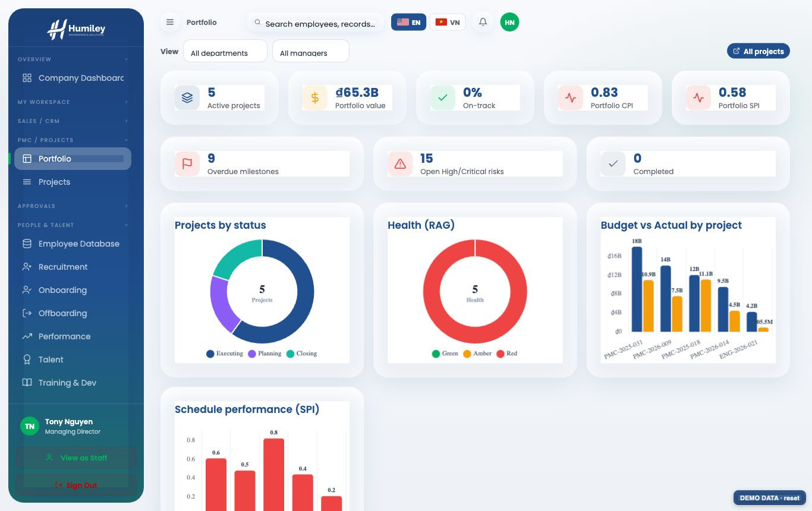

07 | Project Overview

The Overview opens with KPI tiles and PowerBI-style charts — cost (EVM), deliverables by status, schedule tasks and risk exposure — followed by the project charter, change-control log and lessons learned.
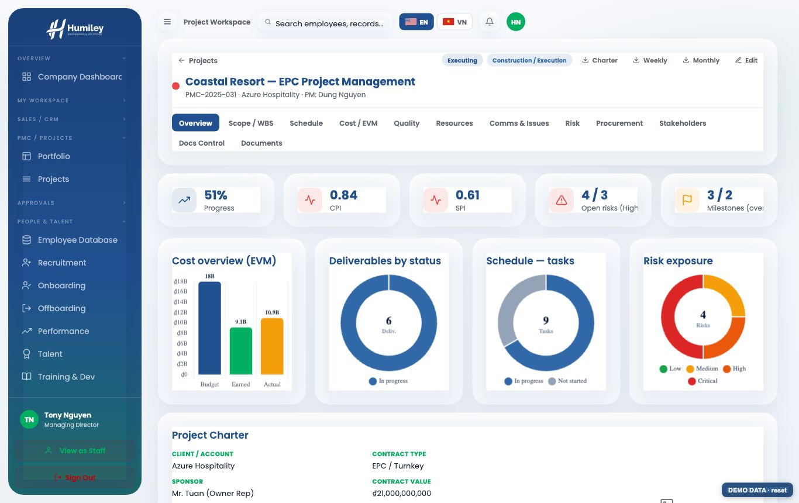

08 | Schedule (Gantt)

The Schedule is a Gantt timeline showing tasks, milestones, the critical path and a “today” marker. Filter by all time, a year, a month, or a custom day-to-day range, and export the schedule to PDF.
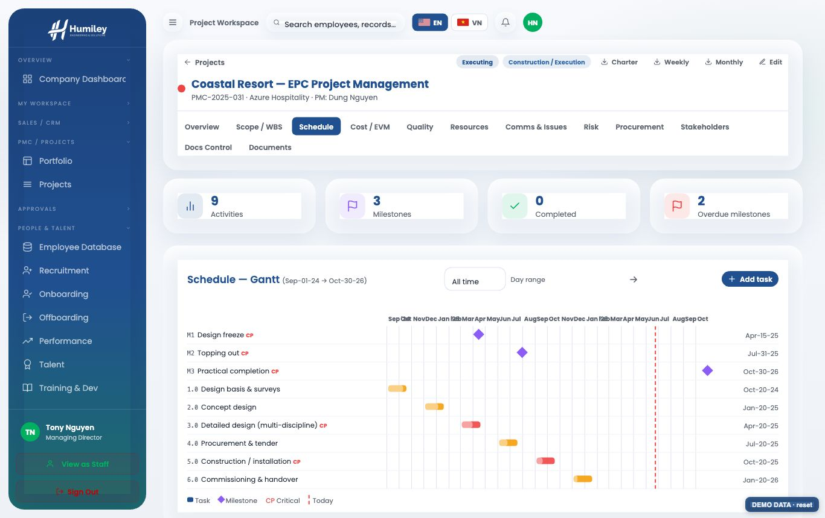

09 | Cost & Earned Value (EVM)

Cost tracks budget vs committed vs actual by category and computes earned-value metrics — CPI, SPI and the forecast at completion (EAC) — to give an early warning on cost and schedule performance.
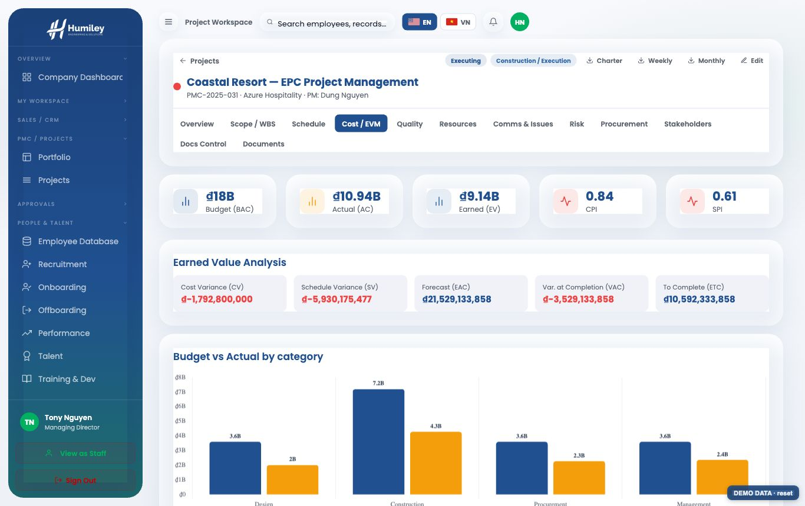

10 | Risk register & heatmap

Risks are scored on a probability × impact heatmap and banded automatically from Low to Critical. The register can be filtered by category, response strategy, owner, contractor or status.
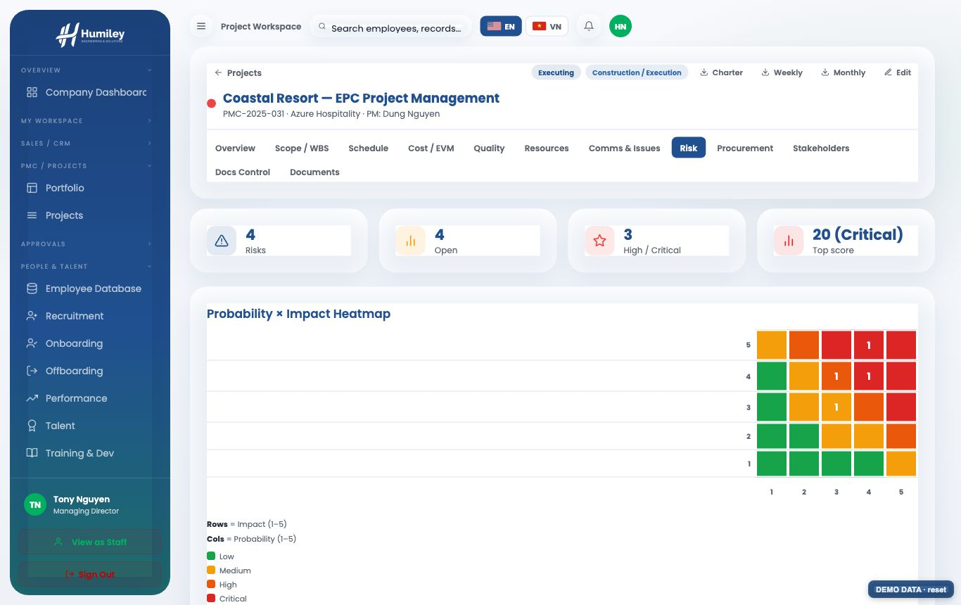

11 | Quality & Inspection-Test Plans

The quality register captures inspections, NCRs, audits and tests. Inspection & Test Plans (ITP) appear on a timeline with planned start/finish dates and a day-range filter.
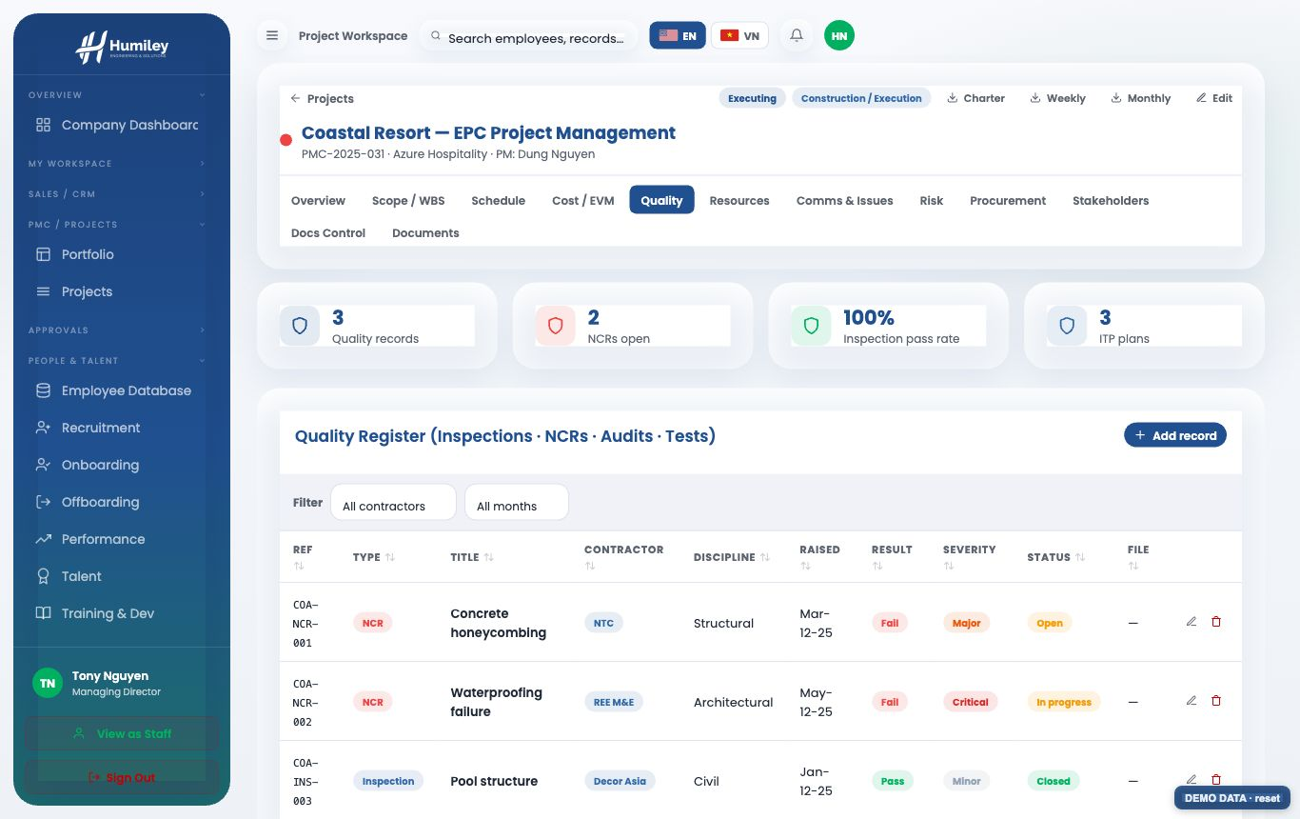

12 | Procurement, contracts & stakeholders

Procurement records subcontract packages, vendors, values, retention and interim payment certificates (IPC). Cost and procurement edits are restricted to managers.
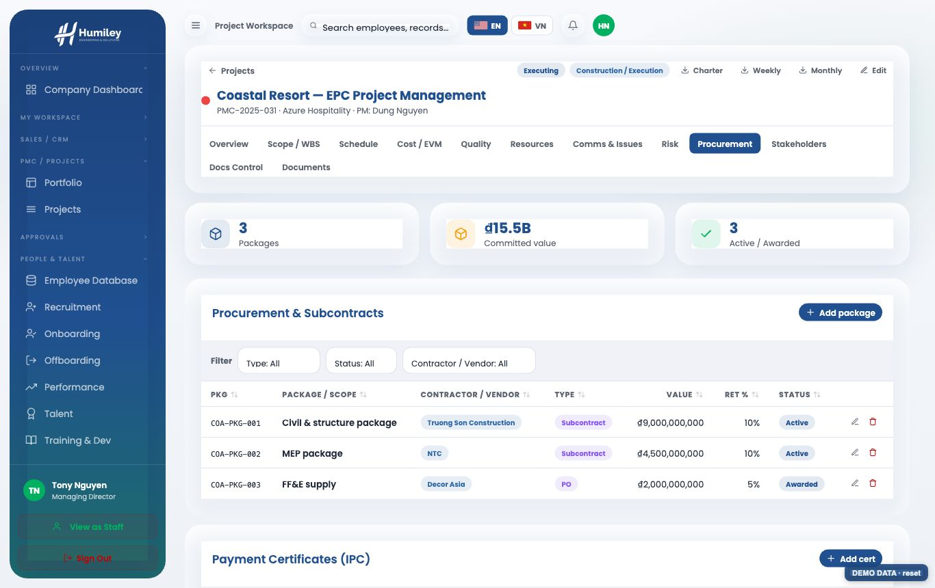
Stakeholders are mapped on a Mendelow power / interest grid so the team can plan engagement by quadrant, tracking influence, interest and attitude.
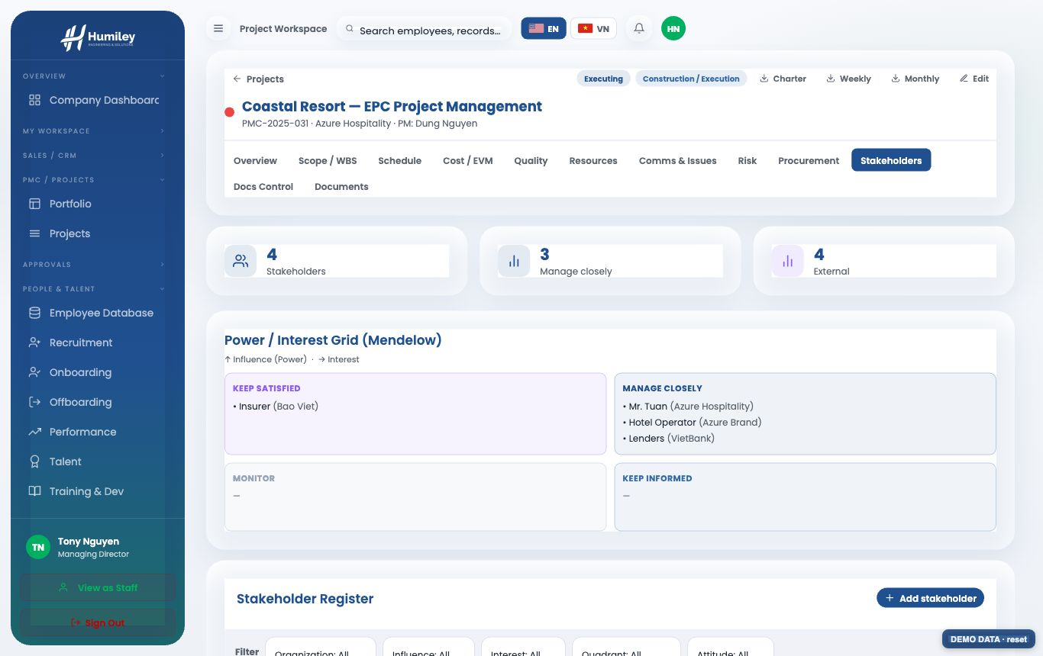

13 | Documents (SharePoint)

BUILD THE PROJECT FOLDERS
- Open the project, click Edit, and paste the project’s SharePoint document-library link into “SharePoint docs folder”.
- Click Save & build folders — when signed in with Microsoft 365, the standard 50-folder PMC structure is created in SharePoint automatically.
- Browse every folder in the Documents tab; each is a one-click link straight into SharePoint.
The folder list carries owner, confidentiality and retention for each folder. SharePoint permissions are managed by IT.
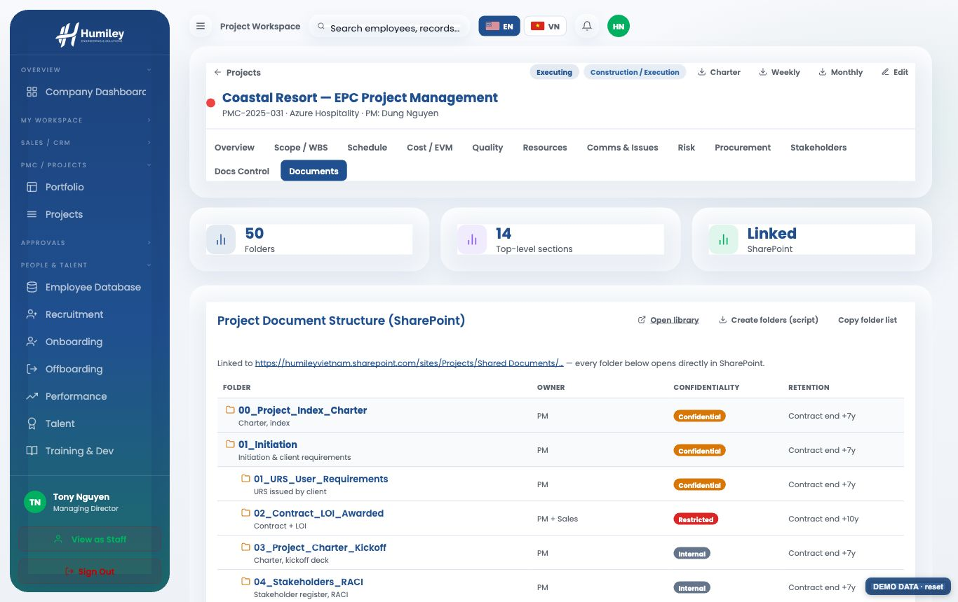

14 | Sales pipeline (CRM)

CRM tracks deals by stage with value and probability, alongside companies, contacts and products. A Won deal can be converted into a PMC project in a single click (Contributor level or above).
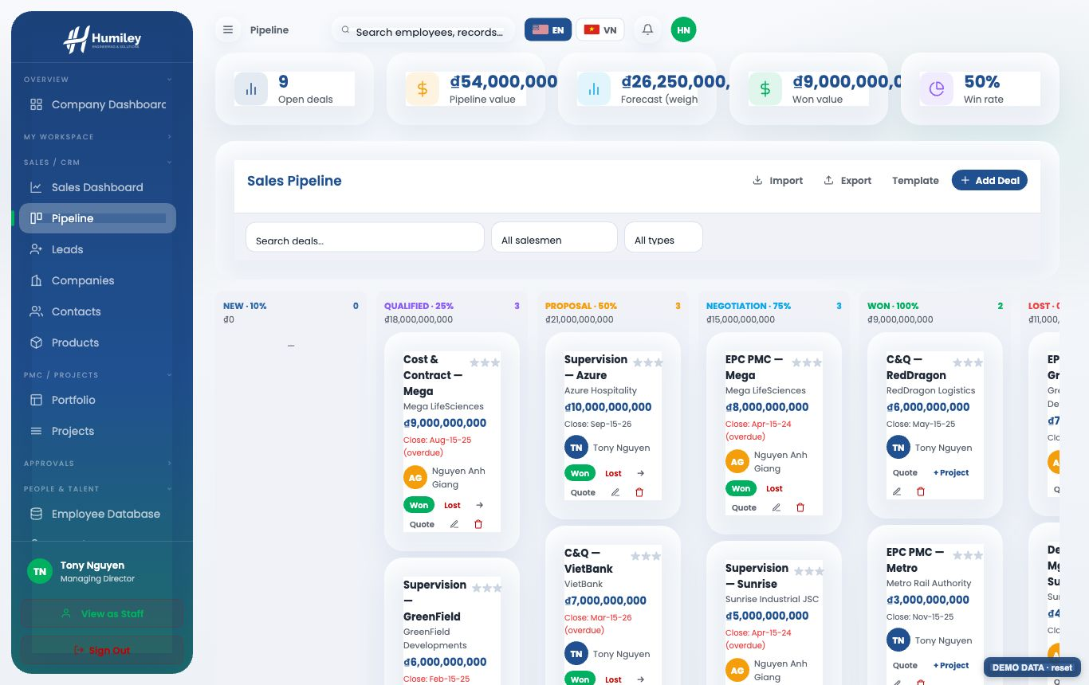

15 | Working in English or Vietnamese

Switch the entire portal between English and Vietnamese using the EN / VN flag in the top bar. Labels, menus, tables and chart legends all translate.
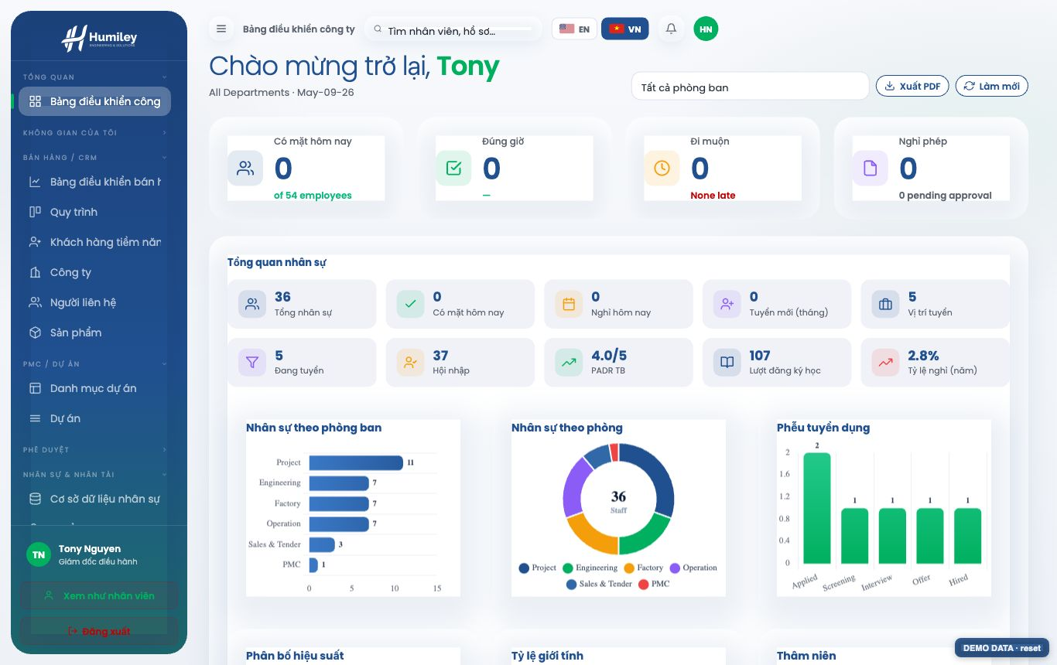

16 | English – Vietnamese glossary

English | Tiếng Việt
Dashboard | Bảng điều khiển
Attendance | Chấm công
Leave | Nghỉ phép
Payroll | Lương
Project | Dự án
Schedule | Tiến độ
Cost / EVM | Chi phí / EVM
Risk | Rủi ro
Quality | Chất lượng
Procurement | Mua sắm
Stakeholders | Bên liên quan
Documents | Tài liệu
Pipeline | Quy trình bán hàng
Access & Permissions | Phân quyền

17 | Administration & data safety

- Updates replace only the application code — the database (timekeeping.db) is never overwritten, so all data is preserved.
- Keep the database on a persistent volume and back it up before each update.
- Access levels and module access are managed under Access & Permissions; changes apply at the user’s next sign-in.

