Name: alsyabi

Contents
1
TASK #02: 2
USE CASE DIAGRAM OF GIVEN SCENARIO 2
USE CASE 01 3
TASK 03: 4
SEQUENCE DIAGRAM 4
EXPLAIN SEQUENCE DIAGRAM 4

TASK #02:

USE CASE DIAGRAM OF GIVEN SCENARIO
Use Case diagram is the unified modeling Language and have Use Cases that can describe data (Arifin et al., 2020). Use case Diagram have actors which are performing actions( Nayaka et al., 2020).
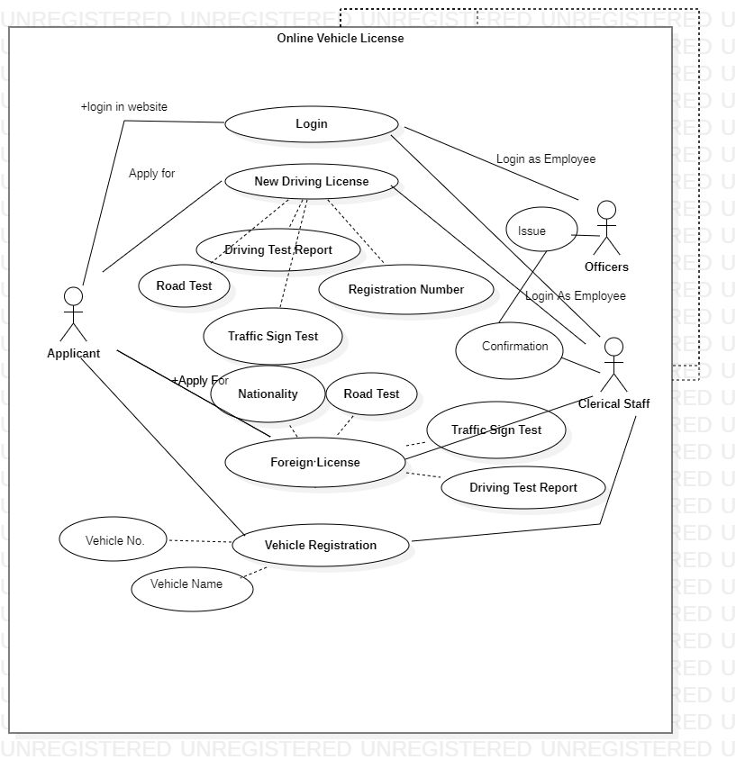

USE CASE 01
Use case Name | New Driving License | ID: 001 | Importance Level:  Very High
Primary Actor | Applicant | Use Case Type:  Real
Stakeholders and Interests | Clerical Staff and officers
Brief Description | To get new Driving License applicant have to apply for the driving license and perform obligatory tests such as Driving Test Report, Road Test etc and then this will be marked by staff member and finally from CEO will issue the Driving License
Trigger | External
Type | Real
Relationships Association: Include:  Extend: Generalization: | Association is with Applicant  Include has New Driving License  Extend is Driving Test.  No generalization
Normal Flow of Events | User has to apply through online form and then give their results to the clerical staff and they will make sure that results are ok. Then they will forward case to officer and he will issue license
Sub Flows | Sub-flows are Check information > complete information >Forwar to Officer
Alternate/Exceptional Flows | User can manually provide information on call  System can be unavailable.

TASK 03:

SEQUENCE DIAGRAM
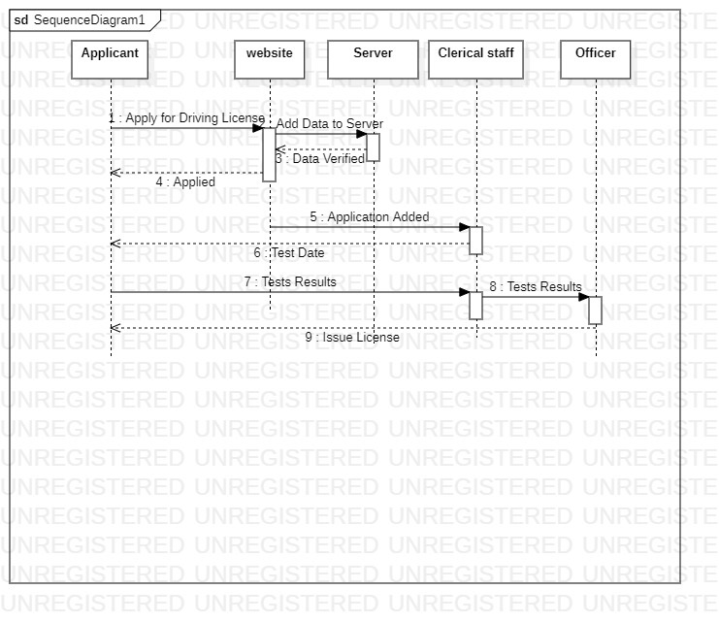

EXPLAIN SEQUENCE DIAGRAM
Sequence diagram is the type of unified Modeling Language that describes the type of interaction and completely explain and describe order and group of objects (Triandini et al., 2019). Lifelines are the objects and create message. Message is described through Line and Text tells about the details. Reply message are described through dotted line.
According to this scenario applicant will apply for driving License through website (Campean., 2017). Then they get acknowledgement and Message will be forwarded to clerical staff. Clerical staff will assign test dates through message and they will get results online.
Result will be forwarded to Officer and then Senior officer will issue License (Karampure., 2021).

REFERENCE:
- Arifin, M. N., & Siahaan, D. (2020). Structural and Semantic Similarity Measurement of UML Use Case Diagram. Lontar Komputer: Jurnal Ilmiah Teknologi Informasi, 11(2), 88.
- Nayaka, A. M. Use Case Point Effort Estimation Method Using the Case of University Attendance Management System Use Case Diagram.
- Fauzan, R., Siahaan, D., Rochimah, S., & Triandini, E. (2019, July). Use case diagram similarity measurement: A new approach. In 2019 12th International Conference on Information & Communication Technology and System (ICTS)(pp. 3-7). IEEE.
- Triandini, E., Fauzan, R., Siahaan, D. O., & Rochimah, S. (2019, July). Sequence diagram similarity measurement: a different approach. In 2019 16th International Joint Conference on Computer Science and Software Engineering (JCSSE) (pp. 348-351). IEEE.
- Campean, F., & Yildirim, U. (2017). Enhanced sequence diagram for function modelling of complex systems. Procedia Cirp, 60, 273-278.
- Karampure, R., Wang, C. Y., & Vashi, Y. (2021). UML sequence diagram to axiomatic design matrix conversion: a method for concept improvement for software in integrated systems. Procedia CIRP, 100, 457-462.

